TISSUES (CONNECTIVE TISSUE): DAILY PRACTICE PAPER (DPP) BY TEACHINGCARE.COM

1. In all connective tissues, the cells secrete fibres of
structural proteins called collagen or elastin except in
- Bone
- Cartilage
- Blood
- Adipose tissue
Ans 3
2. The phagocytic cells in loose connective tissue is/are
1. fibroblasts
2. macrophages
3. mast cells.
4. all the above
Ans 2
3. The excess of nutrients which are not used immediately
are converted into fats and are stored in

- Bone
- Cartilage
- Blood
- Adipose tissue
Ans 4
4.Which of the following statements is not true w.r.t. connective tissue
1. In the dense irregular connective tissues, the elastin fibres are present in
many parallel bundles.
2. Tendons attach skeletal muscles to bones
3. ligaments attach one bone to another are examples of this tissue.
4. Tendons and ligaments attach are examples of dense regular connective tissues
Ans 1
5. Choose the correct one w.r.t. a bone tissue
1. Bones have a hard and non-pliable ground substance
rich in calcium salts and elastin fibres which give bone
its strength .
2. It is not the main tissue that provides structural frame to the body
3.The bone forming cells are called osteoclasts
4. Limb bones interact with skeletal muscles attached to them
to bring about movements
ans. 4

6. the site of production of blood cells is
1. bone
2. cartilage
3. blood
4. areolar tissue
Ans 1

7. The following diagrammes represent respectively

(a)

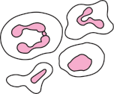
(b)


(c)

- Adipocytes, RBCS and Platelets
- Adipocytes, WBCS and RBCS
- WBCS, RBCS and Platelets
- RBCS, WBCS and Platelets
Ans 4

8. Dense irregular connective tissue is represented by

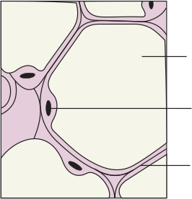

Ans 4

9. The following diagramme represents

(1) Loose connective tissue,
(2) Dense connective tissue
(3) Specialised connective tissue
(4) cartilage
Ans. 1

10. Which of the following diagramme represents a bone

(1)

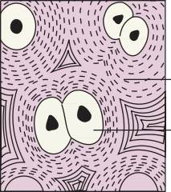
(2)

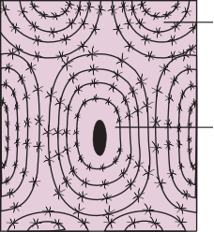
(3)

(4) Both 2 and 3
Ans 3

11. Choose the correct match
1. Bone –chondrocytes
2. Areolar tissue- dense connective tissue
3. Tendons-dense connective tissue
4. Ligaments- loose connective tissue
Ans 3
12. Choose the incorrect regarding cartilage
1. The intercellular material of cartilage is solid and pliable
and resists compression.
2.Cells of this tissue (chondrocytes)
are enclosed in small cavities within the matrix secreted by
them.
3. Most of the cartilages in vertebrate embryos are replaced by bones in adults.
4. None of the above
Ans 4

13. Cartilage is present in
a. the tip of nose,
b. outer ear joints,
c. between adjacent bones of the vertebral column, limbs and hands in adults

- a and b only
- a, b and c
- a only
- b only
ans 2
14. In connective tissues, the cells secrete fibres of
structural proteins called
- collagen
- elastin.
- Keratin
- a only
- b only
- a and b only
- all of the above
ans 3

15. The cells found in connective tissue proper are ?
1.White blood cells and wandering cells
2. mast cells and fibroblasts
3. adipocytes and leukocytes
4. macrophages and osteoblasts
Ans 2

