16
1. IIT–JEE Syllabus
2. Introduction and Nomenclature
2.1 Structure of Amines
  - Classification of Amines
  - Nomenclature of Amines
  - Physical Properties
3. Basicity
3.1 Aliphatic bases
3.2 Aromatic bases
4. Preparation of Amines
4.1 From Alkyl Halides
4.2 From Nitrogen Containing Compounds
4.3 From Carbonyl Compounds
4.4 Curtius Reaction
  - Schmidt Reaction
  - By Reduction of Alkyl Isocyanide
  - Preparation of Tertiary Amines
5. Chemical Reaction
  - Basic Nature
  - Acylation
  - Benzoylation
  - Carbylamine Reaction
  - Action with Aldehyde & Ketone
  - Hofmann mustard oil reaction
  - Reaction with Carbonyl Chloride
  - Reaction of Quaternary Ammonium salt
  - Reaction of Amines with Nitrous Acid
5.10. Coupling Reactions of Arene Diazonium Salts
5.11. Ring Substitution of Aromatic Amines
5.12. Aniline - X rearrangement
6. Separation of Mixture of Amines
6.1 Hinsberg’s Method
  - Hofmann’s Method
7. Test for Amines
7.1 Test for Primary Amines
7.2 Test for Secondary Amines
8. Solutions to Exercises
9. Solved Problems
9.1 Subjective
9.2 Objective
10. Assignments
(Subjective Problems)
11. Assignments
(Objective Problems)
- Answers to Objective
Assignments

Amines

Amines play a vital role in medicinal chemistry. As our body is having a lot of amino acids, these amines help in the regulation of our body. It is also believed that, vitamins were named keeping vital-amines in mind (though many vitamins don't have nitrogen at all). Similarly to produce several synthetic dyes, pigments the amines are used. Therefore, the amines are very important in our everyday life. Let us see how this is.

1. IIT-JEE Syllabus
Basicity of aniline and aliphatic amine, preparation from nitro compounds, reaction with nitrous acid, formation and reactions or diazonium salts, and its coupling with phenols, carbylamine reaction.
2. Introduction and Nomenclature

2.1 Structure of amines
Amines are the alkyl (or) aryl derivatives of NH₃. The general formula of amine is R₃N, where R is an alkyl (or) aryl group or hydrogen.
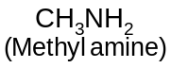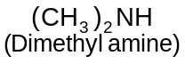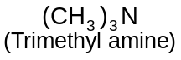
In amines one or more Hydrogen atoms of ammonia are replaced by Alkyl or aryl groups. Here nitrogen atom of amines is like that of NH₃, it is sp³ hybridised. The three Alkyl groups (or hydrogen atoms) occupy corners of a tetrahedron, one of sp³ orbital occupying the unshared electron pair directed towards the other corner. We say shape of amine as “Trigonal Pyramidal”.
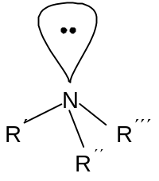
2.2 Classification of amines
Amines are classified as primary, secondary (or) tertiary according to the number of groups attached to the nitrogen atom. If one alkyl group has replaced one hydrogen atom of ammonia, it is primary amine. Similarly, if two hydrogens are replaced, it is secondary amine and if all the three are replaced, it is tertiary amine.
We can also replace all the 4 hydrogens in 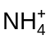 with alkyl groups to get a quaternary tetra alkyl ammonium ion.
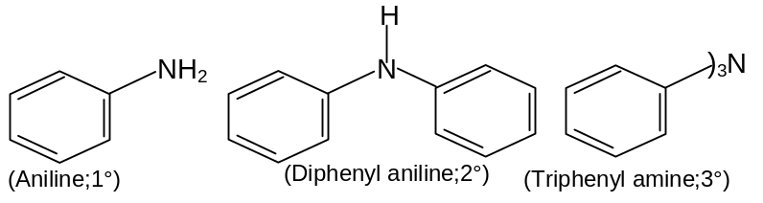
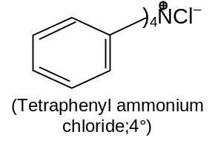
2.3 Nomenclature of amines
Nomenclature of amines is quite simple. Aliphatic amines are named by naming the alkyl group (or) groups attached to nitrogen , and following that by the word amine.
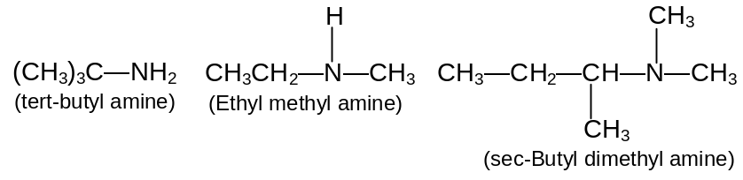
More complicated amines are often named as prefixing amino - (or-N-methylamino -, N-N, diethyl amino -, etc) to the name of the parent chain.
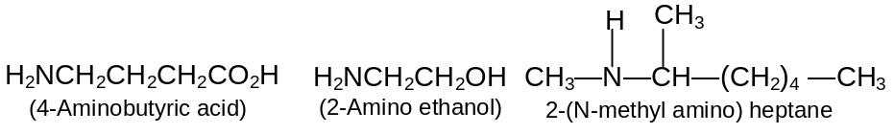
Aromatic amines - those in which nitrogen is attached to an aromatic ring - are generally named as derivatives of the simplest aromatic amine, aniline.
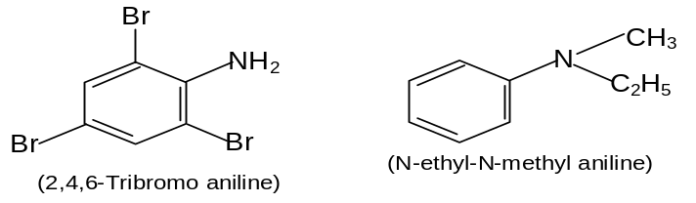
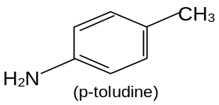
Salts of amines are generally named by replacing - amine by - ammonium (or - aniline by - anilinium), and adding the name of the anion.
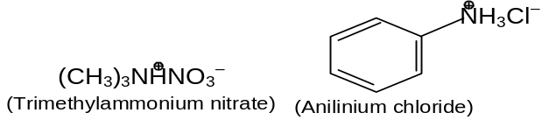
2.4 Physical Properties
Amines are moderately polar substances; they have boiling points that are higher than those of alkanes but generally lower than alcohols of comparable molecular weight. Molecules of primary and secondary amines can form strong hydrogen bonds to each other and to water. Molecules of tertiary amines can not form hydrogen bonds to each other, but they can form hydrogen bonds to molecules of water or other hydroxylic solvents. As a result, tertiary amines generally boil at lower temperatures than primary and secondary amines of comparable molecular weight.
3. Basicity

3.1 Aliphatic Bases
As increasing strength in nitrogenous bases is related to the readiness with which they are prepared to take up protons, and therefore, to the availability of the unshared electron pair on nitrogen, we might expect to see an increase in basic strength on going : NH₃ → RNH₂ → R₂NH→ R₃N, due to the increasing inductive effect of successive alkyl groups making the nitrogen atom more negative. An actual series of amines was found to have related pK_{a} values as follows, however :
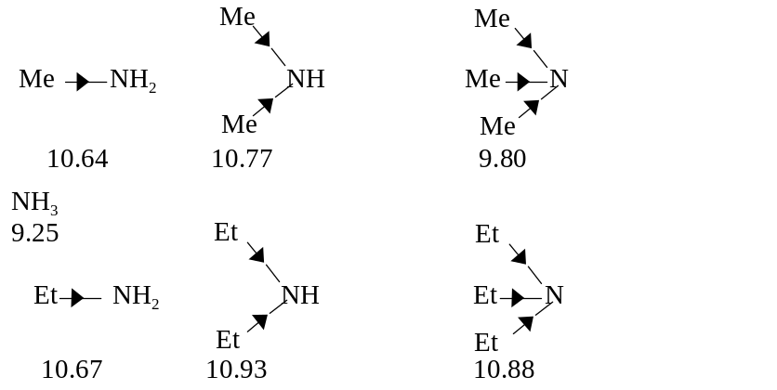
It will be seen that the introduction of an alkyl group into ammonia increases the basic strength markedly as expected. The introduction of a second alkyl group further increases the basic strength, but the net effect of introducing the second alkyl group is very much less marked than with the first. The introduction of a third alkyl group to yield a tertiary amine, however, actually decreases the basic strength in both the series quoted. This is due to the fact that the basic strength of an amine in water is determined not only by electron - availability on the nitrogen atom, but also by the extent to which the cation, formed by uptake of a proton, can undergo solvation, and so become stabilized. The more hydrogen atoms attached to nitrogen in the cation, the greater the possibilities of powerful solvation via hydrogen bonding between these and water :
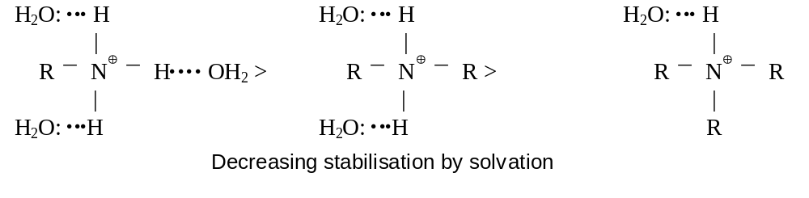
Thus on going along the series, NH₃ → RNH₂ → R₂NH → R₃N, the inductive effect will tend to increase the basicity, but progressively less stabilisation of the cation by hydration will occur which will tend to decrease the basicity. The net replacing effect of introducing successive alkyl groups thus becomes progressively smaller, and an actual changeover takes place on going from a secondary to a tertiary amine. If this is the real explanation, no such changeover should be observed if measurements of basicity are made in a solvent in which hydrogen - bonding cannot take place; it has, indeed, been found that in chlorobenzene the order of basicity of the butylamines is
BuNH₂ < Bu₂NH < Bu₃N
Tetralkylammonium salts, e.g. R₄N⊕ I⁻, are known, on treatment with moist silver oxide, AgOH, to yield basic solution comparable in strength with the mineral alkalis. This is readily understandable for the base so obtained, R₄N⊕ –OH, is bound to be completely ionised as there is no possibility, as with tertiary amines, etc.,
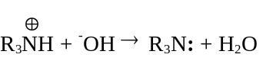
of reverting to an unionised form.
The effect of introducing electron withdrawing groups, e.g. Cl, NO₂, close to a basic center is to decrease the basicity, due to their electron withdrawing inductive effect. Thus the amine is found to be virtually non - basic, due to the three powerfully electron withdrawing CF₃ groups. This can well be explained on the basis of more ‘s’ character on lone pair of N. | 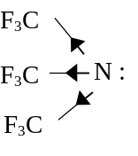

The change is also pronounced with C=O, for not only is the nitrogen atom, with its electron pair, bonded to an electron withdrawing group through an sp² hybridised carbon atom but an electron withdrawing mesomeric effect can also operate : | 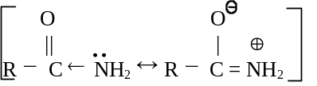
Thus amides are found to be only very weakly basic in water [pK_{a} for ethanamide(acetamide) is ≈ 0.5], and if two C=0 groups are present the resultant imides, far from being basic, are often sufficiently acidic to form alkali metal salts, e.g. benzene - 1, 2 - dicarboximide :
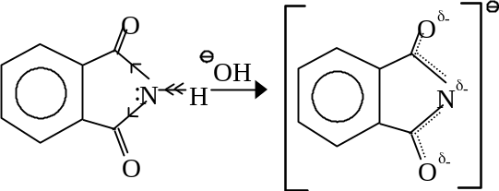

3.2 Aromatic Bases:
The exact reverse of the above is seen with aniline, which is a very weak base (pK_{a} = 4.62) compared with ammonia (pK_{a} = 9.25) or cyclohexylamine (pK_{a} = 10.68). In aniline the nitrogen atom is again bonded to a sp² hybridised carbon atom but, more significantly, the unshared electron pair on nitrogen can interact with the delocalised π orbitals of the nucleus : | 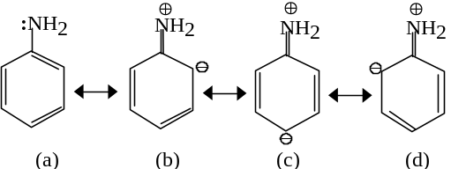
If aniline is protonated, any such interaction, with resultant stabilisation, in the anilinium cation is prohibited, as the electron pair on N is no longer available :
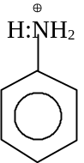
The aniline molecule is thus stabilised with respect to the anilinium cation, and it is therefore ‘energetically unprofitable’ for aniline to take up a proton ; it thus functions as a base with the utmost reluctance (pK_{a} = 4.62, compared with cyclohexylamine,
pK_{a} = 10.68). The base weakening effect is naturally more pronounced when further phenyl groups are introduced on the nitrogen atom ; thus diphenylamine, Ph₂NH, is an extremely weak base (pK_{a} = 0.8), while triphenylamine, Ph₃N, is by ordinary standards not basic at all. Introduction of alkyl, e.g. Me, groups, on to the nitrogen atom of aniline results in small increase in pK_{a} :
C₆H₅NH₂ C₆H₅NHMe C₆H₅NMe₂ MeC₆H₄NH₂
4.62 4.84 5.15 o-4.38
m-4.67
p-5.10
Unlike on such introduction in aliphatic amines this small increase is progressive : suggesting that cation stabilisation through hydrogen - bonded solvation, responsible for the irregular behavior of aliphatic amines, here has less influence on the overall effect. The major determinant of basic strength in alkyl-substituted anilines remains mesomeric stabilisation of the aniline molecule with respect to the cation ; borne out by the irregular effect of introducing Me groups into the o-, m- and p-positions in aniline.
A group with a more powerful (electron - withdrawing) inductive effect, e.g. NO₂ is found to have rather more influence. Electron withdrawal is intensified when the nitro group is in the o- or p-position, for the interaction of the unshared pair of the amino nitrogen with the delocalised π orbital sytsem of the benzene nucleus is then enhanced. The neutral molecule is thus stabilised even further with respect to the cation, resulting in further weakening as a base. Thus the nitro - anilines are found to have related pK_{a} values :
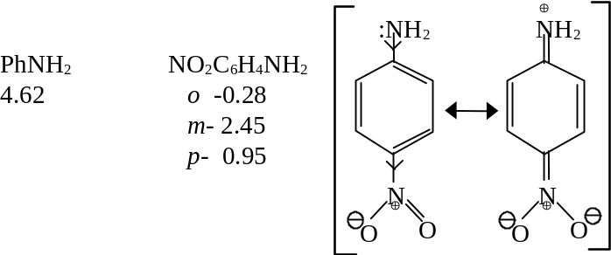
The extra base - weakening effect, when the substituent is in the o-position, is due in part to the short distance, over which its inductive effect is operating, and also to direct interaction, both steric and by hydrogen bonding, with the NH₂ group. o-Nitroaniline is such a weak base that its salts are largely hydrolysed in aqueous solution, while 2, 4 - dinitroaniline is insoluble in aqueous acids, and 2, 4, 6 - trinitroaniline resembles an amide; it is indeed called picramide and readily undergoes hydrolysis to picric acid (2, 4, 6 - trinitrophenol).
With substituents such as OH and OMe that have unshared electron pairs, an electron - donating, i.e. base strengthening, mesomeric effect can be exerted from the o- and p-, but not from the m-position, with the result that the p-substituted aniline is a stronger base than the corresponding m-compound. The m-compound is a weaker base than aniline itself, due to the electron - withdrawing inductive effect exerted by the oxygen atom in each case. As so often, the effect of the o - substituent remains somewhat anomalous, due to the interaction with the NH₂ group by both steric and polar effects. The substituted anilines are found to have related pK_{a} values as follows :
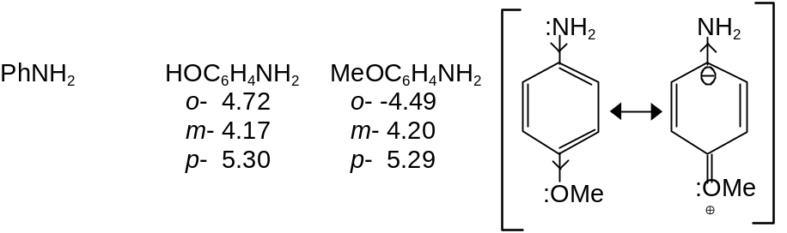
Exercise-1 : i) Amines are stronger bases than ammonia. Why?
ii) Aniline is a weak base than ethylamine. Why?
4. Preparation of Amines
Now, that we have learnt something about amines, we shall now get into the methods of their preparation.
4.1 From Alkyl halides
Many organic halogen compounds are converted into amines by treatment with aqueous (or) alcoholic solution of ammonia. This reaction is generally carried out either by allowing the reactants to stand together at room temperature (or) by heating them under pressure. Displacement of halogen by NH₃ yields the amine salt, from which free amine can be liberated with hydroxide ion.
CH₃Cl + NH₃ ⎯→ 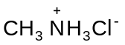 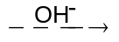CH₃NH₂ + Cl– + H₂O
The above reaction is a class of substitution reaction, which we know as nucleophilic substitution.
Ammonia can act as a nucelophile and it can also act as a base.
If ammonia acts a nucleophile substitution takes place,
CH₃CH₂CH₂Br + NH₃ ⎯→ CH₃CH₂CH₂NH₂ + HBr
And, if ammonia acts as a base, elimination takes place.
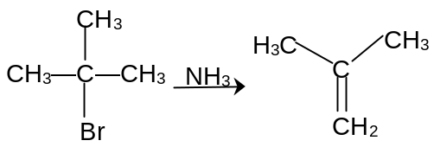
It is very evident that primary alkyl halides under go substitution very easily than tertiary alkyl halides, which undergo elimination very easily.
Look at the sequence of reactions below,
RX 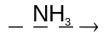 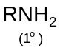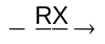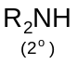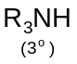 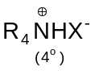
The reaction is quite simple and we can convert alkyl halide into all class of amines.
Exercise 2: How does the formation of 2° and 3° amines can be avoided during the preparation of 1° amines by alkylation?
4.2 From nitrogen containing compounds
4.2.1 Nitro compounds

Nitro alkanes can be reduced quantitatively to their corresponding amines.
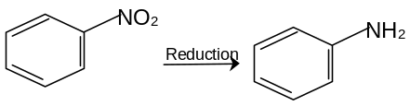
Nitro compound can be reduced in two general ways: (A) by catalytic hydrogenation using molecular hydrogen, or (B) by chemical reduction, usually by a metal and acid.
This method cannot be used when the molecule also contains some other easily hydrogenated group, such as a Carbon carbon double bond. Chemical reduction is most often carried out by adding hydrochloric acid to a mixture of the nitro compound and metal, usually granulated tin or iron.
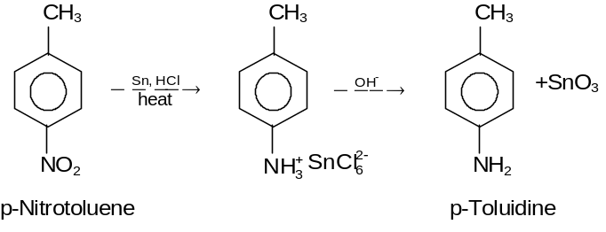
4.2.2 Nitriles

Alkyl and aryl cyanides can be reduced to their corresponding amines using LiAlH₄
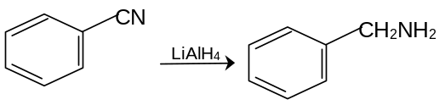

4.2.3 Amides

Amides can directly be converted into their corresponding amines. This reaction is carried out by treating the amide with a mixture of base and bromine (KOH + Br₂). This reaction is called as Hofmann Bromamide reaction.

The reaction is as follows,

RCONH₂ + Br₂ + 4KOH ⎯⎯→ RNH₂ + K₂CO₃ + 2KBr + 2H₂O

Here we can see that the amine formed has one carbon less than that of the corresponding amide. Due to the loss of carbon atom, this reaction is also called as Hofmann degradation of amides.
The mechanism of the reaction is as follows:
Step 1 | 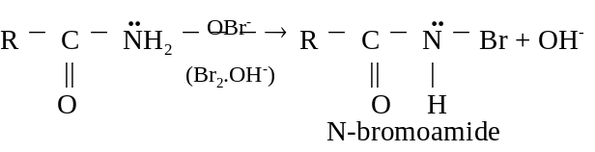  (one of the hydrogen attached to nitrogen is substituted by a bromine atom)
Step 2 | 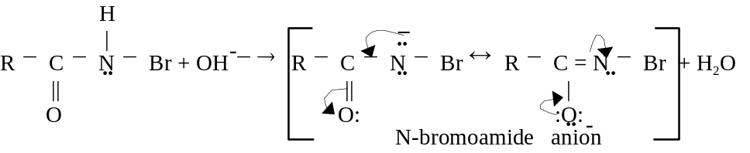  (The N-bromamide anion thus formed as a result of proton by base is stabilized by resonance)
Step 3 | 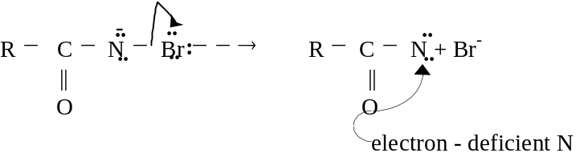  (Bromine leaves and we have an electron deficient nitrogen)
Step 4 | 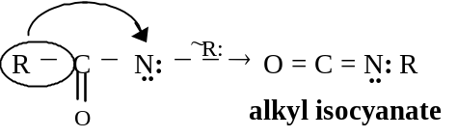  (There is a shift of alkyl group to the nitrogen)
Step 5 | 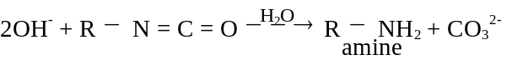  (A simple hydrolysis of an imine gives us the amine)
Apart from this, amides can be dehydrated by P₂O₅ to their corresponding nitriles and nitriles can then be reduced.
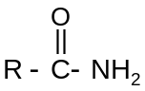 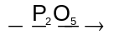R—C ≡ N 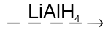 R—CH₂NH₂
By this method you are retaining the number of carbon atoms in both amide and the amine.
4.3 From carbonyl compounds
While studying carbonyl compounds we have seen that carbonyl compounds can be converted into any other functional group. How are we converting carbonyl group into amino group?
See, the following sequence,
CH₃CH = O + NH₃ ⎯⎯→ 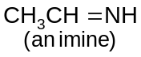 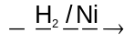 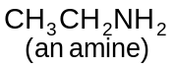
The reactions are clear and simple so that, we can get an amine from carbonyl compound just by reductive amination (amination and reduction).
Using this reductive amination we can go from 1° amine to 2° amines. How? Look at the following reaction.
CH₃CH₂CH = O + 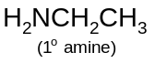 ⎯⎯→ CH₃CH₂CH=NCH₂CH₃
↓H₂/Ni
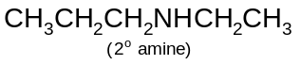
4.4 Curtius reaction
Amines can be prepared by treating acid chloride with sodium azides the isocyanate thus formed is decomposed with treatment of water and amines are obtained.
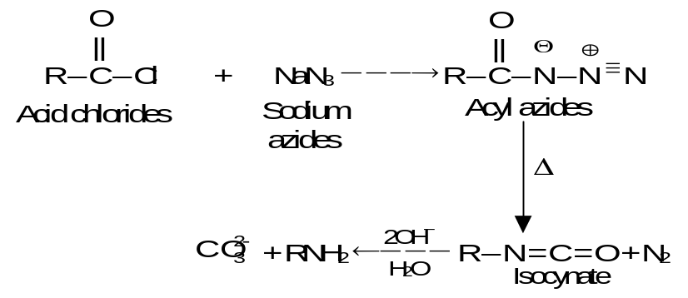

4.5 Schmidt reaction
Hydrozoic acid reacts with carboxylic acid in presence of a mineral acid to give amines.

4.6 By the reduction of an alkyl isocyanide
RNC + 4[H] ⎯⎯→ R – NH – CH₃

4.7 Preparation of Tertiary Amines
3RX + NH₃ 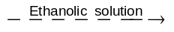 R₃N + 2HX
(in excess)
Exercise 3: In the presence of base, acyl derivatives of hydroxamic acids undergo the Lossen rearrangement to yield isocyanates or amines.
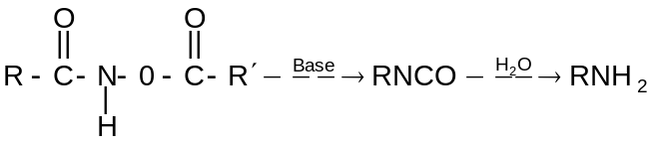
Write mechanism for the reaction.
5. Chemical Reaction

5.1 Basic Nature
Amines turn red litmus blue and also combine with water and mineral acids to form corresponding salts.
R – NH₂ + HCl ⎯→ R – 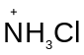–
R–NH₂ + H₂SO₄ ⎯⎯→ 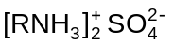
When the amine salts are treated with strong bases like NaOH, the parent amines are regenerated.
RN⁺H₃Cl– + OH– ⎯⎯→ RNH₂ + H₂O + Cl–
Amine salt Amine
(Soluble is water) (insoluble in water)
Further, due to basic character amines react with auric and platinic chlorides in presence of HCl to form double salts.
Chloroplatinic acid
These double salts decompose on ignition to pure metal, therefore, the formation and decomposition of the double salts is used for determining the molecular weight of amines.
5.2 Acylation (Reaction with Acyl Chlorides or Acid Anhydrides)
Primary and secondary amines can react with acid chlorides or acid anhydrides to form substituted amides.
RNH₂ + R′COCl ⎯→ R′CO NHR an N-substituted amide
R₂NH + R′COCl ⎯→ R′CO.NR₂ an N,N disubstituted amide
5.3 Benzoylation (Schotten Baumann Reaction)
Primary amine reacts with benzoyl chloride to give the acylated product.
^{(Benzoyl chloride)} ^{Benzoyl alkyl amine}
5.4 Carbylamine Reaction (Given Only by Primary Amines)
Primary amines when heated with chloroform and alcoholic caustic potash give isocynaides (carbylamines) having very unpleasant smell, which can be easily detected
C₂H₅NH₂ + CHCl₃ + 3KOH ⎯→ C₂H₅NC + 3KCl + 3H₂O
Ethylamine Ethyl isocyanide
C₆H₅ NH₂ + CHCl₃ + 3KOH ⎯→ C₆H₅NC + 3KCl + 3H₂O
Aniline Phenyl isocyanide
5.5 Action with Aldehyde and Ketone
Both primary aliphatic and aromatic amines react with aldehydes and ketones to form schiff’s bases also called anils.
C₂H₅NH₂ + CH₃CHO ⎯→ C₂H₅N = CHCH₃ + H₂O
Ethylamine Acetaldehyde Ethylidene ethylamine
(Schiff’s base)
5.6 Hofmann Mustard Oil Reaction
Primary amines when warmed with alcoholic carbon disulphide followed by heating with excess of mercuric chloride form isothiocyanates having pungent smell similar to mustard oil.
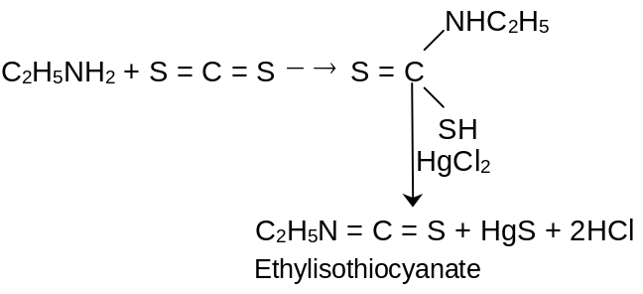
C₆H₅NH₂ + S = C = S 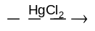C₆H₅NCS + 2HCl + HgS
5.7 Reaction with Carbonyl Chloride
This reaction is given only by primary amines.
C₂H₅ – NH₂ + COCl₂ ⎯→ C₂H₅NCO + 2HCl
Ethylisocyanate
5.8 Reaction of Quaternary Ammonium Salts
5.8.1 Hofmann Elimination
When a quaternary ammonium hydroxide is heated strongly (125° or higher) it decomposes to yield water, a tertiary amine and an alkene
This reaction is called as the Hofmann elimination. The formation of quaternary ammonium salts followed by an elimination of the kind just described and identification of the alkene and tertiary amine formed was once used in the determination of the structure of complicated amines.
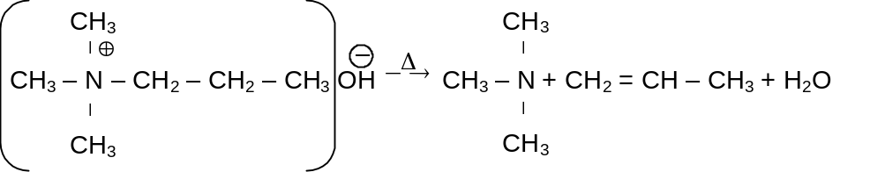
5.9 Reaction of Amines with Nitrous Acid
5.9.1 The diazonium salts of amines
What are these diazonium salts? Let us look at the name. The name suggests that, the compound has two nitrogen atoms (diazo) and the whole group has a positive charge (ium). There is also an anion to balance it (It is a salt)
So, the possible structure can be
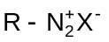
How to prepare them? The preparation is quite simple if we adhere to the experimental conditions.
These diazonium salts are prepared by treating a primary amine with NaNO₂ in presence of con. HCl; the temperature being 0°C. (Here the temperature has to be taken care of and if the temperature exceeds 5°C, the reaction will not take place.)
Let us take a case of aliphatic amines,
CH₃CH₂CH₂NH₂ 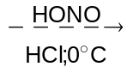 CH₃CH₂CH₂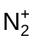Cl–

Mechanism for Diazotization is as follows
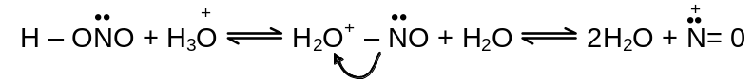
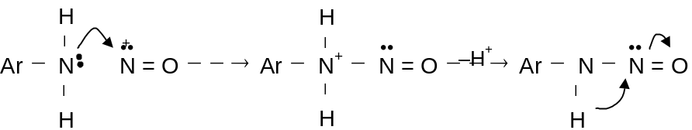
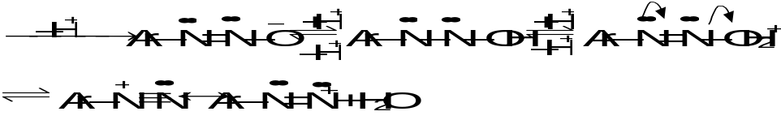
The diazonium salts of aliphatic amines are generally unstable and they decompose to give different products.
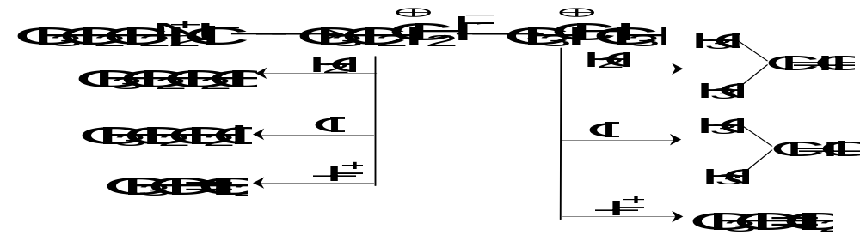
Thus we can have a wide range of products. Let us now see some thing about aromatic amines
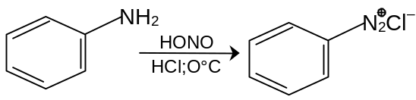
These aryl diazonium salts undergo a variety of displacement reaction. The reactions are simple and are summarised below.
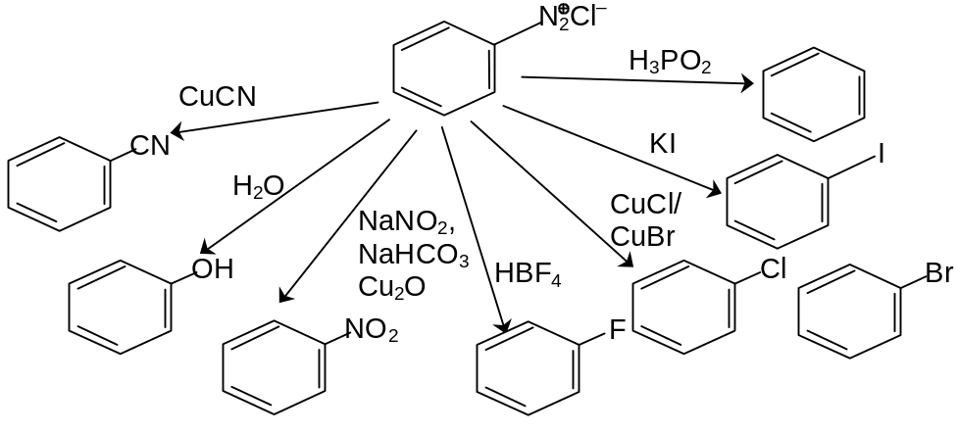
Mechanism of ArN₂⁺ Cl– + H₃PO₂ reaction takes place through free radical pathway.
Chain initiation
ArN₂⁺Cl– + H₃PO₂ = HCl + ArN₂PH(O)OH
ArN₂PH(O)OH ⎯→ Ar⋅ + N₂ + 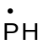(O)OH
Chain propagation
Ar⋅ + H₂PO₂ ⎯→ ArH + 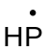(O)OH
ArN₂⁺ + (O)OH ⎯→ ArN₂• + P⁺H(O)OH
ArN₂• ⎯→ Ar⋅ + N₂ P⁺H(O)OH + H₂O ⎯→ H₃PO₃ + H⁺
5.9.2 Reaction of secondary Amines with Nitrous acid
Secondary amines both aryl and alkyl react with nitrous acid to yield N-nitrosoamines. N-nitrosoamines usually separate from the reaction mixture as oily yellow liquid.
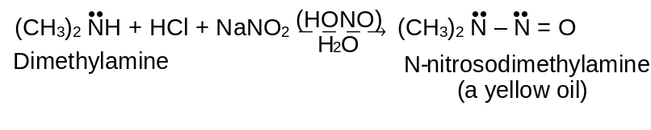
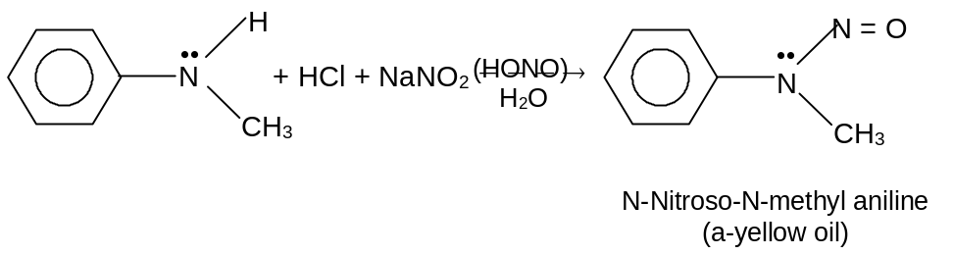
N-nitrosoamines are very powerful carcinogens (cancer causing substances)
5.9.3 Reaction of Tertiary amines with Nitrous acid
When a tertiary aliphatic amine is mixed with nitrous acid, an equilibrium is established among the tertiary amine, its salt, and an N-Nitrosoammonium compound.
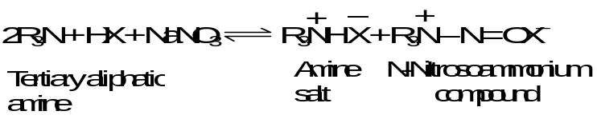
Tertiary arylamines react with nitrous acid to form C-nitroso aromatic compound. Nitrosation takes place almost exclusively at the para position if it is open and if not, at the ortho position. The reaction is another example of electrophilic aromatic substitution.
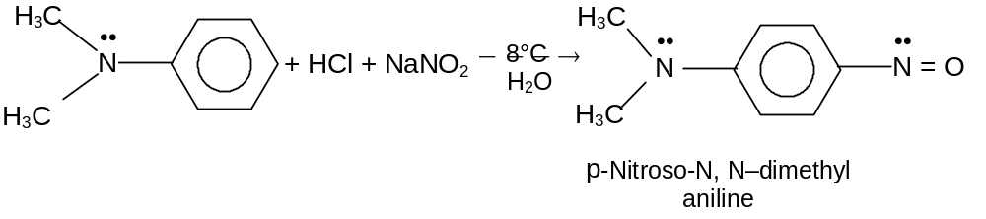
5.10 Coupling Reactions of Arene Diazonium Salts
Arenediazonium ions are weak electrophiles; they react with highly reactive aromatic compounds with phenols and tertiary arylamines to yield azo compound. This electrophilic aromatic substitution is called a diazo coupling reaction occurring mainly at p-position.
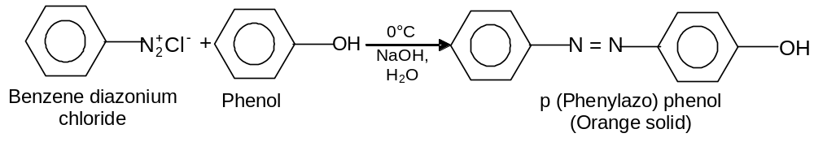
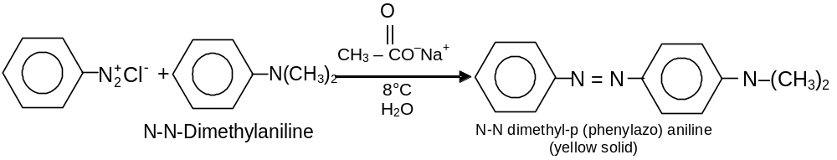
Couplings between arenediazonium cations and phenols take place most rapidly in slightly alkaline solution. If the solution is too alkaline (pH > 10), however, the arenediazonium salt itself reacts with hydroxide ion to form a relatively unreactive diazohydroxide or diazotate ion.
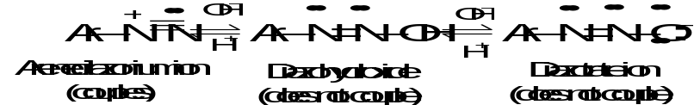
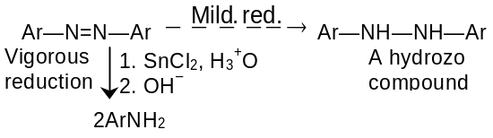
Hydrazo compounds are also made as follows:
Ph—NO₂ 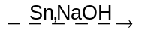 Ph—NH—NH—Ph
Diaryl hydrazo compounds undero the benzidine rearrangement
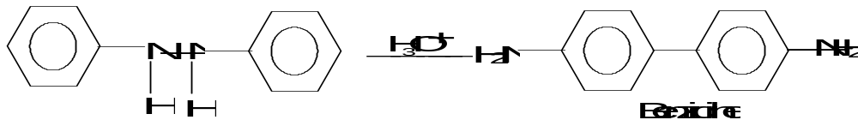
Mechanism:
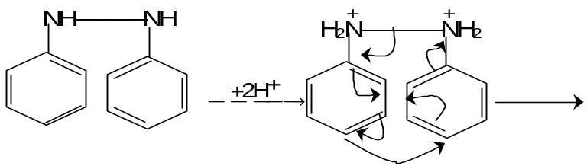
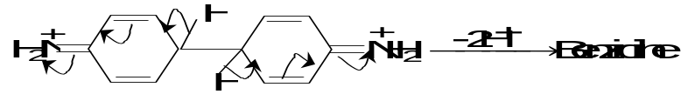
Exercise – 4: A weakly basic solution favours coupling with phenol. Is there any other explanation?
5.11 Ring Substitution in Aromatic Amines
The –NH₂, – NHR and –NR₂ are benzene activating groups through resonance effect of nitrogen where the lone one pair of electron of nitrogen is shifted to the benzene ring making ortho and para, position available for electrophilic attack.
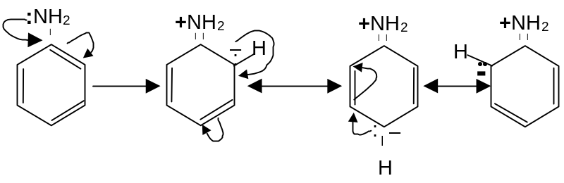
The carbocation formed as intermediate are
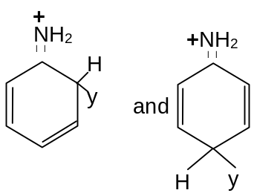
The group – NHCOCH₃ is less powerful ortho and para director because of the electron-withdrawing character of oxygen makes nitrogen a poor source of electrons. This fact is made use in preparing mono substituted aniline. The –NH₂ group is such a powerful activator, that substitution occurs at all available ortho and para positions of aniline. If, however, –NH₂ group is converted to –NHCOCH₃, the molecule becomes less powerful activator. Hence only mono substitution products are obtained. Finally – NHCOCH₃ is converted back to –NH₂ by hydrolyzing with acid. This technique is especially used while nitrating aniline as strong oxidizing agent destroys the highly reactive ring.
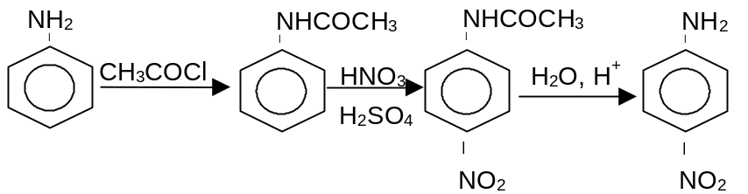
Exercise-5: Explain the following
i) It is necessary to acetylate aniline first for preparing bromoaniline.
ii) While carrying out an electrophilic substitution reaction on aniline. Lewis acid is not used
Exercise 6: | 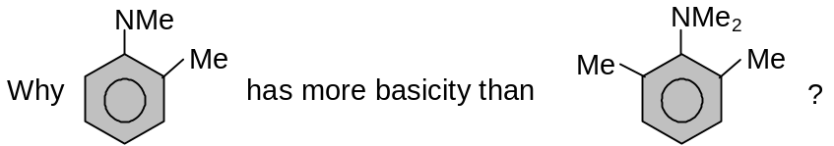
Exercise 7: Why the reagents to prepare
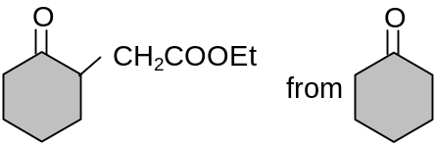
5.12 Aniline -X rearrangement
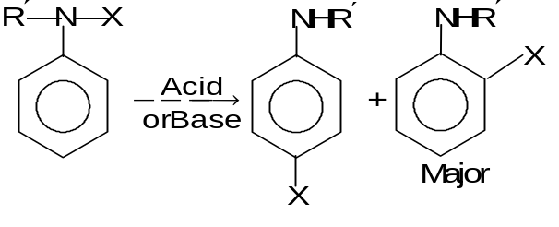
Such compounds are not much stable so the group X migrates mainly at p-position.
1. Fisher-Hepp rearrangement
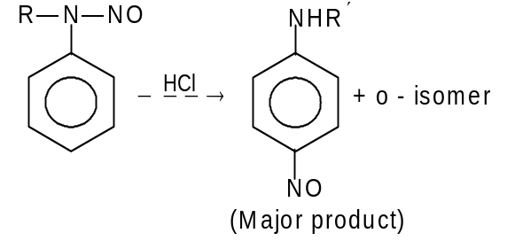
2. Phenylhydroxylamine - p-aminophenol rearrangement.
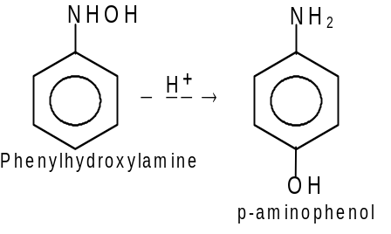
Mechanism
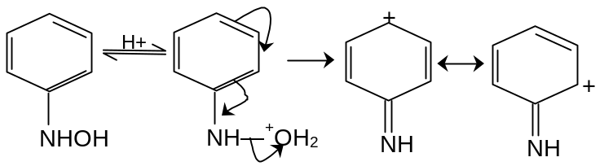
Nucleophilic attack by H₂O at p - position.
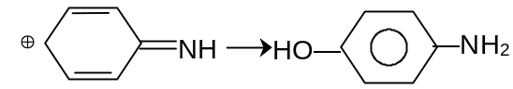

6. Separation of a Mixture of Amines

6.1 Hinsberg’s Method
Treating a mixture of 3 amines with Hinsbergs reagent (benzene sulfonyl chloride) and finally treating the product formed with NaOH can separate the 3 class of amines.
6.1.1 Primary amine:
RNH₂ + C₆H₅SO₂Cl ⎯→ C₆H₅– SO₂ – NH – R + HCl
(N-alkyl benzene sulfonamides)
(Dissolves in NaOH due to acidic H-attached to Nitrogen)
6.1.2 Secondary amine
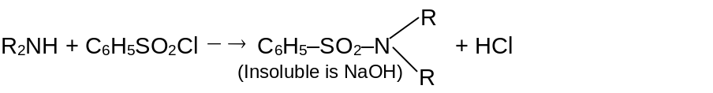
6.1.3 Tertiary amine
Tertiary amines do not react with Hinsberg’s reagent.
After reacting with NaOH the aqueous layer and the second layer [Secondary and Tertiary) can be separated by ether. Aqueous layer Hydrolysed with conc. HCl gives primary amine. The ether layer is distilled and tertiary amine is distilled over. Residue hydrolysed with conc. HCl to recover secondary amine.
6.2 Hofmann’s Method
The mixture of amines is treated with diethyloxalate, which forms a solid oxamide with primary amine, a liquid oxime ester with secondary amine. The tertiary amine does not react.
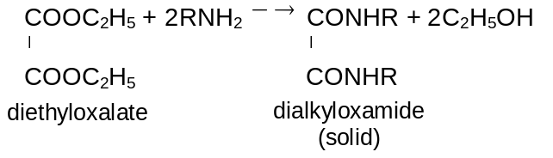
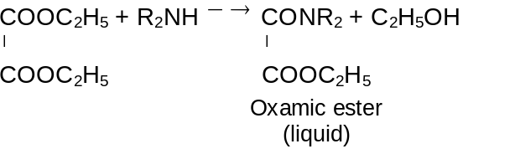
7. Test for Amines

7.1 Test for Primary Amines (Carbyl Amine Reaction):
When a primary amine is treated with a strong base in presence in chloroform, an isocyanide is formed and this isocyanide thus formed has a very foul smell.
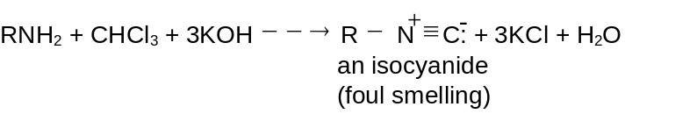
Here attacking electrophile is the dichlorocarbene (:CCl₂). The primary amine can be identified with its foul smell.
7.2 Test for Secondary Amines(Libermann Reaction)
The secondary amine is converted into nitrosoamine by treating the amine with nitrous acid. The resultant solutions warmed with phenol and concentrated H₂SO₄, a brown or red colour is formed at first soon it changes to blue and then to green. The colour changes to red on dilution and further changes to greenish blue on treating with alkali.
Tertiary arylamines react with nitrous acid to form o-nitroso aromatic compound.

8. Solution to Exercises
Exercise 1: i) Amines have electron-repelling groups, which increase the electron density on nitrogen, while ammonia has no such group.
ii) In aniline the electron pair of nitrogen atom is delocalised due to resonance and hence lesser available for protonation while ethylamine does not undergo resonance.
Exercise 2: Use of excess ammonia reduces chances of reaction of 1° amine with alkyl halide to form 2° and 3° amines.

Exercise 3: | 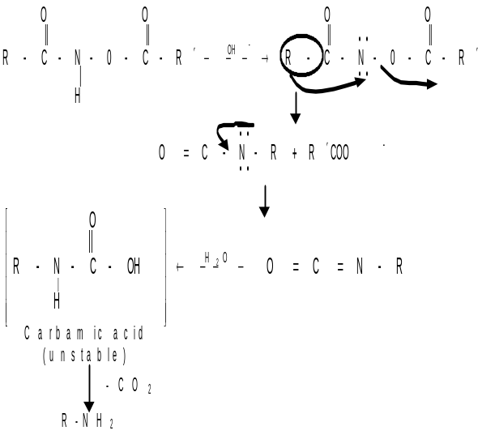
Exercise 4: High acidity suppresses the ionisation of C₆H₅OH to the more reactive C₆H₅O–. In presence of weak base, C₆H₅O– is formed and coupling takes place.
Exercise 5: i) Amino group, being activating group, activates bromination of aniline and forms tribromoaniline.
ii) In presence of Lewis acids, aniline undergoes protonation to from anilinium ion, which being m-directing forms unexpected m-substituted derivative.
Exercise 6: This is because of strain relief on N atom in former one in its conjugate acid than the later one.
Exercise 7: Reagents are pyrolidine (any secondary cyclic amine), TsOH, BrCH₂COOEt, H₃O⁺.

9. Solved Problems

9.1 Subjective

Problem -1: Give name of the following structures

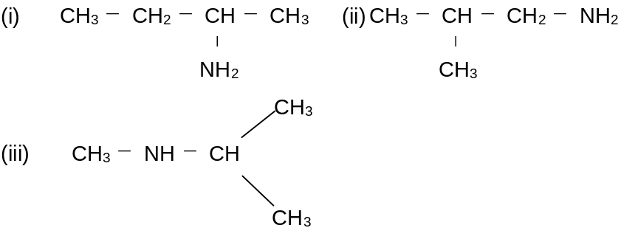
Solution: i) 2-aminobutane
ii) 2-methylpropanamine
iii) N-methyl-2-aminopropane
Problem 2: Arrange the following amines in the increasing order of boiling points giving proper reasoning (A) n-butylamine (B) Ethyldimethylamine (C) diethylamine.
Solution: A > C > B. It is because 1° and 2° amines, unlike 3° amines, form intramolecular H-bonds. A with two H's available for H - bonding has a higher boiling point than C.
Problem 3: Convert Benzene to benzylamine.
Solution: The structure of benzylamine is
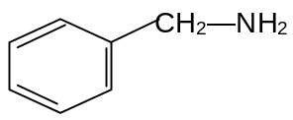
This can be obtained by reacting NH₃ with benzyl chloride.
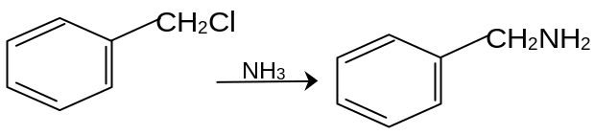
Now, let us find a way to prepare benzyl chloride. It can be easily, prepared from toluene by photochemical chlorination.
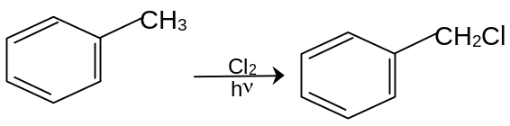
Now, Friedel - crafts alkylation, can easily obtain Toluene from benzene. The sequence of reaction is thus
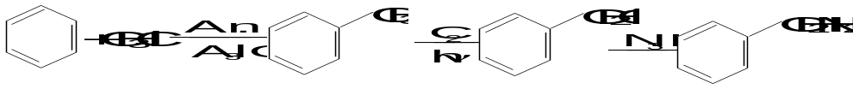
Problem 4: Convert benzoic acid into benzylamine and aniline
Solution: Here we are asked to do two conversions. They are
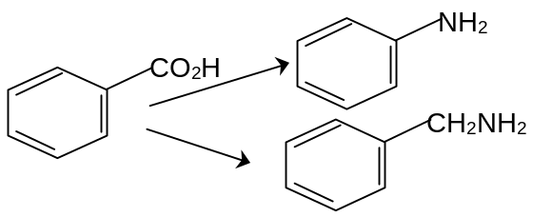
Here, both the products are amines and one of them is having the same number of carbon atoms as in the acid and another is having one carbon less.
So,
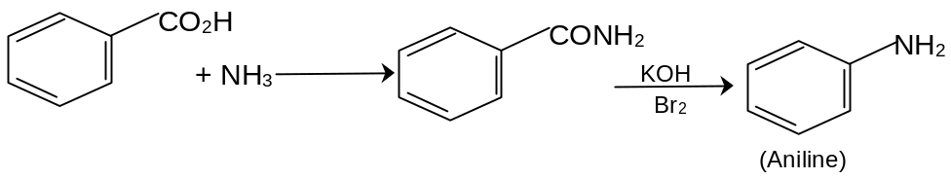
For the other conversion, we can proceed as,
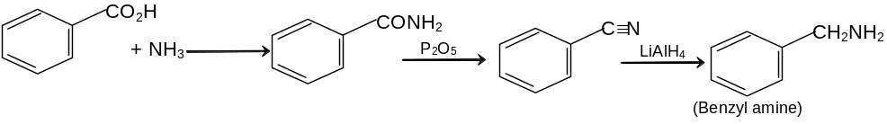
Thus we are effecting the conversions.
Problem 5: Starting with carbon and hydrogen can we obtain isopropyl amine.
Solution: At first sight this might look impossible. But if you think quietly you can find that this can be done with real ease.
Let us work backwards,
The amine can be obtained from the imine.
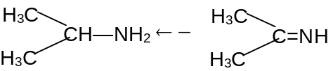
The imine, from the ketone,
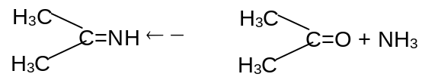
Now, if you remember, alkynes chapter, you must have converted propyne, to acetone.
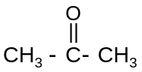 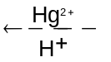 CH₃ — C ≡ CH
Propyne can be obtained from, acetylene.
CH₃ —C ≡ CH 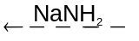 CH₃—I + HC ≡CH
Acetylene can be obtained from the electrical discharge of graphite rods in presence of hydrogen gas.
C + H₂ 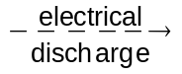 HC ≡ CH
Now, we have a synthetic route, as follows,

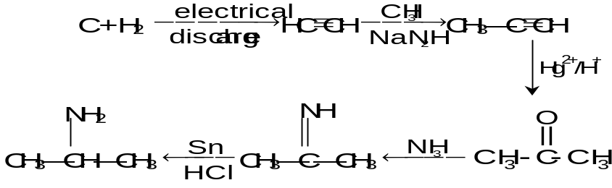
Problem 6: The C—N—C bond angle in Me₃N is 108°.
a) Describe the hybridization and shape of Me₃N.
b) Why is an amine of the type R¹R²R³N chiral?
c) Why is it not possible to separate the enantiomers?
Solution: a) N forms three sp³ hybridized σ bonds to the C’s of the Me groups and has a nonbonding electron pair in the fourth sp³ orbital. Me₃N has a roughly pyramidal shape.
b) Because of its pyramidal geometry, such an amine is chiral, the unshared pair being considered a fourth “different” group.
c) The enantiomers rapidly interconvert; having enough kinetic energy at room temperatures, by a process called nitrogen inversion. For this process H‡ ≈ 6 kcal/ mol (25kJ / mol) and the inversion thus does not involve bond – breaking and subsequent formation. The TS for the inversion is planar, the N being sp² hybridized, with the unshared pair in the p_{z} orbital.
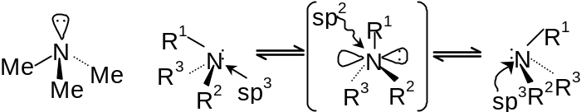
Problem 7: Account for the following order of increasing basicity:
RC ≡N: < R′CH = NR < RNH₂
nitrile imine amine
Solution: The more s character in the hybrid orbital of the N with the unshared pair of e–s, the less basic is the molecule. The nitrile N using sp HO’s has the most s character, the imine N using sp² HO’s has the intermediate s character, and the amine N using sp³ HO’s has the least s character.
Problem 8: In terms of s character, explain why NH₃ with bond angles of 107° is much more basic than NF₃ with bond angles of 103°. The bond angles of
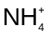 are 109°.
Solution: The bond angle of 109° in indicates that N uses pure sp³ HO’s. The bond angle of 107° in NH₃ shows that, although N essentially uses sp³ HO’s, it nevertheless has slightly more p character in its bonding HO’s and slightly more s character in its lone pair HO. The bond angle of 103° in NF₃ indicates that N has even more p character in its bonding HO’s and even more s character in its lone pair HO. NF₃ is less basic than NH₃ because its lone pair orbital has more s character.
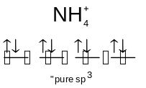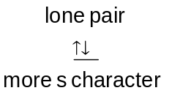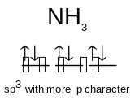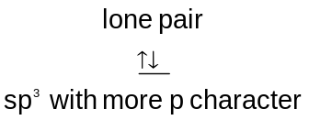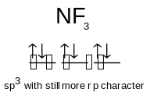

Problem 9: Compare the basicities of
a) H₂C = CHCH₂NH₂, CH₃CH₂CH₂NH₂ and HC ≡ CCH₂NH₂, and
b) C₆H₅CH₂NH₂, cyclohexyl – CH₂NH₂ and p-NO₂C₆H₄CH₂NH₂.
Solution: a) The significant difference among these three bases is the kind of hybrid orbital used by C^{β} — the more s character it has, the more electron - withdrawing (by induction) and base weakening it will be. The HO conditions are H₂C = C^{β}HCH₂NH₂(sp²), CH₃C^{β}H₂CH₂NH₂(sp³), and HC ≡ C^{β}CH₂NH₂(sp). The increasing order of electron – attraction is propargyl > allyl > propyl >, and the decreasing order of basicity is
CH₃CH₂CH₂NH₂> H₂C = CHCH₂NH₂ > HC ≡ CCH₂NH₂
b) The decreasing order is
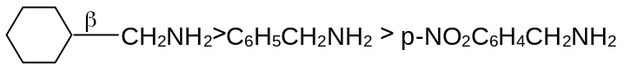
The C^{β} is cyclohexyl – CH₂NH₂ uses sp³ HO’s while C^{β} in the benzylamines uses sp² HO’s. The electron withdrawing p-NO₂ makes the phenyl ring even more electron–withdrawing and base weakening.
Problem 10: Account for the fact that although N,N—dimethylaniline is only slightly more basic than aniline, 2,6-dimethyl N,N-dimethylaniline is much more basic than 2,6 – dimethylaniline.
Solution: Extended π bonding between the amino N and the ring requires that the σ bonds on N become coplanar with the ring and its ortho bonds. Bulky substituents in the ortho 2,6 – positions sterically hinder the attainment of this geometry and interfere with the base – weakening extended π bonding. This effect is called steric inhibition of resonance. | 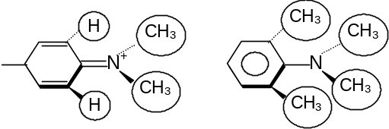
Problem 11: Place the isomeric compounds ethylenediammine(A), n-buytlamine (B) and diethyl amine(C) in order of decreasing boiling points and give an expalantion.
Solution:. B > C > A
1° and 2° amines, unlike 3° amines, form intramolecular H-bonds, B with two H’s available for HG-bonding has a higher boiling than C.
Problem 12: a) Why is an amine of the type R¹R²R³N chiral?
b) Why is it not possible to separate the enantiomers?
Solution: a) Because of the pyramidal geometry, the amine is chiral, the unshared pair being considered as fourth different group.
b) The enantiomers rapidly interconvert, having enough kinetic energy at room temperature by a process called nitrogen inversion. For this process 4 kcal/mole (25 kJ/mole) and the inversion thus does not involve bond breaking and subsequent formation. The TS for the inversion is planar, the N being sp² hybridized, with the unshared pair in the 2p_{z} orbital.
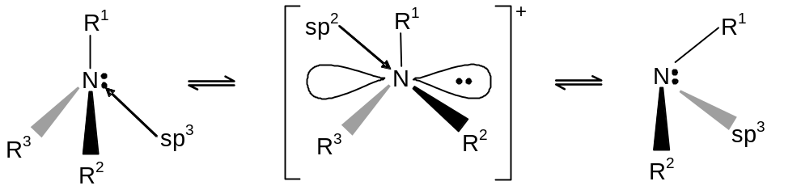
Problem 13: Why the following compound is resolvable?
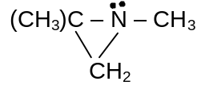
Solution: N-inversion requires too high an H≠ (activation energy) because the N in such a small ring cannot attain the 120° angles required in the TS as shown in the previous cell angle.
Problem 14: a) In general the order of base strength as measured by K_{b} values for aqueous solution of aliphatic amines is R₂NH > RNH₂ < R₃N > NH₃. Explain the order
b) What order would you expect to observe in the gas phase.
Solution: a) Two effects, induction and rotation, determine the K_{b} of an alkyl amine. Inducting, alkyl groups, being electron releasing, increase the electron density on nitrogen, making the amine more basic (larger K_{b}). Consequently, they stabilize the positive charge on the conjugate acid, making the ammonium ion less acidic. [It is better to use bases for comparisons rather than the conjugate acids, as was done for carboxylic acids. In terms of induction alone, increasing the number of R’s should increase the basicity. Solvation through H-bonding with H₂O is more important in the conjugate acid than in the free amine because the ammonium ion has a +ve charge and a greater number of H’s. In terms of solvation alone, the more H’s in the ammonium ion the more it is stabilized through H-bonding and the equilibrium shifts more to the rightward. As R’s replace H’s H-bonding deadlines and basicity of amines decrease. Hence the non-uniformity of K values.
b) Free from solvation effects only induction prevails and the order is R₃N > R₂NH > RNH₂ > NH₃.
Problem 15: Place ethylamine, 2-aminoethanol and 3-amino-1-propanol in order of decreasing basicity and give your reason.
Solution: (CH₃CH₂NH₂) > HO(CH₂)₃NH₂ > HO(CH₂)₂NH₂. The electron withdrawing inductive effect of the –OH decreases the electron density on N, lowering the amine’s basicity. This effect diminishes with distance from the amino group.
Problem 16: In terms of s-character, which N of guanidine NH = C(NH₂)₂, is more likely to be protonated? Account for the basicity of guanidine.
Solution: The N(sp³) of NH₂ with less ‘s’ character N(sp²) of the imino should be the more basic site and the protonated. If N of imino group is protonated then this leads to a symmetrical resonance stabilized cation.
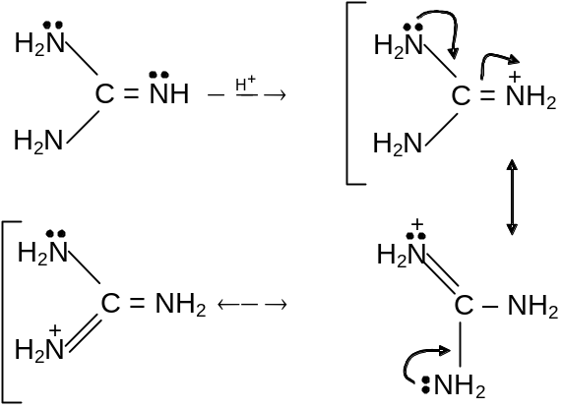
Resonance involving three equivalent contributing structures accounts for the large delocalisation energy and unusual stability of the cation, resulting in the enhanced basicity of guanidine. This is the strongest organic base known.
Problem 17: a) Provide a structure for A. CH₃CH₂CH = O + tipesidine 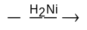A.
b) What is the intermediate that is reduced
Solution: a) | 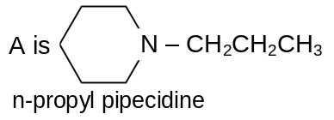
b) The intermediate is either a carbionolamine or the iminium ion formed from it
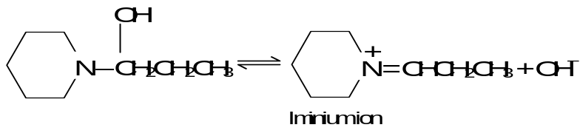
9.2 Objective

Problem 1: A nitrogeneous substance X is treated with HNO₂ and the product So formed is further treated with NaOH solution, which produces blue colouration. X can be
(A)CH₃CH₂NH₂ (B) CH₃CH₂NO₂
(C) CH₃CH₂ONO (D) (CH₃)₂CHNO₂

Solution: (CH₃)₂CHNO₂ 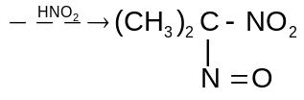 (Pseudo nitrol blue)
∴ (D)

Problem 2: A compound X with seven carbon atoms on treatment with Br₂ and KOH gives Y. Y gives carbylamine test and upon diazotisation and coupling with phenol gives azodye. X is
(A) C₆H₅CONH₂
(B) CH₃ – (CH₂)₅ – CONH₂
(C) CH₃ – 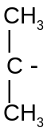CH₂ – CH₂ – CONH₂
(D) O – CH₃ – C₆H₄NH₂

Solution: Since Y gives coupling reaction after diazotisation it suggest that Y can be aniline or benzener ring substituted aniline. Since Y has been obtained from Hoffmann bromamide it means has – CO NH₂ group with benzene ring. Hence it is C₆H₅CONH₂.
∴ (A)

Problem 3: Methyl ethyl propyl amine forms non-super imposable mirror images but it does not show optical activity because
(A) of rapid flipping
(B) Amines are basic in nature
(C) Nitrogen has a lone pair of electrons
(D) of absence of asymmetric nitrogen

Solution: | 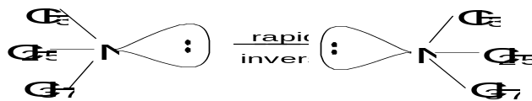
The inter conversion of d and l-forms are so fast that it is not possible to isolate these.
∴ (A)

Problem 4: A compound (A) when reacted with PCl₅ and then with NH₃ gave (B), (B) when treated with Br₂ and KOH produced (C). (C) on treatment with NaNO₂ and HCl at 0°C and the boiling with water forms o-cresol. Compound A is
(A) o-toluic acid (B) o-chlorotoluene
(C) o-bromo toluene (D) m-toluic acid

Solution: | 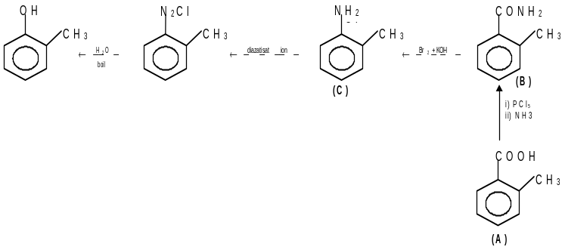

Problem 5: The product obtained when phenol reacts with benzene diazonium chloride is
(A) Phenyl hydroxylamine (B) Para-aminoazobenzene
(C) Phenylhydrazine (D) Para-hydroxyazobenzene

Solution: diazonium acts as an electrophile and attacks phenol to form a coupled product
∴ (D)

Problem 6: Aniline on treatment with conc. HNO₃ + conc. H₂SO₄ mixture yields
(A) o- and p-nitro anilines (B) m-nitroaniline
(C) a black tarry matter (D) no reaction

Solution: Nitration occurs on the ring and since –NH₂ group is an ortho,para orienter a mixture of ortho and para isomer is obtained
∴ (A)

Problem 7: Towards electrophilic substitution, the most reactive is
(A) nitrobenzene (B) aniline
(C) aniline hydrochloride (D) N-acetylaniline

Solution: NH₂ group is a ring activating group and others are deactivating
∴ (B)

Problem 8: Treatment of ammonia with excess of ethyl chloride will yield
(A) diethyl amine (B) ethane
(C) tetraethylammonium chloride (D) methyl amine

Solution: Excess of R—X gives quartenary salt
∴ (C)

Problem 9: Amongst the following, the most basic compound is
(A) Benzylamine (B) Aniline
(C) Acetanilide (D) p-Nitroaniline

Solution: Aliphatic amines are less basic than aromatic amines
∴ (A)

Problem 10: Correct order of increasing basicity
(A) NH₃ < C₆H₅NH₂ < (C₂H₅)₂NH < C₂H₅NH₂ < (C₂H₅)₃N
(B) C₆H₅NH₂ < NH₃ < (C₂H₅)₃N < (C₂H₅)₂NH < NH₃
(C) C₆H₅NH₂ < NH₃ < (C₂H₅)₃N < (C₂H₅) NH < (C₂H₅)₂NH₂
(D) C₆H₅NH₂ < (C₂H₅)₃N < NH₃ < C₂H₅NH₂ < (C₂H₅)₂NH
10. Assignments (Subjective Problems)

Level – I
1. Identify A and B in the following
a) CH₂CH₂CH₂⋅CH₂Br + NH₃ ⎯→ A
b) CH₃ – 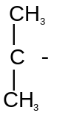Br + NH₃ ⎯→ B

2. Synthesize(a) pyrolidine from 1, 3propanediol, (b) PhN(CH₂CH₂CH₂CH₃)₂ from PHNH₂

3. | 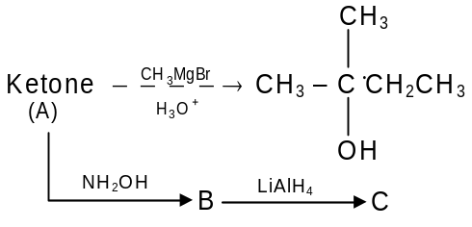
What are A, B and C

4. RNH₂ can be alkylated to form RNHR′ (2° amine) but 3° amine and quarternary ammonium salts are also obtained as side products.
Suggest a way that RNH₂ forms only 2° amine?

5. Convert CH₃COOH into (CH₃)₂NH

6. | 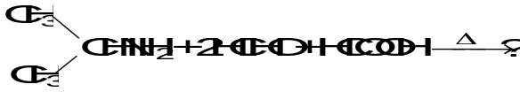
Identify the products

7. | 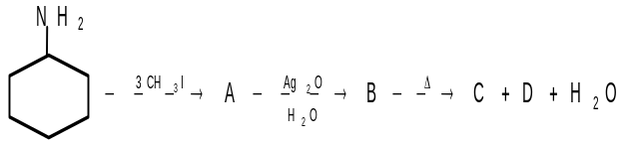
What are A, B, C and D

8. | 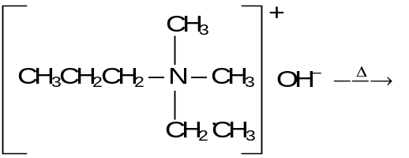
What are the products due to Hofmann elimination?
9. An organic compound containing carbon, hydrogen and nitrogen was found to contain C = 61.03%, N = 23.71%. Its vapour density = 29.5. On treatment with nitrous acid, it gave out nitrogen. Identify the compound and explain the reaction.

10. Give structural formulae of compounds A through D
Phthalimide + KOH ⎯→ A
A + CH₃ – CH₂ – CH₂ – Br, heat ⎯→ B
B + H₂O, OH– heat ⎯→ C (C₃H₉N) + D

Level – II
1. Identify the compound C₆H₁₃N(D) and all intermediates involved in the following sequence of exhaustive methylation and Hoffmann degradations D reacts with 2 eq. of MeI and Ag₂O/Δ giving (E) C₈H₁₇N. After reaction with MeI and further Hoffmann degradation, E gives CH₂ = CH – 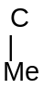= CHCH₃(F) and NMe₃.
2. Compound (X) containing chlorine, on treatment with NH₃, gives a solid ‘Y’ which is free from chlorine (Y) analysed as C = 49.3% H = 9.59% and N = 19.18% and reacts with Br₂ and caustic soda to give a basic compound (Z), (Z) reacts with HNO₂ to give ethanol suggest structures for (X), (Y) and (Z).
3. An organic compound (A) with molecular formula C₅H₁₃N reacts with 1 mole of methyl iodide to form quaternary ammonium iodide which when treated with moist silver oxide yields the corresponding hydroxide. The hydroxide on heating gives propane. Deduce the structure of A.
4. The reaction of n-butylamine with sodium nitrite and hydrochloric acid yields nitrogen and the following mixture; n-butyl alcohol, 25%; sec butyl alcohol, 13%; 1 butene and 2-butene, 37%, n-butyl chloride, 5%; sec butyl chloride, 3% what is the most likely intermediate common to all of these product, and how is it formed.
5. An organic compound (A) gave the following data in analysis C = 61.1%,
H = 15.25% and N = 23.74%. (A) on heating with HNO₂ gives (B). Which contains C = 60%, H = 13.33% and no nitrogen. (B) on careful oxidation gave (C) which shows iodoform test and has molecular weight 58. What are (A), (B) and (C).
6. A basic volatile nitrogen compound gave a foul smelling gas when treated with CHCl₃ and alcoholic KOH. A 0.295 g sample of the substance dissolved in aqueous HCl and treated with NaNO₂ solution at 0°C liberated a colourless; odourless gas whose volume correspond to 112 ml at STP. After the evolution of the gas was complete, the aqueous solution was distilled to give an organic liquid, which did not contain nitrogen and which on warming with alkali, and iodine gave yellow precipitate. Identify the original substance. Assume it contains one N atom per molecule.
7. An optically active amine (A) is subjected to exhaustive methylation and Hofmann elimination to yield an alkene (B). (B) on ozonolysis gives an equimolar mixture of formaldehyde and butanal. Deduce the structures of (A) & (B). Is there any structural isomer to (A), if yes draw its structure.
8. One mole of each of bromo derivative (A) and NH₃ react to give one mole of an organic compound (B). (B) reacts with CH₃I to give (C), both (B) and (C) react with HNO₂ to give compounds (D) and (E), respectively. (D) on oxidation gives 2-methoxy-2-methyl propane. Give structures of (A) to (E) with proper reasoning.
9. A, B and C are the three organic compound having C, H and N only. With nitrous acid A yield nitrogen and methanol B, does not react with nitrous acid but when treated by the Hofmann exhaustive methylation procedure yields methanol and trimethyl amine. C reacts with nitrous acid to give an oil substance, which may be reduced to unsym-dimethyl hydrazine. Give the formulae of A, B and C
10. How will you synthesize the following compounds from benzene?
(A) | 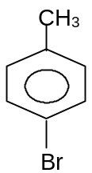
(B) | 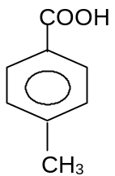
(C) | 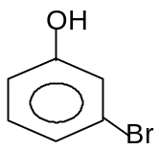

LEVEL – III
1. An organic acid (A) C₃H₄O₃ is catalytically reduced in presence of ammonia to give B C₃H₇NO₂. (B) reacts with acetyl chloride, hydrochloric acid and alcohol. It can also react with nitrous acid to give another compound (C), C₃H₆O₃, along with evolution of N₂. What are (A), (B) and (C)
2. A neutral organic compound (A) C₅H₁₁O₂ N when treated with reducing agent forms a basic compound (B) C₅H₁₃N. (B) on treatment with excess of CH₃I followed with moist Ag₂O gives (C) C₈H₂₁ON. On heating (C) decomposes to give trimethyl amine and 2-methylbutene-1. What are (A), (B) and (C).
3. One mole of each of bromo derivative (A) and NH₃ react to give one mole of an organic compound (B). (B) reacts with CH₃I to give (C). Both (B) and (C) react with HNO₂ to give compounds (D) and (E), respectively. (D) on oxidation and subsequent decarboxylation gives 2-methoxy -2-methyl propane. Give structures of (A) to (E) with proper reasoning.
4. From analysis and molecular weight determination , the molecular formula of (A) is C₃H₇NO. The compound gave following reactions.
i) On hydrolysis it gives an amine (B) and a carboxylic acid (C).
ii) Amine (B) reacts with benzene sulphonyl chloride and gives a product which is insoluble in aqueous NaOH solution.
iii) Acid (C) on reaction with Tollen's reagent gives a mirror. What are (A), (B) and (C). Explain the reactions.
5. An organic compound A (C₄H₁₁N) on reacting with HNO₂ gave a compound B (C₄H₁₀O). Compound B on mild oxidation gave C (C₄H₈O). Compound C on drastic oxidation gave D (C₂H₄O₂). Compound D on treatment with PCl₅ followed by NH₃ gave (C₂H₅NO) which on treatment with Br₂/NaOH gave F (CH₅N). Deduce the structures of A,B,C,D,E & F with reasoning. Write down the reactions involved.
6. Reaction of a compound A (C₁₁H₁₄) with trioxygen and then water gave B (C₈H₈O) and C (C₃H₆O) in equimolar amounts. C was unaffected by ammoniacal silver nitrate, but B reacted with this reagent to give D(C₈H₈O₂). When D was treated successively with sulphur dichloride oxide and ammonia, E(C₈H₈NO) was formed. E reacted with bromine and sodium hydroxide to give F (C₇H₉N), a much weaker base than methylamine. Identify the compounds A to F, as far as is possible and comment on the reactions. Suggest further experiments (i) to confirm the identification of C and (ii) to be carried out on compound D to complete the identification of compounds D-F.
7. A compound (A) gave an analysis C, 61.0%; H, 15.2%; N,23.7%. Treatment of A with acid and sodium nitrite yielded a compound (B) of molecular formula C₃H₈O. Oxidation of B with chromic acid gave C with a molecular formula C₃H₆O. The product C gave a positive iodoform reaction and formed a crystalline derivative with sodium hydrogen sulphite but did not react with ammoniacal silver nitrate. The compound B when treated with ethanoic anhydride gave a product D corresponding to C₅H₁₀O₂. Deduce the identity of A,B,C and D. Explain the sequence of reactions by means of equations involving structural formulae for the organic molecules.
8. A pungent smelling liquid A was analysed and found to contain carbon, hydrogen, chlorine and possibly oxygen and upon reaction with aqueous ammonia a neutral compound B was formed. When this was treated with bromine and potassium hydroxide a base C resulted. In acidic solution substance C reacted with sodium nitrite, giving nitrogen and an alcohol D. Upon mild oxidation, the alcohol D was converted into compound E of M.F. C₂H₄O which gave a positive test with ammoniacal silver nitrate solution. Describe the chemistry involved in these reactions and identify the compounds A,B,C,D and E.
9. An aromatic compound contains 69.4%C and 5.8%. Hydrogen and remaining elements are Nitrogen and Oxygen. A sample of 0.303 g of the compound was analysed for N₂ by Kjeldahl’s method. The NH₃ evolved was absorbed in 50 ml of 0.05 M H₂SO₄. The excess acid required 25 ml of 0.1M NaOH for neutralisation deduce the molecular formula of the compound if its molecular weight is 121. Give two possible structures for the compound. [IIT-JEE ‘82]
10. Give the products of the reaction of ArN = NAr′ with SnCl₂ (b) Reduce the structures of the azo compounds that yield the following aromatic amines on reduction with SnCl₂; (I) p-toludine and p-aminodimethyl aniline, and (ii) 1 mole of 4, 4′-diamine biphenyl and 2-moles of 2-hydroxy-5-amino benzoic acid.

11. Assignments (Objective Problems)

LEVEL – I

1. What will be the product A of the following reaction
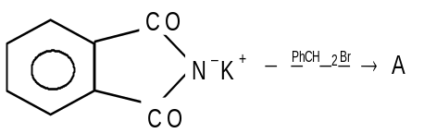
(A) | 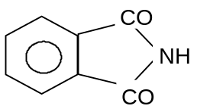 | (B) | 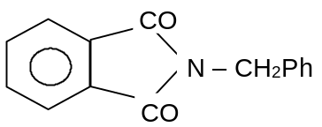
(C) | 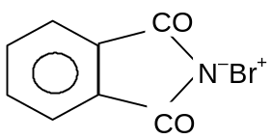 | (D) | None of these

2. PhNH₂ 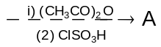. Product (A) is
(A) o-ClSO₂C₆H₄NHCOCH₃ (B) o-ClSO₂C₆H₄NHCOCH₃
(C) m-ClSO₂C₆H₅NHCOCH₃ (D) C₆H₅NHCOCH₃

3. p-Cl C₆H₄NH₂ and PhNH₃⁺Cl– can be distinguished by
(A) Ag(OH) (B) NaOH
(C) AgNO₃ (D) None of these

4. Acetamide is treated with the following reagents. Which one of these would give methylamine?
(A) PCl₅ (B) NaOH + Br₂
(C) Soda lime (D) Hot conc. HSO₄

5. Treatment of ammonia with excess of ethyl chloride will yield
(A) diethyl amine (B) ethane
(C) tetraethylammonium chloride (D) methyl amine

6. Amongst the following, the most basic compound is
(A) Benzylamine (B) Aniline
(C) Acetanilide (D) p-Nitroaniline

7. Correct order of increasing basicity
(A) NH₃ < C₆H₅NH₂ < (C₂H₅)₂NH < C₂H₅NH₂ < (C₂H₅)₃N
(B) C₆H₅NH₂ < NH₃ < (C₂H₅)₃N < (C₂H₅)₂NH < NH₃
(C) C₆H₅NH₂ < NH₃ < (C₂H₅)₃N < (C₂H₅)₂NH < C₂H₅NH₂
(D) C₆H₅NH₂ < (C₂H₅)₃N < NH₃ < C₂H₅NH₂ < (C₂H₅)₂NH

8. The order of basic strength among the following amines in benzene solution is
(A) CH₃NH₂ > (CH₃)₃N> (CH₃)₂NH (B) (CH₃)₂NH > CH₃NH₂ > (CH₃)₃N
(C) CH₃NH₂ > (CH₃)₂NH > (CH₃)₃N (D) (CH₃)₃N > CH₃NH₂ > (CH₃)₂NH
9. The action of nitrous acid on ethylamine gives
(A) Ethane (B) Ethyl nitrite
(C) Ethyl alcohol (D) Nitroethane

10. A nitrogen containing compound on heating with CHCl₃ and alc.KOH evolved very bad smelling vapors. The compound is
(A) Nitrobenzene (B) Benzamide
(C) N,N-Dimethyl aniline (D) Aniline

11. Which of the following does not reduce ArNO₂ to ArNH₂
(A) Fe/HCl (B) Zn/HCl
(C) LiAlH₄ (D) SnCl₂ in HCl

12. In the reaction PhSO₂Cl + EtNH₂ ⎯⎯→ A 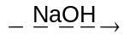 B 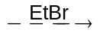C
Then C will be
(A) PhSO₂NHEt (B) PhSO₂NEt₂
(C) PhSO₂OH (D) None

13. For the reaction : C₆H₅OH + H₂C=O + R₂NH ⎯⎯→ P
Here P will be
(A) | 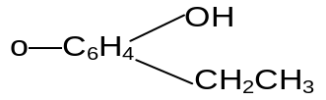 | (B) | 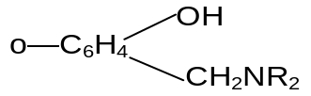
(C) | 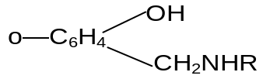 | (C) | None

14. Which of the following reagents can convert benzene diazonium chloride into benzene?
(A) Water (B) Acid
(C) Hypophosphorous acid (D) HCl

15. Activation of benzene ring by –NH₂ in aniline can be reduced by treating with
(A) Dilute HCl (B) Ethyl alcohol
(C) Acetic acid (D) Acetyl chloride

LEVEL – II

1. Identify Z in the sequence
C₆H₅NH₂ 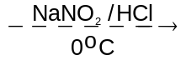X 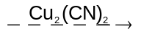Y 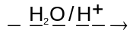Z
(A) C₆H₅NH₂COOH (B) C₆H₅COOH
(C) C₆H₅NHCH₃ (D) C₆H₅CH₂NH₂

2. The major product (70-80%) of the reaction between m - dinitrobenzene with NH₄HS is
(A) | 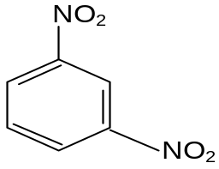 | (B) | 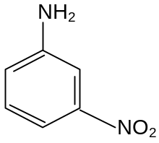
(C) | 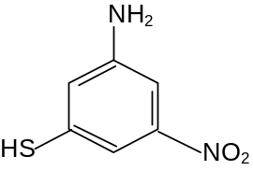 | (C) | 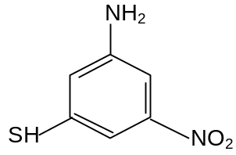

3. Allylisocyanide contains
(A) 9σ and 3π bonds (B) 9σ and 9π bonds
(C) 3σ and 4π bonds (D) 5σ and 7π bonds

4. Acetoaldoxime reacts with P₂O₅ to give
(A) Methyl cyanide (B) Methyl cyanate
(C) Ethyl cyanide (D) None of these

5. Among the following statements on the nitration of aromatic compounds, the false one is
(A) the rate of nitration of benzene is almost the same as that of hexadeuterobenzene
(B) the rate of nitration of toluene is greater than that of benzene
(C) the rate of nitration of benzene is greater than that of hexadeutero benzene
(D) nitration is an electrophilic substitution reaction

6. C₆H₅C≡ N and 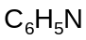 C exhibit which type of isomerism?
(A) Position (B) Functional
(C) Dextroisomerism (D) Positional isomerism

7. Nitrosoamines (R₂N—N = O) are in-soluble in water. On heating with conc. H₂SO₄, they give secondary amines. The reaction is called
(A) Libermann nitroso reaction (B)Etard reaction
(C) Fries reaction (D) Perkin reaction
8. The compound obtained by heating a mixture of a primary amine and chloroform with ethanolic KOH is
(A) An alkyl halide (B) An alkyl isocyanide
(C) An amide (D) An amide and a nitro compound

9. Among the following, the strongest base is
(A) C₆H₅NH₂ (B) p-NO₂C₆H₄.NH₂
(C) m-NO₂.C₆H₄.NH₂ (D) C₆H₅CH₂NH₂

10. A positive carbylamine test is given by
(A) N,N-dimethylaniline (B) 2,4-dimethylaniline
(C) N-methyl-o-methylaniline (D) p-methyl benzylamine

11. What is the end product in the following sequence of reactions?
C₂H₅NH₂ 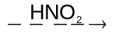A 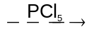B C
(A) Ethyl cyanide (B) Ethyl amine
(C) Methyl amine (D) Acetamide

12. Hinsberg's test is used to identify
(A) alcohol (B) ketone
(C) amine (D) alkyne

13. | 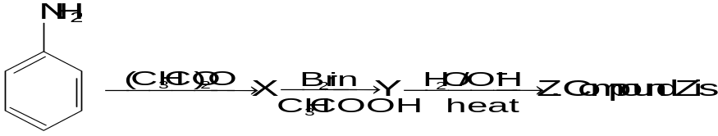
(A) p-Bromoaniline (B) 2,4,6-Tribromoaniline
(C) Nitrobenzene (D) m-Bromoaniline

14. The decreasing order of basicity amongst the amines, CH₃NH₂,(CH₃)₂NH, C₆H₅NH₂ and (C₆H₅)₂NH is
(A) CH₃NH₂ > (CH₃)₂NH > C₆H₅NH₂ > (C₆H₅)₂NH
(B) (CH₃)₂NH > CH₃NH₂ > C₆H₅NH₂ > (C₆H₅)₂NH
(C) (CH₃)₂NH > CH₃NH₂ < (C₆H₅)₂NH > C₆H₅NH₂
(D) C₆H₅NH₂ > (C₆H₅)₂NH > CH₃NH₂ > (CH₃)₂NH

15. Which statement is not correct?
(A) Amines form hydrogen bond
(B) Ethylamine has higher boiling point than propane
(C) Methylamine is more basic than ammonia
(D) Dimethyl amine is less basic than methylamine

12. Answers (Objective Assignment)

LEVEL – I

1. B 2. B
3. C 4. B
5. C 6. A
7. C 8. B
9. C 10. D
11. C 12. B
13. B 14. C
15. D

LEVEL – II

1. B 2. B
3. A 4. A
5. C 6. B
7. A 8. B
9. D 10. D
11. B 12. C
13. A 14. B
15. D
6
Amines

Subjective Problems

LEVEL – I

1. a) CH₂CH₂CH₂CH₂NH₂ by substitution
b) CH₂ – 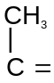CH₂ by elimination

2. a) | 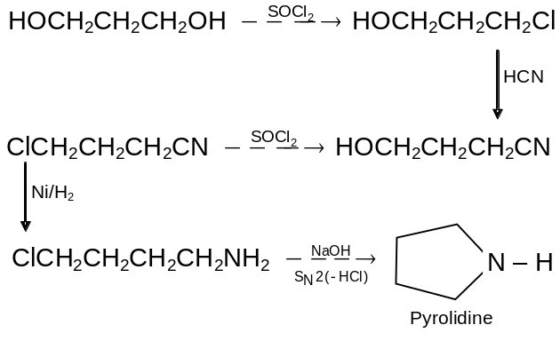

3. | 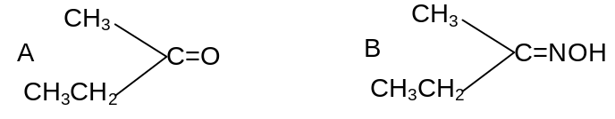
 | 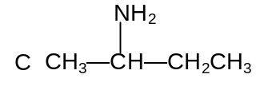

4. Hint - Carbylamine reaction followed by reduction

5. Follow path amide 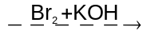 RNH₂ 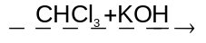 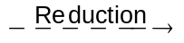

6. | 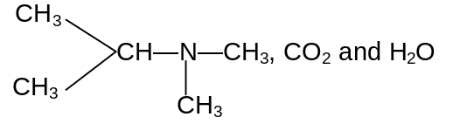

7. | 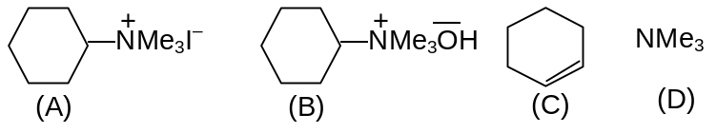
8. |  | 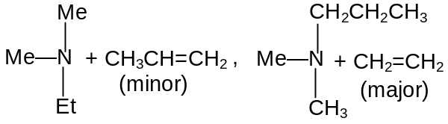
9. n-propyl amine

10. | 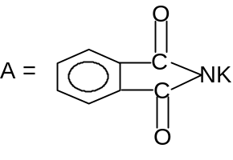
 | 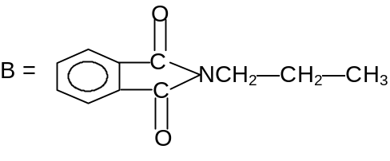
C = CH₃—CH₂—CH₂NH₂
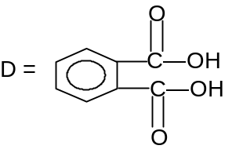

LEVEL – II

1. | 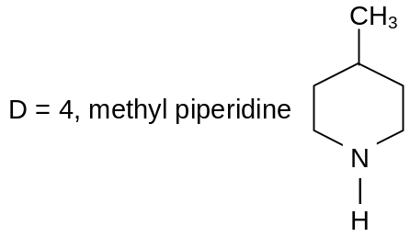
 | 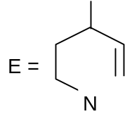
 | 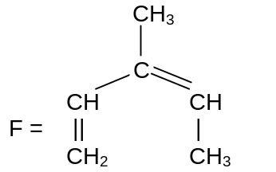

2. (X) CH₃CH₂COCl
(Y) CH₃—CH₂—CONH₂
(Z) CH₃—CH₂—NH₂

3. n or Iso C₃H₇—N(CH₃)₂
4. n-Butyl cation
5. | A = (CH₃)₂ CHNH₂  B = (CH₃)₂CHOH  C = (CH₃)₂CO
(C) HCOOH

6. | 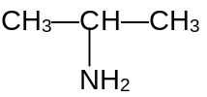

7. | 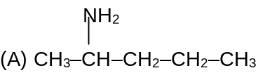  (B) CH₂=CH–CH₂–CH₃
8. |  | 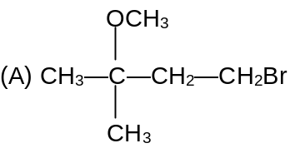  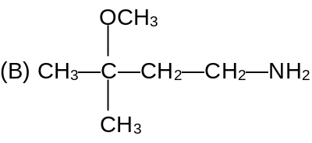  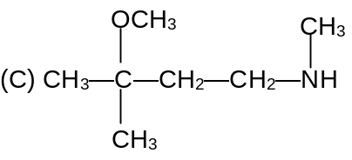  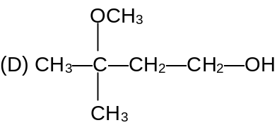  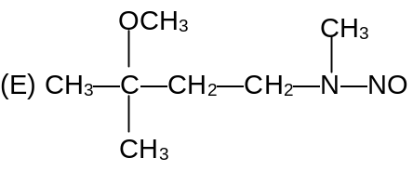

9. (A) CH₃—NH₂
(B) (CH₃)₃N
(C) (CH₃)₂N—NH₂
10. a) Benzene → toluene →p-bromo toluene.
b) Benzene → toluene → p-amino toluene → p-cyano toluene → p-methyl benzoic acid.
c) Benzene → nitro benzene → m-bromo nitrobenzene → m-bromo aniline → m-bromo phenol.

LEVEL - III

1. | A | CH₃COCOOH
 | B | 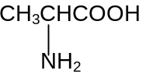
 | C | 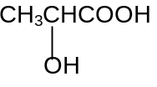

2. | A | 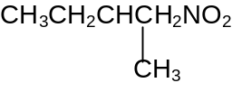
 | B | 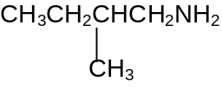
 | C | 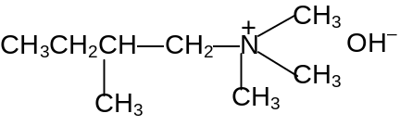

3. | A | 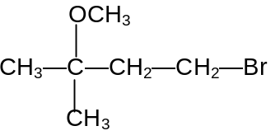
 | B | 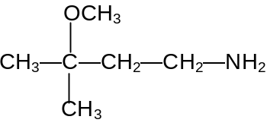
 | C | 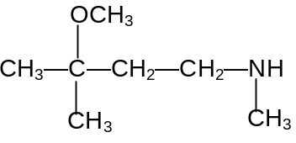
 | D | 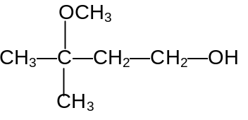
 | E | 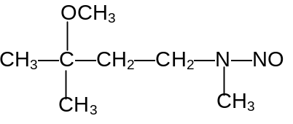

4. A = HCON(CH₃)₂
B = (ch₃)₂nh
C = HCOOH
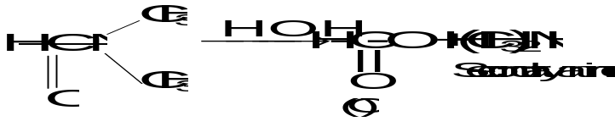
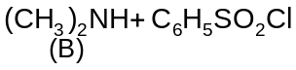⎯⎯→ 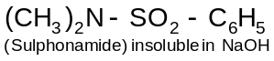
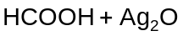⎯⎯→ 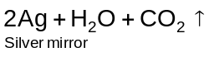

5. (A) CH₃CH(NH₂)CH₂CH₃
(B) CH₃CH(OH)CH₂CH₃
(C) CH₃COCH₂CH₃
(D) CH₃CO₂H
(E) CH₃CONH₂
(F) CH₃NH₂
6. A : CH₃—C₆H₄—CH=C(CH₃)₂;
B : CH₃C₆H₄—CHO;
C : CH₃COCH₃ ;
D : CH₃—C₆H₄—CO₂H ;
E : CH₃—C₆H₄CONH₂ ;
F : CH₃—C₆H₄—NH₂ .

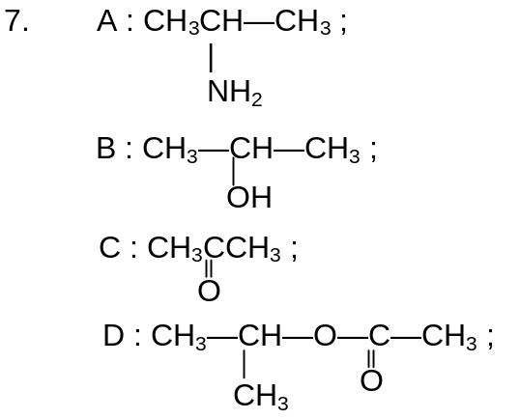

8. A : CH₃CH₂COCl ; B : CH₃CH₂CONH₂;
C : CH₃CH₂NH₂; D : CH₃CH₂OH;
E : CH₃CHO

9. 50 ml of 0.05 M H₂SO₄ = 50 ml and 0.1 N H₂SO₄
Amount of H₂SO₄ used up = 25 ml of 0.1 N = 2.5 ml of 1N
Amount of NH₃ liberated = 2.5 ml of 1N
= 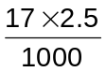 = 0.0425 g
Amount of Nitrogen present in 0.303 g
= 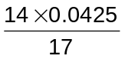 = 0.035 g
% N₂ = 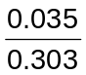× 100 = 11.55
The % of O₂ = 100– 86.75 = 13.25
C H N O
69.4 5.8 11.55 13.25
Dividing by respective atomic weight
5.78 5.8 0.825 0.828
Dividing by the least number
7 7 1 1
The empirical formula is C₇H₇NO
Empirical formula weight = 121
∴ Molecular formula = C₇H₇NO
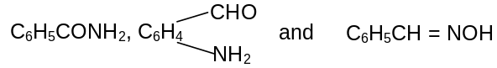
are the possible structures

10. a) Reductive cleavage converts the azo compound to two 1° amines. ArNH₂, Ar′NH₂. The amine N’s originate from N’s of the cleaved azo bond.

b) i) | 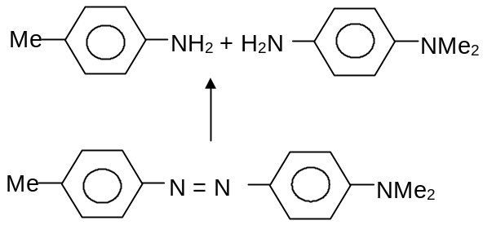
ii) | 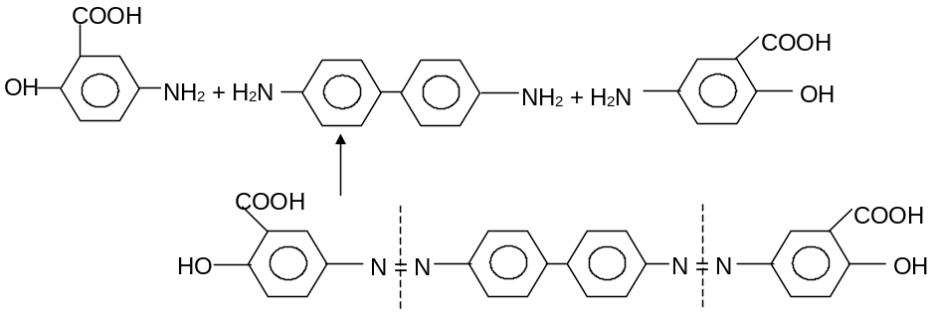

6

