17
1. IIT-JEE Syllabus
2. Carbohydrates
2.1 Introduction
2.2 Classification
3. Monosaccharides
3.1 Trioses
3.2 Aldotetroses
3.3 Aldopentoses
3.4 Aldohexoses
3.5 Epimers
3.6 Cyclic structures of monosaccharides
3.7 Cyclic structure of glucose- Anomers
3.8 Cyclic structure of fructose
3.9 Mutatarotation
3.10 Reactions of glucose
4. Disaccharides
4.1 Sucrose
4.1.1 Hydrolysis
5. Polysaccharides
5.1 Starch
6. Amino Acids
6.1 Introduction & Nomenclature
6.2 Physical Properties & Structure
6.3 Isoelectric Point
7. Peptides
7.1 Naming of Polypeptides
7.2 Structure of Polypeptides
7.3 Sanger's method
8. Polymers
8.1 Introduction
8.2 Polymers and Polymerization
8.2a) Free radical vinyl polymerization
8.2b) Copolymerization
9. Answers to Exercise
10. Solved Problems
(Subjective)
11. Assignments
(Subjective Problems)
12. Assignments
(Objective Problems)
13. Answers to Objective Assignments

Carbohydrates, Amino Acids & Polymers

Carbohydrates are the source that we rely on mostly for energy. What are these carbohydrates? We can encounter carbohydrates at almost every turn of our daily lives. The paper on which this material is printed is largely cellulose; so too is the cotton of our clothes and wood of our houses. So, carbohydrates meet all our basic necessities. The mystery of the energy in human body completely rests on the source carbohydrates.
With this idea about carbohydrates let us study the chemistry involved. Shall we?
Here we will also study about amino acids & polymers

1. IIT-JEE Syllabus
Carbohydrates: Classification – mono, di and polysaccharides (Glucose, Sucrose and Starch only); hydrolysis of sucrose. Amino acids and Peptides: General structure and physical properties. Properties and uses of some important polymers (natural rubber, cellulose, nylon, teflon, PVC),

2. Carbohydrates

2.1 Introduction
The group of compounds known as carbohydrates received their general name because of early observations that they often have the formula C_{x}(H₂O)_{y} - that is, they appear to be hydrates of carbon.
Limitations: The above definition could not survive long due to the following reasons:
i) A number of compounds such as rhamnose, (C₆H₁₂O₅) and deoxyribose (C₅H₁₀O₄) are known which are carbohydrates by their chemical behaviour but cannot be represented as hydrates of carbon.
ii) There are other substances like formaldehyde (HCHO, CH₂O) and acetic acid [CH₃COOH, C₂ (H₂O)₂] which do not behave like carbohydrates but can be represented by the general formula, C_{x}(H₂O)_{y}.
Carbohydrates are defined as polyhydroxy aldehydes or polyhydroxy ketones or substances which give these on hydrolysis and contain at least one chiral carbon atom. It may be noted here that aldehydic and ketonic groups in carbohydrates are not present as such but usually exist in combination with one of the hydroxyl group of the molecule in the form of hemiacetals and hemiketals respectively.

2.2 Classification
The carbohydrates are divided into three major classes depending upon whether or not they undergo hydrolysis, and if they do, on the number of products formed.
i) Monosaccharides: The monosaccharides are polyhydroxy aldehydes or polyhydroxy ketones which cannot be decomposed by hydrolysis to give simpler carbohydrates. Examples are glucose and fructose, both of which have molecular formula, C₆H₁₂O₆.
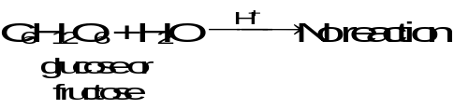
ii) Oligosaccharides: The oligosaccharides (Greek, oligo, few) are carbohydrates which yield a definite number (2-9) of monosaccharide molecules on hydrolysis. They include,
a) Disaccharides, which yield two monosaccharide molecules on hydrolysis. Examples are sucrose and maltose, both of which have molecular formula, C₁₂H₂₂O₁₁.
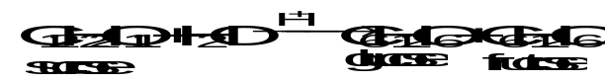
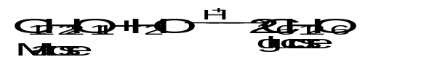
b) Trisaccharides, which yield three monosaccharide molecules on hydrolysis. Example is, raffinose, which has molecular formula, C₁₈H₃₂O₁₆.
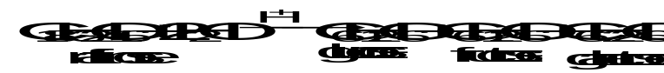
c) Tetrasaccharides, etc.
iii) Polysaccharides: The polysaccahrides are carbohydrates of high molecular weight which yield many monosaccharide molecules on hydrolysis. Examples are starch and cellulose, both of which have molecular formula, (C₆H₁₀O₅)_{n}.
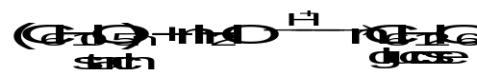
In general, the monosaccharides and oligosaccharides are crystalline solids, soluble in water and sweet to taste. They are collectively known as sugars. The polysaccharides, on the other hand, are amorphous, insoluble in water and tasteless. They are called non-sugars.
The carbohydrates may also be classified as either reducing or non-reducing sugars. All those carbohydrates which have the ability to reduce Fehling’s solution and Tollen’s reagent are referred to as reducing sugars, while others are non-reducing sugars. All monosaccharides and the disaccharides other than sucrose are reducing sugars.

3. Monosaccharides
The monosaccharides are the basis of carbohydrate chemistry since all carbohydrates are either monosaccharides or are converted into monosaccharides on hydrolysis. The monosaccharides are polyhydroxy aldehydes or polyhydroxy ketones. There are, therefore, two main classes of monosaccharides.
1. the Aldoses, which contain an aldehyde group 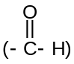
2. the Ketoses, which contain a ketone group (— 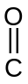—)
The aldoses and ketoses are further divided into sub-groups on the basis of the number of carbon atoms in their molecules, as trioses, tetroses, pentoses, hexoses, etc. To classify a monosaccharide completely, it is necessary to specify both, the type of the carbonyl group and the number of carbon atoms present in the molecule. Thus monosaccharides are generally referred to as aldotrioses, aldotetroses, aldopentoses, aldohexoses, ketohexoses, etc.
The aldoses and ketoses may be represented by the following general formulas. | 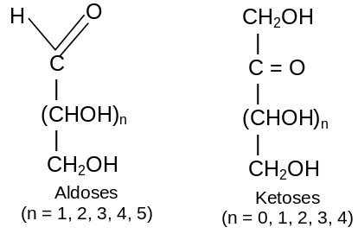
Glucose and fructose are specific examples of an aldose and a ketose.
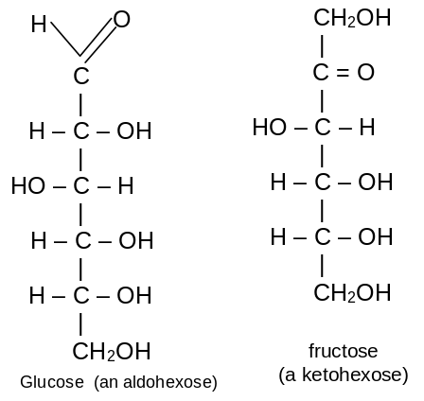
3.1 Trioses
D and L Terminology: The simplest of all carbohydrates that fit the definition we have given for carbohydrates are the trioses, glyceraldehyde and dihydroxyacetone. Glyceraldehyde is aldotriose, and dihydroxyacetone is a ketotriose. | 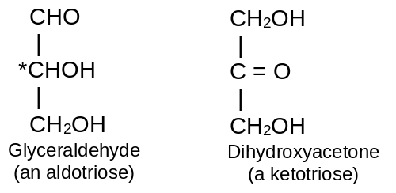
Glyceraldehyde contains one asymmetric carbon atom (marked by an asterisk) and can thus exist in two optically active forms, called the D-form and the L-form. Clearly, the two forms are mirror images that cannot be superimposed, that is they are enantiomers. | 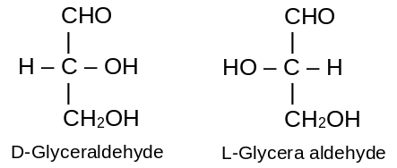
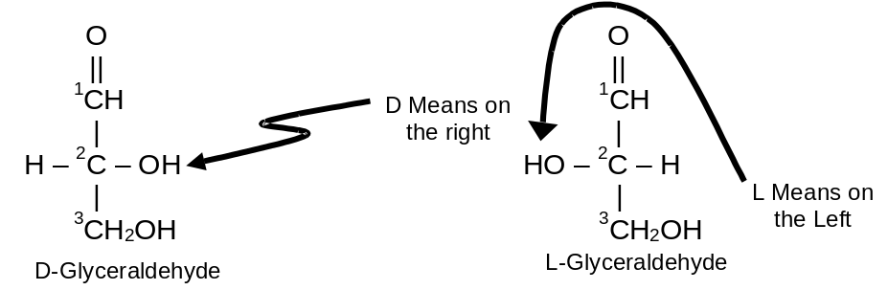
The two forms of glyceraldehyde are especially important because the more complex monosaccharides may be considered to be derived from them. They serve as a reference point for designating and drawing all other monosaccharides. In carbohydrate chemistry, the Fischer projection formulas are always written with the aldehyde or ketone groups at the top of the structure. By definition, if the hydroxyl group on the asymmetric carbon atom farthest from aldehyde or ketone group projects to the right, the compound is a member of the D-family. If the hydroxyl group on the farthest asymmetric carbon projects to the left, the compound is a member of the L-family. The maximum number of optical isomers of a sugar is related to the number of asymmetric carbon atoms in the molecule and may be calculated by the following simple equation.
Maximum Number of Optical Isomers = 2^{n,} where n = the number of asymmetric carbon atoms.
Since glyceraldehyde contains only one asymmetric carbon atom, the number of optical isomer is 2¹. We know that 2¹ is = 2, and we have seen that there are indeed two different glyceraldehydes.
3.2 Aldotetroses
If we examine the general formula of an aldotetrose, we see that they contain two asymmetric carbon atoms (marked by asterisks).  This means that 2² or 4 optical isomers are possible. They may be represented as the following two pairs: | 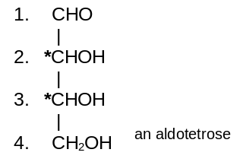
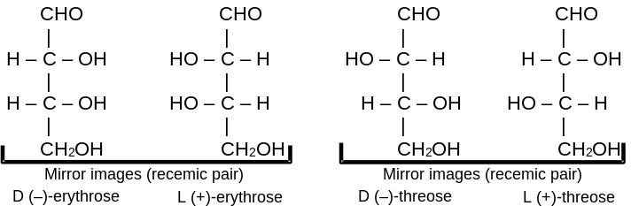
All four isomers have been prepared synthetically. The D- and L-erythrose are mirror images, that is, they are enantiomers. They have exactly the same degree of rotation but in opposite directions. Equal amounts of the two would constitute a racemic mixture, that is, a mixture that would allow a plane-polarised light to pass through the solution unchanged but could be separated into detrorotatory and laevorotatory isomers. The same comments hold for D- and L-threose. However, D-erythrose and L-threose are not images, that is, they are diastereomers (optical isomers that are not mirror images are called diastereomers), and the degree of rotation of each would probably differ.
3.3 Aldopentoses
If we examine the general formula of an aldopentose, we see that they contain three asymmetric carbon atoms.  This means that 2³ or 8 optical isomers are possible.  These are:- D(–) lyxose, L(+)-lyxose, D(–) xylose, L(–)xylose, D(–) arabinose, L(+)-arabinose, D(–)-ribose, L(+)-ribose | 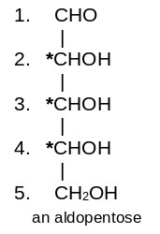
3.4 Aldohexoses
If we examine the general formula of aldohexose, we see that it contains four asymmetric carbon atoms.  This means that 2⁴ or 16 optical isomers are possible. D and L forms of altrose, allose glucose, mannose, galactose, talose, arabinose and idose  Only three of the sixteen possible aldohexoses are found in nature (all sixteen isomers have been prepared synthetically). They are D-glucose, D- mannose, and D-galactose. No one of these three optical iosmers is a mirror image of any of the others, so all three are diastereomers of each other. | 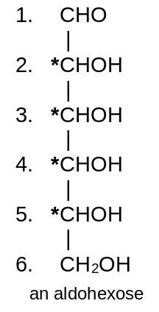

3.5 Epimers
A pair of diastereomers that differ only in the configuration about of a single carbon atom are said to be epimers. e.g D(+)- glucose is epimeric with D(+) -mannose and D(+) -galactose as shown below: | 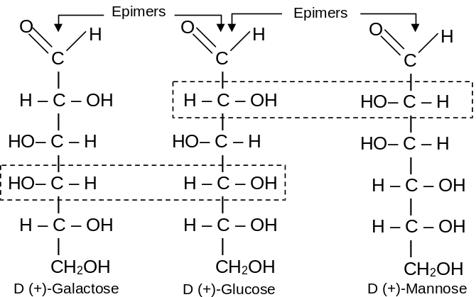
3.6 Cyclic structure of monosaccharides
We know that aldoses (and ketoses) react with alcohols to give first hemiacetals (and hemiketals) and then acetals (and ketals), i.e.,
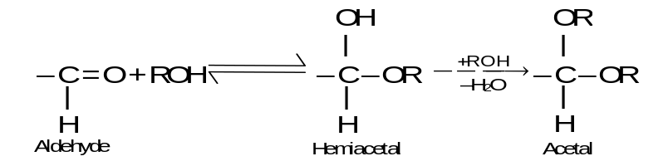
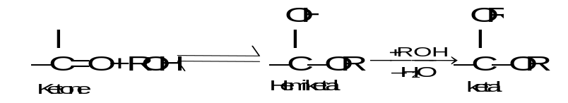
Since monosaccharides contain a number of hydroxyl groups and an aldehyde or a keto group, therefore, any one of the –OH groups (usually C₄ or C₅ in aldohexoses and C₅ or C₆
in ketohexoses) may combine with the aldehyde or the keto group to form intramolecular hemiacetal or hemiketal. As a result, the open chain formulae do not represent the actual structures of the monosaccharides. Their actual structures are cyclic involving five or six membered rings containing an oxygen atom. The five | 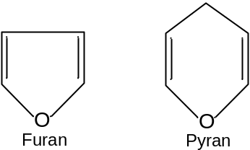
membered ring containing one oxygen atom because of its similarity with furan is called the furanose form and the six membered ring containing one oxygen atom because of its resemblance with pyran is called the pyranose form. In nut shell, all the monosaccharides (pentoses and hexoses) in the free state always exist in the pyranose form. However, in the combined state some monosaccharides such as ribose, 2-deoxyribose, fructose etc., usually exist in the furanose form.
3.7 Cyclic structure of Glucose – Anomers
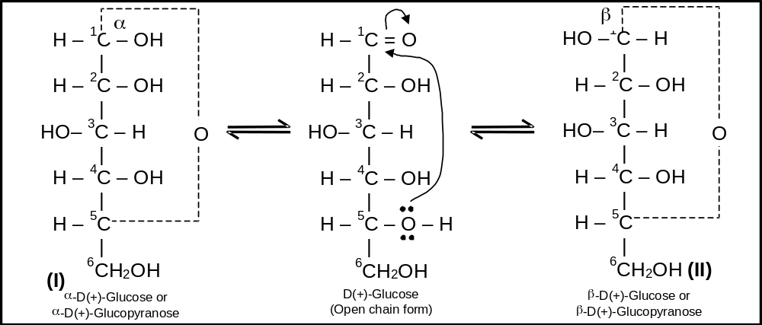
We have discussed above that monosaccharides have cyclic hemiacetal or hemiketal structures. To illustrate, let us first consider the example of D-glucose. During hemiacetal formation C₅ – OH of glucose combines with the C₁ – aldehydic group. As a result, C₁ becomes chiral or asymmetric and thus has two possible arrangements of H and OH groups around it. In other words, D-glucose exists in two stereoisomeric forms, i.e., α-D-glucose and β-D-glucose as shown below:
In α-D-glucose, the OH group at C₁ is towards right while in β-D-glucose, the OH group at C₁ is towards left. Such a pair of stereoisomers which differ in configuration only around C₁ are called anomers and the C₁ carbon is called Anomeric carbon (or glycosidic carbon. The cyclic structures of monosaccharides can be better represented by Haworth Projection formulae. To get such a formula for any monosaccharide (say α-and β-D-glucose), draw a hexagon with its oxygen atom at the upper right hand corner. Place all the groups (on C₁, C₂, C₃ and C₄) which are present on left hand side in structures I and II, above the plane of the ring and all those groups on the right hand side below the plane of the ring.
The terminal – CH₂OH group is always placed above the plane of the hexagon ring (in D-series). Following the above procedure, Haworth Projection Formulae for α-D-glucose (I) and β-D-glucose (II) are obtained as shown below:
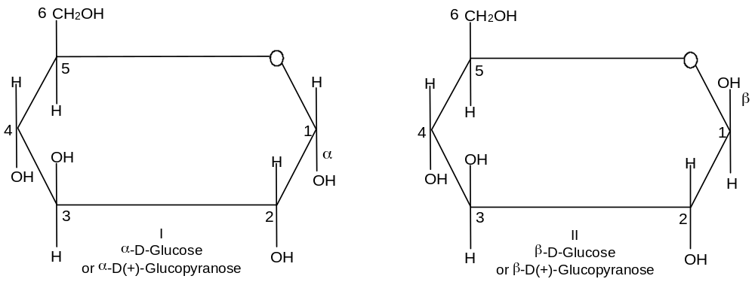
Exercise 1. Give the two isomeric products from the reaction of D-threose with NaCN/HCN. What is the net result of this reaction? Why epimers formed are in unequal amounts?
3.8 Cyclic structure of Fructose
Like glucose, fructose also has a cyclic structure. Since fructose contains a keto group, it forms an intramolecular hemiketal. In the hemiketal formation, C₅– OH of the fructose combines with C₂-keto group. As a result, C₂ becomes chiral and thus has two possible arrangements of CH₂OH and OH group around it. Thus, D-fructose exists in two stereoisomeric forms, i.e., α-D-fructopyranose and β-D fructopyranose. However in the combined state (such as sucrose), fructose exists in furanose form as shown below:
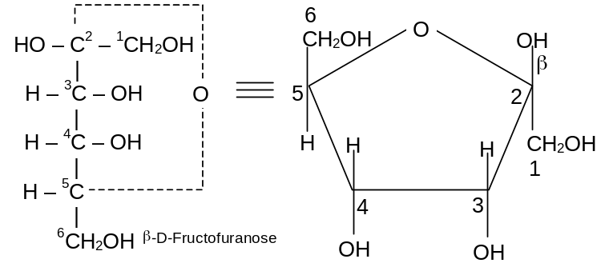
3.9 Mutarotation
The two stereoisomeric forms of glucose, i.e., α-D-glucose and β-D-glucose exist in separate crystalline forms and thus have different melting points and specific roations. For example α-D-glucose has a m.p. of 419 K with a specific rotation of +112° while β-D-glucose has a m.p. of 424 K and has a specific rotation of +19°. However, when either of these two forms is dissolved in water and allowed to stand, it gets converted into an equilibrium mixture of α-and β-forms through a small amount of the open chain form.
As a result of this equilibrium, the specific rotation of a freshly prepared solution of α-D-glucose gradually decreases from of +112° to +52.7° and that of β-D-glucose gradually increases from +19° to +52.7°.
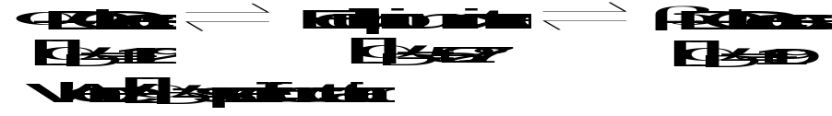
This change in specific rotation of an optically active compound in solution with time, to an equilibrium value, is called mutarotation. During mutarotation, the ring opens and then recloses either in the inverted position or in the original position giving a mixture of α-and-β-forms. All reducing carbohydrates, i.e., monosaccharides and disacchardies (maltose, lactose etc.) undergo mutarotation in aqueous solution.
3.10 Reactions of Glucose

a) With HI/P: It undergoes reduction to form n-hexane while with sodium amalgam it forms sorbitol.
n-hexane
sorbitol
b) With H₂O: It forms neutral solution
c) With Hydroxylamine (NH₂OH)
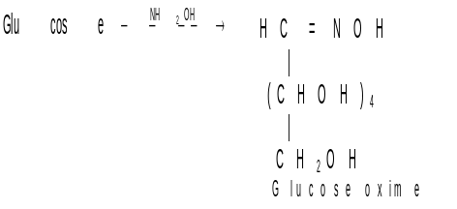
d) With HCN: It form addition product cyanohydrin
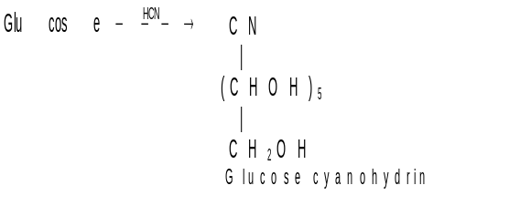
e) Oxidation: Glucose on oxidation with Br₂ gives gluconic acid which on further oxidation with HNO₃ gives glucaric acid
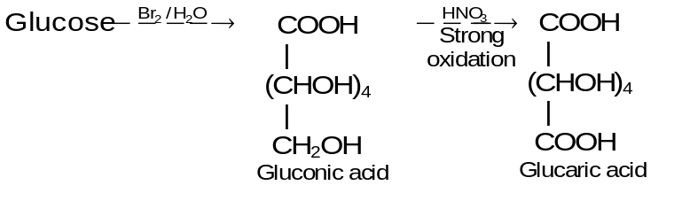
f) With Tollen reagent and Fehling solution. Glucose forms silver mirror and red ppt. of Cu₂O respectively.
g) With acetic anhydride. In presence of pyridine glucose forms pentaacetate.
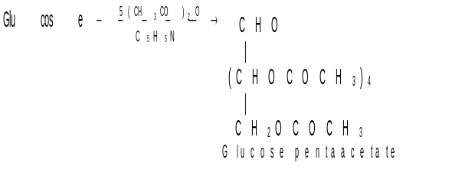
h) With phenylhydrazine: it forms glucosazone
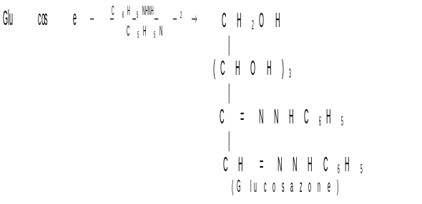
i) With conc. HCl acid: Glucose gives laevulinic acid
j) Glycoside formation: When a small amount of gaseous HCl is passed into a solution of
D (+) glucose in methanol , a reaction takes place that results in the formation of amomeric methyl acetals.
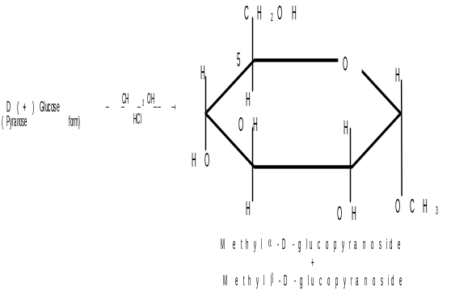
Carbolydrate acetals, genrally are called glycosides and an acetal of glucose is called glucoside.
Other reactions:
a) Kiliani - Fischer Synthesis: - This is a method of lengthening the carbon chain of an aldose. To illustrate, we take synthesis of D-threose and D-erythrose (Aldotetroses) from D-glyceraldehyde (an aldotriose).
Addition to HCN to glyceraldehyde produces two epimeric cyanohydrins because reaction creates a new stereoicenter. The cyanohydrins can be separated easily (since they are diastereomers) and each can be converted to an aldose through hydrolysis, acidification and lactonisation, and reduction with Na—Hg. One cyanohydrin ultimately yields D-erythrose and D-threose.
Here we can see that both sugars are D-sugars because starting compound is D-glyceraldehyde and its stereocentrer is unaffected by its synthesis.
b) Ruff Degradation: It is opposite to Kiliani Fischer synthesis that can be used to shorten the chain by a similar unit. The ruff degradation involves (i) Oxidation of the aldose to an aldonic acid using Bromine water. (ii)Oxidative decarboxylation of the aldonic acid to the next lower aldose using H₂O₂ and Fe₂(SO₄)₃. D-ribose for example can be reduced to D-erythrose.
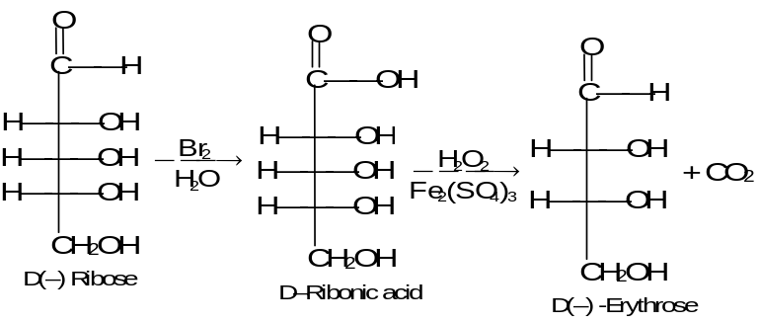
Exercise 2: a) Give structures for E through G. Given:
An aldohexose 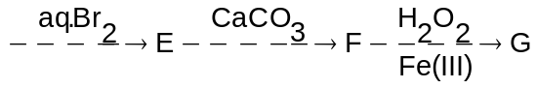
b) Name this overall method (c). Discuss possibility of epimer formation.

4. Disaccharides
Carbohydrates which upon hydrolysis give two molecules of the same or different monosaccharides are called disaccharides. Their general formula is C₁₂H₂₂O₁₁. The three most important disaccharides are sucrose, maltose, and lactose. Each one of these on hydrolysis with either an acid or an enzyme gives two molecules of the same or different monosaccharides as shown below:
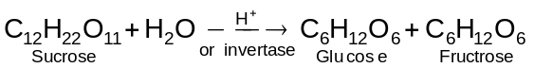

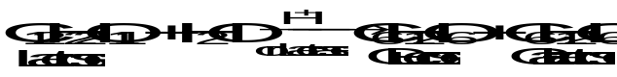
Disaccharides may also be considered to be formed by a condensation reaction between two molecules of the same or different monosaccharides with the eliminatioin of a molecule of water. This reaction involves the formation of an acetal from a hemiacetal and an alcohol in which one of the monosaccharides acts as the hemiacetal while the other acts as the alcohol.
4.1 Sucrose
It is formed by condensation of one molecule of glucose and one molecule of fructose. Unlike maltose and lactose, it is non-reducing sugar since both glucose (C₁ - α) and fructose (C₂ - β) are connected to each other through their reducing centres. Its structure is shown below:
4.1.1 Hydrolysis  (Invert Sugar or Invertose). Hydrolysis of sucrose with hot dilute acid yields D-glucose and D-fructose.  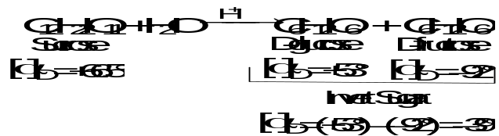Sucrose is dextrorotatory, its specific rotation being +66.5%, D-glucose is also dextrorotatory, [α]_{D} = +53°, but D-fructose has a large negative rotation, [α]_{D} = -92°. Since D-fructose has a greater specific rotation than D-glucose, the resulting mixture is laevorotatory. Because of this the hydrolysis of sucrose is known as the inversion of sucrose, and the equimolecular mixture of glucose and fructose is known is invert sugar or invertose. | 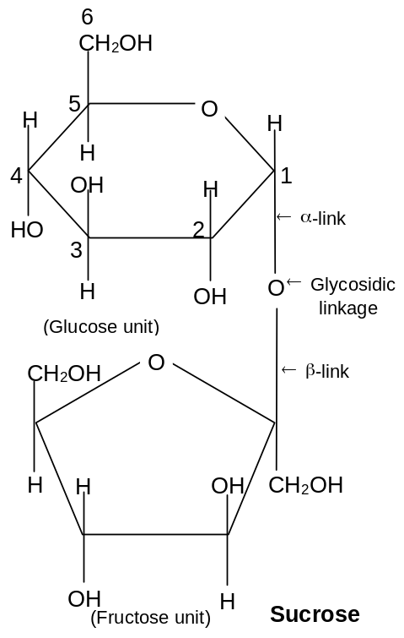

5. Polysaccharides
Polysaccharides are formed when a large number (hundreds to even thousands) of monosaccharide molecules join together with the elimination of water molecule. Thus, polysaccharides may be regarded as condensation polymers in which the monosaccharides are joined together by glycosidic linkages. Some important polysaccharides are:
1. Cellulose 2. Starch
3. Glycogen 4. Gums and
5. Pectins

5.1 Starch
It is a polymer of glucose. Its molecular formula is (C₆H₁₀O₅)_{n} where the value of
n (200 – 1000) varies from source to source. It is the chief food reserve material or storage polysaccharide of plants and is found mainly in seeds, roots, tubers, etc. Wheat, rice, potatoes, corn, bananas etc., are rich sources of starch.
Starch is not a single compound but is a mixture of two components – a water soluble component called amylose (20%) and a water insoluble component called amylopectin (80%). Both amylose and amylopectin are polymers of α-D-glucose.
Amylose is a linear polymer of α-D-glucose. It contains about 200 glucose units which are linked to one another through α-linkage involving C₁ of one glucose unit with C₄ of the other as shown below:
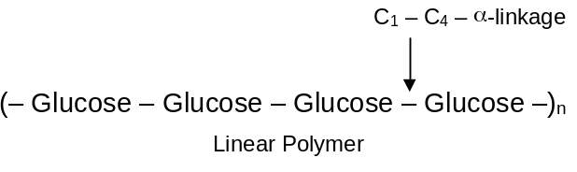
Amylopectin, on the other hand, is a highly branched polymer. It consists of a large number (several branches) of short chains each containing 20-25 glucose units which are joined together through α-linkages involving C₁ of one glucose unit with C₄ of the other. The C₁ of terminal glucose unit in each chain is further linked to C₆ of the other glucose unit in the next chain through C₁ – C₆ α-linkage. This gives amylopectin a highly branched structure as shown below.-
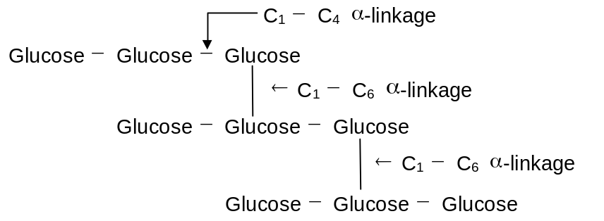
Hydrolyis: Hydrolysis of starch with hot dilute acids or by enzymes gives dextrins of varying complexity, maltose and finally D-glucose. Starch does not reduce Tollen’s reagent and Fehling’s solution.
Uses: It is used as a food. It is encountered daily in the form of potatoes, bread, cakes, rice etc. It is used in coating and sizing paper to improve the writing qualities. Starch is used to treat textile fibres before they are woven into cloth so that they can be woven without breaking. It is used in manufacture of dextrins, glucose and ethyl alcohol. Starch is also used in manufacture of starch nitrate, which is used as an explosive.

6. Amino Acids

6.1 Introduction and Nomenclature
Amino acids are molecules, which contain two functional groups, one is carboxylic group and another is amino group. Amino acids are derivatives of carboxylic acids in which one hydrogen atom of carbon chain is substituted by Amino group.
Amino group may be at α, β, γ position with respect to carboxylic group
H₂N ⎯ CH₂ ⎯ COOH Amino acetic acid, or Glycine
CH₃ ⎯ CH (NH₂) ⎯ COOH α - Amino propionic acid or Alanine
H₂N ⎯ CH₂ ⎯ CH₂ ⎯COOH β - Amino propionic acid
H₂N ⎯ CH₂ ⎯ (CH₂)₂ ⎯ COOH γ - Amino butyric acid
Some amino acids contain a second carboxyl group or a potential carboxyl group in the form of carboxamide: these are called acidic amino acid some contain a second basic group which may be an amino group these are called basic amino acids.
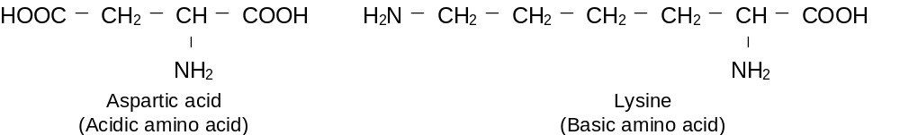
6.2 Physical Properties and Structure
Although the amino acids are commonly shown as containing an amino group and a carboxyl group, certain properties are not consistent with this structure.
1. In contrast to amines and carboxylic acids, the amino acids are nonvolatile solids, which melt at fairly high temperatures.
2. They are insoluble in organic solvents [i.e. non polar solvents] and are highly soluble in water.
3. Their aqueous solution is neutral.
4. Their aqueous solutions behave like solutions of substances of high dipole moment.
5. Acidity and basicity constants are ridiculously low for - COOH and – NH₂ groups
All these properties are quite consistent with a dipolar ion structure for the amino
acids (I)
⁺H₃N ⎯ CHR ⎯ COO––
(I)
Amino acid : dipolar ions
In the physical properties melting points, solubility, and high dipole moment are just what would be expected of such a salt.
The acid base properties also become understandable when it is realized that the measured Ka actually refers to the acidity of an ammonium ion, RNH₃⁺
⁺H₃NCHRCOO– + H₂O H₃O⁺ + H₂NCHRCOO–
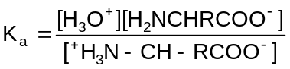
and K_{b} actually refers to the basicity of a carboxylate ion, RCOO–
⁺H₃N ⎯ CH ⎯ RCOO– + H₂O ⁺H₃N ⎯ CHR ⎯COOH + OH–
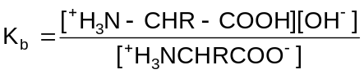
When the solution of an amino acid is made alkaline, the dipolar ion(I) is converted to the anion (II); the stronger base, hydroxide ion, removes a proton from the ammonium ion and displaces the weaker base, the amine
⁺H₃N ⎯ CHRCOO– + OH– H₂N CHRCOO– + H₂O
(I) (II)
Stronger Stronger Weaker Weaker
acid base base acid
When the solution of an amino acid is made acidic; the dipolar ion I is converted into the cation (III); the stronger acid 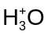, gives up a proton to the carboxylate ion, and displaces the weaker carboxylic acid.
⁺H₃N CHRCOO– + H₃O⁺ ⁺H₃N CHRCOOH + H₂O
(I) (III)
Stronger Stronger Weaker Weaker
base acid acid base
In summary, the acidic group of a simple amino acid like glycine is 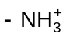not –COOH, and basic group is –COO⁻ not –NH₂.
Exercise 3: How does acidic medium of stomach helps in the digestion of proteins.

6.3 Iso Electric Point
What happens when a solution of an amino acid is placed in an electric field depends upon the acidity or basicity of solution. In quite alkaline solution.
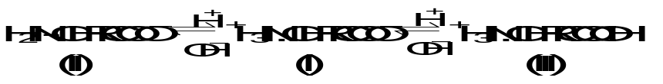
Anions (II) exceed cations (III), and there is a net migration of amino acid toward the anode. In quite acidic solution cations (III) are in excess, and there is a net migration of amino acid towards the cathode. If (II) and (III) are exactly balanced, there is no net migration; under such conditions any one molecule exists as a positive ion and as a negative ion for exactly the same amount of time and any small movement in the direction of one electrode is subsequently cancelled by an equal movement back towards the other electrode. The hydrogen ion concentration of the solution in which a particular amino acid does not migrate under the influence of an electric field is called the isoelectric point of that amino acid.
An amino acid shows its lowest solubility in a solution at the isoelectric point, since here there is the highest concentration of the dipolar ion. As the solution is made more alkaline or more acidic, the concentration of one of the more soluble ions, II or III increases.
If an amino acid has amino group and one carboxyl group, it has two pK values. The isoelectric point (PI) of this amino acid has the average value of the both pK values.
We take example of glycine.
H₃⁺N ⎯ CH₂ ⎯ COOH H₃N⁺ ⎯ CH₂ ⎯ COO– + H⁺ …(1)
Conjugated acid (CA) Dipolar Ion (DI)
At equilibrium 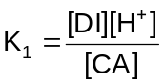
H₃N⁺ ⎯ CH₂ ⎯ COO– H₂N ⎯ CH₂ ⎯ COO– + H⁺ …(2)
DI Conjugated Base (CB)
At equilibrium 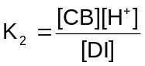
[CA] = 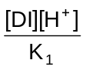
[CB] = 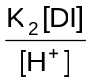
At isoelectric point [CA] = [CB]
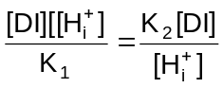 Where 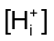 = conc. of [H⁺] at isoelectric point.
or, 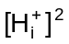 = K₁ K₂
or, 2log [H_{i}⁺] = log K₁ + log K₂
or –2 log (H_{i}⁺] = - log k₁ – logK₂
or 2pH_{i} = pK₁ + pK₂
or pH_{i} = 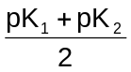

7. Peptides
As the amino acid molecules contain both basic as well as acidic group it might be expected that an intermolecular reaction may take place between the carboxyl group of one amino acid and the amino group of another amino acid, with the elimination of a molecule of water.
R R′ R R′
⏐ ⏐ ⏐ ⏐
H₂N ⎯ CH ⎯ COOH + H₂N ⎯ CH ⎯ COOH ⎯→ H₂ N ⎯ CHCO ⎯ NH ⎯ CHCOOH
Since the resulting molecule still has a free amino and a carboxyl group, it may react with other amino acids at either of the ends to give a higher molecular weight linear or condensation product. Every two amino acids are linked by means of a –CO-NH group, which is commonly referred as peptide bond. So now we can define a peptides as the amides formed by interaction between amino groups and carboxyl groups of amino acids.
Depending upon the number of amino acid residues per molecule, they are known as dipeptides, tripeptides and so on and finally polypeptides.

7.1 Naming of Polypeptide
A convenient way of representing peptide structures by use of standard abbreviations. According to convention the N-terminal amino acid residue [having the free amino group] is written as the left and the C terminal amino acid residue (having the free carboxyl group) at the right end.
A peptide is named by indicating its sequence of amino acids beginning with the N-terminal residue.
H₂N ⎯ CH ⎯ CONH ⎯ CH ⎯ CONH ⎯ CH ⎯ CONH ⎯ CH ⎯ CONHCH₂ COOH
| | | |
CH₃ CH₂-OH CH₂-C₆H₅ CH₂-CONH₂
Alanine Serine Phenylalamine Asparagine glycine
This pentapeptide is called alanyl-sery-phenylalanyl-asparaginyl-glycine or using the common abbreviations as H-Ala-Ser-phe-Asn-gly-OH. All naturally occurring important peptides, however, posses a shorter individual name.
7.2 Structure of Poly peptides
To identify the structure of a peptide, the peptide in question is first hydrolysed to its constituent amino acids, which are separated and identified. The amount of each amino acid is measured, and hence the number of each kind of amino acid can be calculated.
The next problem is to determine the sequence of the various amino acids constituting the peptide. This is very difficult task, because there is a large number of possibilities in which the constituent amino acids may be linked in the peptide, e.g. even is a dipeptide, having glycine and alanine, the two amino-acids may be present in either of the two ways.
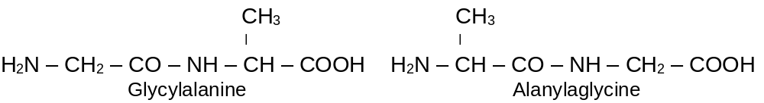
The two structures differ in the respect that in the first the N-terminal amino acid is glycine (i.e. the amino group of glycine is free) and C-terminal amino acid is alanine, while in the latter the N-terminal amino acid is alanine and C-terminal acid is glycine. Various chemical methods have been developed to remove either of the two terminal amino acid residues of a polypeptide in a stepwise manner and hence the arrangement of the various amino acids in a polypeptide can be established.
7.3 Sanger’s Method
Sanger reagent, 1-fluoro-2, 4-dinitrobenzene (FDNB) was first used to determine that which amino acid constituted the amino end of the polypeptide. The method consists in treating the polypeptide with the reagent in the presence of sodium-hydrogen-carbonate solution at room temperature to form a 2, 4-dinitrophenyl (DNP) derivative of the polypeptide. The product is hydrolysed be means of acid (which causes the cleavage of the peptide bond connecting the N-terminal amino acid to the rest of the polypeptide molecule) to form dinitrophenyl (DNP) derivative of the N-terminal amino acid and the rest of the polypeptide molecule or amino acid residues.
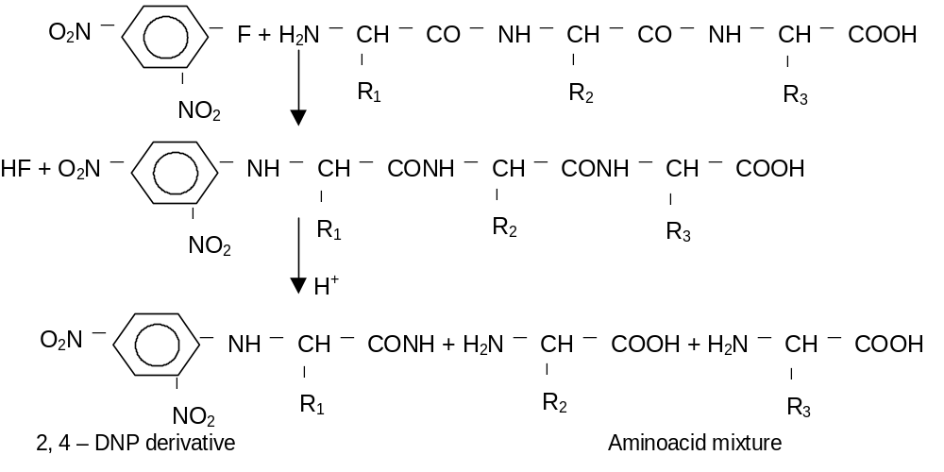

8. Polymers

8.1 Introduction
Sit quietly and think about your activities today from the morning. You wake up in the morning, You want to brush your teeth. You fetch your toothpaste. The tube is made up of a polymer. Your brush is made up of a polymer. When you want to rinse your mouth, you open your plastic(polymer) tap. The pipe lines used to bring water to your tap is made of PVC(polymer). Skip it. You start preparing your break fast. You take a non-stick tawa. Non-stick? What does that mean? What is it made of? It is poly tetrafluoro ethylene abbreviated as teflon, a polymer. See, how polymers play an important role in our daily life from dawn to dusk. The molded chair in which you are sitting is a polymer. The pen with which I'm writing this is a polymer. Want to know more about polymers? Read further.
Polymers can be called as macromolecules. Macromolecules can be considered as an association of small molecules to give a big molecule. Macromolecules can be man-made, too. The first syntheses were aimed at making substitutes for the natural macromolecules, rubber and silk; but a vast technology has grown up that now produces hundreds of substances that have no natural counterparts. Synthetic macromolecular compounds include: elastomers, which have the particular kind of elasticity characteristic of rubber; fibers, long, thin and threadlike, with the great strength along the fiber that characterizes cotton, wool, and silk; and plastics, which can be extruded as sheets or pipes, painted on surfaces, or molded to form countless objects. We wear these manmade materials, eat and drink from them, sleep between them, sit and stand on them; turn knobs, pull switches, and grasp handles made of them; with their help we hear sounds and see sights remote from us in time and space; we live in houses and move about in vehicles that are increasingly made of them.

8.2 Polymers and polymerization
Macromolecules, both natural and man-made, owe their great size to the fact that they are polymers (Greek: many parts); that is, each one is made up of a great many simpler units — identical to each other or at least chemically similar — joined together in a regular way. They are formed by a process we touched on earlier: polymerization, the joining together of many small molecules to form very large molecules. The simple compounds from which polymers are made are called monomers.
Polymers are formed in two general ways.
- In chain-reaction polymerization, there is a series of reactions each of which consumes a reactive particle and produces another, similar particle; each individual reaction thus depends upon the previous one. The reactive particles can be free radicals, cations, or anions. A typical example is the polymerization of ethylene. Here the chain-carrying particles are free radicals, each of which adds to a monomer molecule to form a new, bigger free radical.
Rad. + CH₂ = CH₂ ⎯→ RadCH₂CH₂⋅ 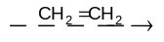RadCH₂CH₂CH₂CH₂⋅ ⎯→ etc.
b) In step reaction polymerization, there is a series of reactions each of which is essentially independent of the preceding one; a polymer is formed simply because the monomer happens to undergo reaction at more than one functional group. A diol, for example, reacts with a dicarboxylic acid to form an ester; but each moiety of the simple ester still contains a group that can react to generate another ester linkage and hence a larger molecule, which itself can react further, and so on.
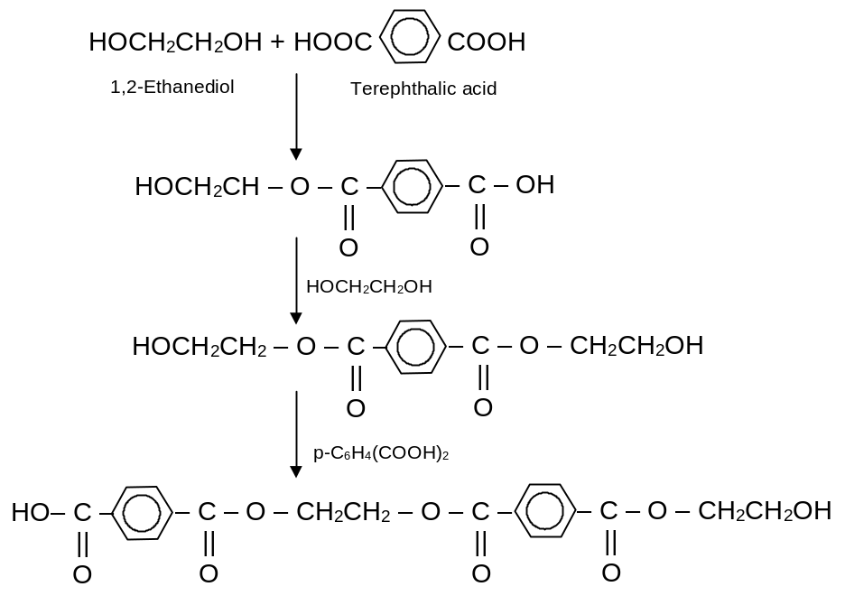

a) Free-radical vinyl polymerization: In we discussed briefly the polymerization of ethylene and substituted ethylenes under conditions where free radicals are generated — typically in the presence of small amounts of an initiator, such as a peroxide. Reaction occurs.
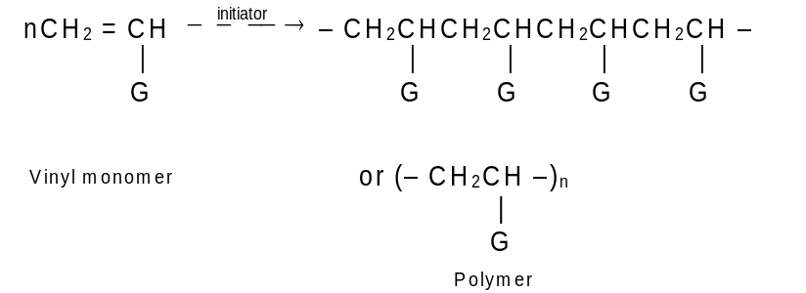
At the doubly bonded carbons — the vinyl groups — and is called vinyl polymerization. A wide variety of unsaturated monomers may be used, to yield polymers with different pendant groups (G) attached to the polymer backbone. For example.
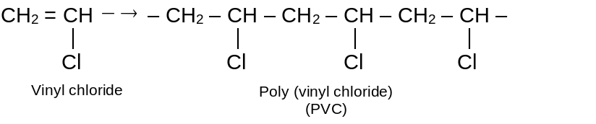
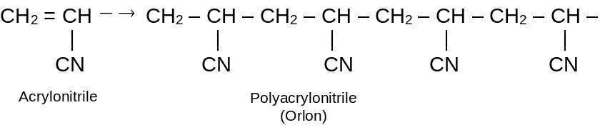
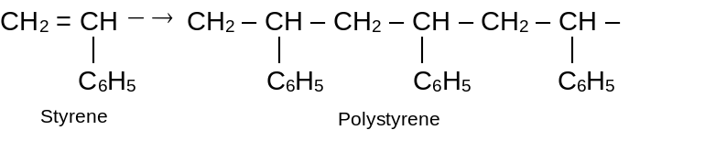

b) Copolymerization: So far, we have discussed only polymerisation of a single monomeric compound to form a homopolymer, a polymer made up — except, of course, at the two ends of the long molecule — of identical units.
Now, if a mixture of two (or more) monomers is allowed to undergo polymerization, there is obtained a copolymer a polymer that contains two (or more) kinds of monomeric units in the same molecule. For example:
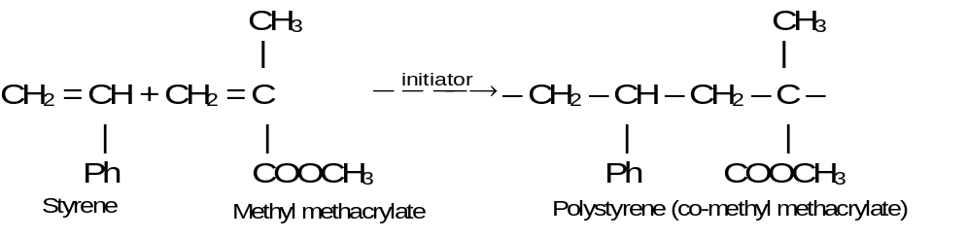
Through copolymerization there can be made materials with different properties than those of either homopolymer, and thus another dimension is added to the technology. Consider, for example, styrene. Polymerized alone, it gives a good electric insulator that is molded into parts for radios, television sets, and automobiles. Copolymerization with butadiene (30%) adds toughness; with acrylonitrile (20-30%) increases resistance to impact and to hydrocarbon; with maleic anhyride yeilds a material that, on hydrolysis, is water-soluble, and is used as a dispersant and sizing agent. The copolymer in which butadiene predominates (75%) butadiene, 25% styrene) is an elastomer, and since World War II has been the principal rubber substitute manufactured in the United States.
Copolymers can be made not just from two different monomers but from three, four, or even more. They can be made not only by free-radical chain reactions, but by any of the polymerization methods we shall take up; ionic, coordination, or step-reaction. The monomer units may be distributed in various ways, depending on the technique used. As we have seen, they may alternate along a chain, either randomly or with varying degrees of regularity. In block copolymers sections made up of one monomer alternate with sections of another:
— M₁M₁M₁M₁M₁ – M₂M₂M₂M₂ — Block copolymer
If graft copolymers, a branch of one kind is grafted to a chain of another kind:
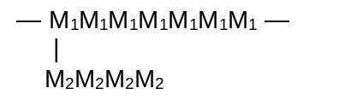
Fibres are long thin, threadlike bits of material that are characterized by great tensile (pulling) strength in the direction of the fiber. The natural fibres – cotton, wool, silk – are typical. Fibres are twisted into threads, which can then be woven into cloth, or embedded in plastic material to impart strength. The tensile strength can be enormous, some synthetic fibres rivaling – on a weight basis – steel.
The gross characteristics of fibres are reflected on the molecular level – the molecules, too, are long, thin, and threadlike. Furthermore, and most essential, they lie stretched out alongside each other, lined up in the direction of the fiber. The strength of the fiber resides, ultimately, in the strength of the chemical bonds of the polymer chains. The lining-up is brought about by drawing – stretching — the return to random looping and coiling is overcome by strong intermolecular attractions. In a fiber, enthalpy wins out over entropy. This high degree of molecular orientation is usually — although not always — accompanied by appreciable crystallinity.
An elastomer possesses the high degree of elasticity that is characteristic of rubber: it can be greatly deformed — stretched to eight times its original length, for example — and yet return to its original shape. Here, as in fibres, the molecules are long and thin; as in fibres, they become lined up when the material is stretched. The big difference is this: when the stretching force is removed, the molecular chains of an elastomer do not remain extended and aligned but return to their original random conformations favored by entropy. They do not remain aligned because the intermolecular forces necessary to hold them that way are weaker than in a fiber. In general, elastomers do not contain highly polar groups or sites for hydrogen bonding; the extended chains do not fit together well enough for Vander Waals forces to do the job. In an elastomer entropy beats enthalpy.
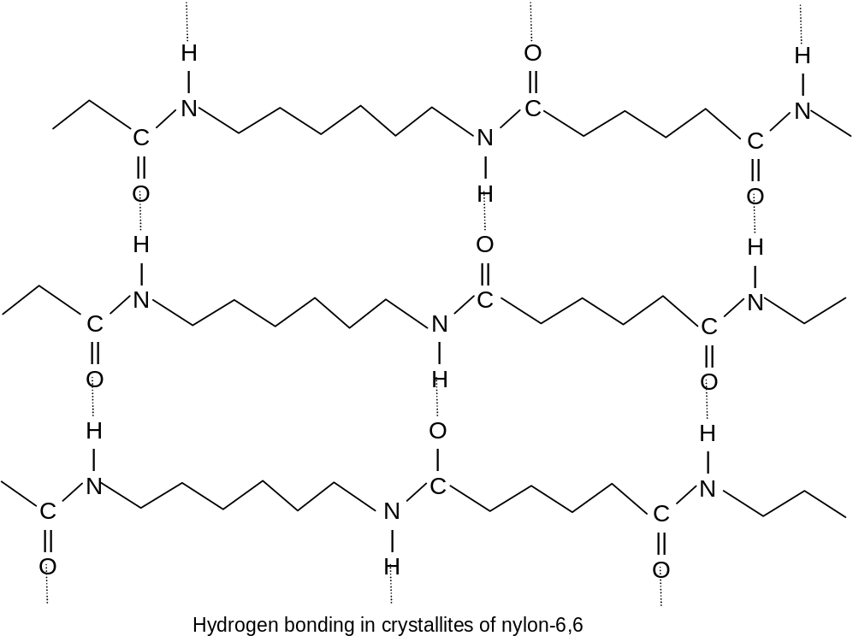
One further requirement the long chains of an elastomer must be connected to each other by occasional cross – links: enough of them to prevent slipping of molecules past one another; not so many as to deprive the chains of the flexibility that is need for ready extension and return to randomness.
Natural rubber illustrates these structural requirements of an elastomer; long flexible chains; weak intermoecular forces and occasional cross – linking. Rubber is cis 1,4-polyisoprene . With no highly polar substituents, intermolecular attraction is largely limited to van der Waals forces. But these are weak because of the all – cis configuration about the double bond. Figure below compares the extended chains of rubber with those of its trans stereoisomer. As we can see, the trans configuration permits highly regular zig – zags that fit together well; the cis configuration does not. The all-trans stereoisomer occurs naturally as gutta percha; it is highly crystalline and non-elastic.
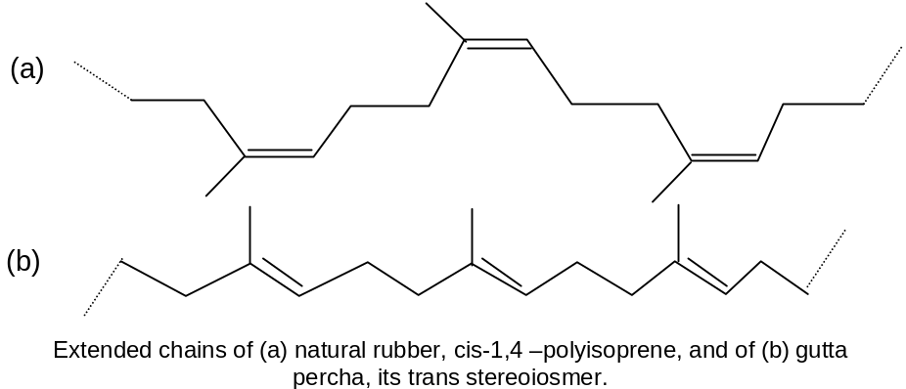
Chief among the synthetic elastomers is SBR, a copolymer of butadiene (75%) and styrene (25%) produced under free-radical conditions; it competes with natural rubber in the main use of elastomers, the making of automobile tires. All-cis polybutadiene and polyisoprene can be made by Ziegler – Natta polymerization.
An elastomer that is entirely or mostly polydiene is, of course, highly unsaturated. All that is required of an elastomer, however, is enough unsaturation to permit cross-linking. In making butyl rubber for example, only 5% of isoprene is copolymerized with isobutylene.
Some Important Polymers:
a) Natural Rubber: Natural rubber is an addition polymer of isoprene (2-methyl-1,3-butadiene)
Rubber has an average chain length of 5000 monomer units of isoprene.
The rubber in which the arrangement of carbon chain is trans with respect to the double bond is known as Gutta Percha and this is the natural rubber obtained from bark of various trees. Natural rubber is sticky material. This disadvantage is removed by 'VULCANISATION' which involves addition of sulphur to rubber and heating the mixture. sulphur forms short chains of sulphur atoms that link two hydrocarbon (isoprene) units together.
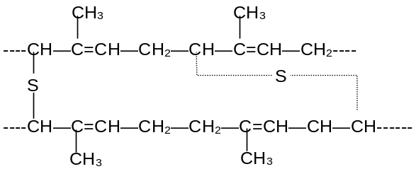
When tension is applied the chains can strengthen out but they cannot slip past each other because of sulphur bridges. Thus rubber can be stretched only to a certain extent and hydrocarbon chains have the tendency to regain their shape when tension is removed.
Vulcanised rubber is thus stronger and less sticky than the natural rubber.
b) Synthetic rubber: (Polychloroprene) or Neoprene) It is obtained by free radical polymerisation of chloroprene in
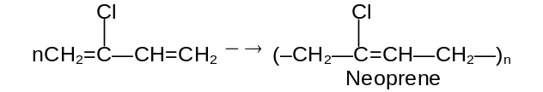
it is a thermoplastic and need not to be vulcanised. It is a good general purpose rubber and superior to natural rubber as it is resistant to the reaction of aire, heat, light chemicals, alkalis and acids below 50% strength. It is used for making transmission belts, printing rolls and flexible tubing employed for conveyence of oil and petrol.
c) Buna rubbers: Butadiene polymerises in the presence of sodium to give a rubber substitute viz. BuNa. It is of two types
i) Buna - N or GRA: it is synthetic rubber obtained by copolymerisation of one part of acryl nitrile and two parts of butadiene.
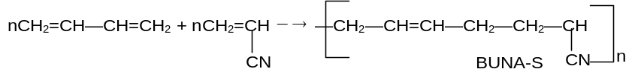
It is more rigid responds less to heat and very resistant to swelling action of petorol, oils and other organic solvents.
ii) Buna -S or GRS (General purpose Styrene rubber): It is a copolymer of three moles of butadiene and one mole of styrene\ and is an elastomer. It is obtained as a result of free radical copolymerisation of its monomers.
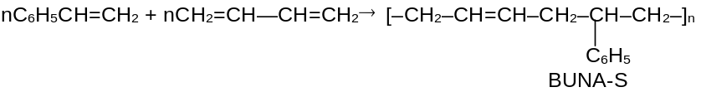
It is generally compounded with carbon black and vulcanised with sulphur. It is extremely resistant to wear and tear and finds use in manufacture of tyres and other mechanical rubber goods.
d) Teflon: It is polymer of tetrafluorethylene (F₂C=CF₂) which on polymerisation gives Telfon.
nCF₂=CF₂ 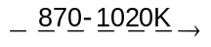 (—CF₂—CF₂—)_{n}
It is thermoplastic polymer with a high softening point (600K). It is very tough and difficult to work. It is inert to most chemicals except fluorine and molten alkali metals. It withstands high temperatures. Its electrical properties make it an ideal insulating material for high frequency installation.
e) Nylon -66: It is a polymer resin. It is a condensation polymer formed by reaction between adipic acid and hexamethylene diamine. Both monomer units consist of 6 carbon atoms and therefore named nylon -66.
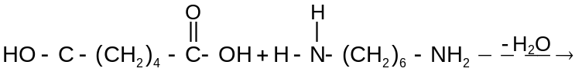
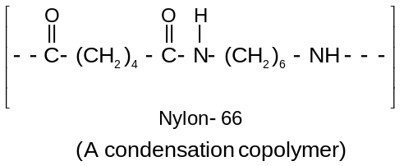
It is thermoplastic polymer when extruded above its melting point (536 K) through spinneret, it gives nylon fiber which is extremely tough and resistant to friction. It possess greater tensile strength, elasticity and lusture than any natural fiber. It is chemically inert and is fabricated into sheet, bristles and textile fibres.
f) Nylon 6 or Perolon - L: A polyamide is prepared by prolonged heating of caprolactam at 530 - 540 K.
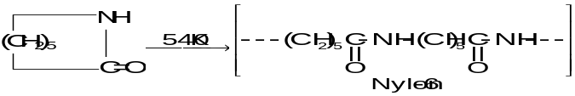
The fiber is practically identical to Nylon in properties
Exercise 4: Show the fundamental unit of structure common to all polypeptides and proteins and show how cross linking occurs between two chains by
H - bonding.

\

9. Answers to Exercise
Exercise 1: | 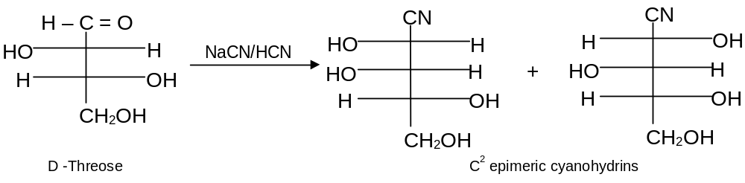
Net result is that carbon chain is increased by one. The presence of stereocentres in sugars causes their C = O groups to have diastereotopic faces that react at different rates, giving different amounts of diastereomers.
Exercise 2: a) E is an aldonic acid, F is its calcium salt
[CH₂OH (CHOH)₄COO–]₂Ca²⁺, G is an aldopentose.
b) This oxidative decarboxylation is called Ruff degradation.
c) The α-CHOH is oxidised to –CH = O without any configurational changes of other chiral carbons. No epimers are formed.
Exercise 3: The acid denatures proteins and then proteins are hydrolysed first to polypeptides and finally to amino acids.
Exercise 4: | 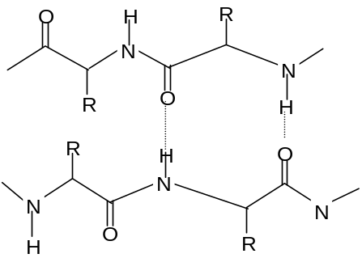

10. Solved Problems (Subjective)
Problem 1: Treatment of (+)– glucose with HIO₄ gives results that confirm its aldohexose structure. What product should be formed, and how much HIO₄ should be consumed.
Solution: Since in glucose there are five –OH groups so five moles of HIO₄ are consumed giving main product formic acid and formaldehyde as shown below
Glucose + 5HIO₄ ⎯→ 5HCOOH + HCHO
Problem 2: a) Show how an aldohexose can be used to synthesize 2-ketohexose. (b) Since glucose is converted to fructose by this method, what can you say about the configurations of C³, C⁴ and C⁵ in the sugars.
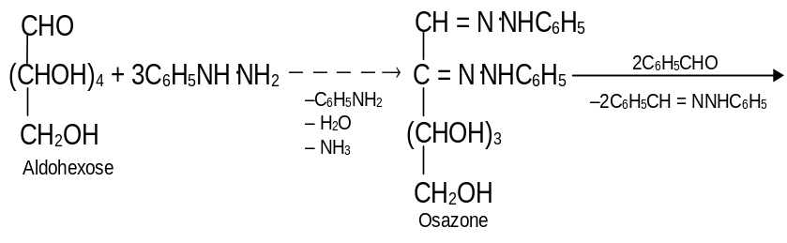
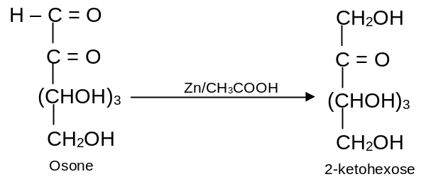
Here aldohexose reacts with one molecule of phenylhyrazine which condenses with the aldehyde group to give phenylhydrazone. When warmed with excess of phenyl hydrazine, the secondary alcoholic group adjacent to the aldehyde group is oxidised by another molecule of phenylhydrazine, to a ketonic group. With this ketonic group, the third molecule of phenylhydrazine condenses to give osazone. The phenylhydrazinyl group is transferred from osazone to C₆H₅CHO giving C₆H₅CH = N⋅NHC₆H₅ and a dicarbonyl compound called an osone. The more reactive aldehyde group of the osone is reduced, not the less reactive keto group and it gives the 2-ketohexose.
b) The configurations of these carbons which are unchanged in the reactions, must be identical in order to get the same osazone.
Problem 3: Supply structures for H through K. Given:
An aldohexose K. (b) Explain the last step (c). What is net structural change (d) Name this overall method. (e) Discuss the possibility of epimer formation.
Solution: a) H is an oxime HOCH₂(CHOH)₄CH = NOH; I is the completely acetylated oxime, AcOCH₂(CHOAc)₄CH = NOAc that loses 1 mole of HOAc to form J, AcOCH₂(CHOAc)₄ C≡N; K is an aldopentose, HOCH₂(CHOH)₃CHO.
b) The acetates undergo transesterification to give methyl acetate freeing all the sugar OH’s. This is followed by reversal of HCN addition.
c) There is loss of one C from the carbon chain.
d) Wohl degradation
e) The α-CHOH becomes the –CH = O without any configurational changes of the other chiral carbons. Thus no epimers are formed.
Problem 4: Although both polymers are prepared by free radical processes, poly (vinyl chloride) is amorphous and poly (vinylidene chloride) (saran) is highly crystallilne. How do you account for the different? (vinylidene chloride is 1,1-dichloroethene).
Solution: 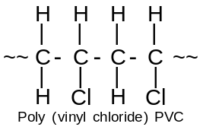 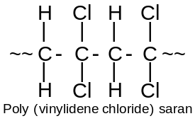
As poly (vinyl chloride) is able to show stereoisomerism and further it is formed by a free radical process, it is atactic (chlorine atoms distributed randomly), the molecules fit together poorly.
Poly (vinylidene chlroide) has two identical substituents on each carbon and the chains fit together well.
Problem 5: a) What is the structure of nylon-6, made by alkaline polymerisation of caprolactom?
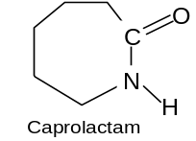
b) Suggest a mechanism for the process. Is polymerisation of the chain reaction or step reaction type?
Solution : a) 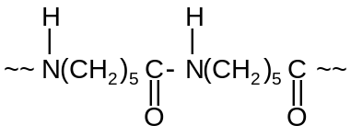
b) | 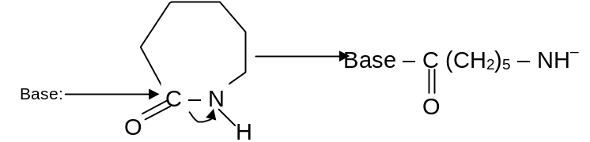
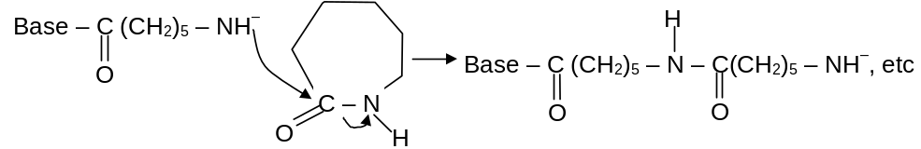
The reaction is anionic chain reaction polymerization, involving nucleophilic substitution at the acyl group of the cyclic amide. The base could be OH– itself or the anion formed by abstraction of the –NH proton from a molecule of lactam.
Problem 6: a) i) Sucrose has no free anomeric OH. (ii) D-glucose and D-fructose are linked by their anomeric OH′s, the α of one with β OH of other (hydrolysis by emulsion). (iii) The glucose unit is a pyranoside because the C⁵OH is unmethylated.
b) Fructose ring size and the glycosidic linkage (actual linkage is α to glucose and β to fructose.
c) α-D-glucopyranosyl-β-D-fructofuranoside or
β-D-fructofuranosyl-α-D-glucopyranoside.
Solution: a) Give the structure of disaccharide sucrose, the common table sugar from following (i) It does not reduce Fehling reagent and does not mutarotate (ii) It is hydrolysed by maltase or emulsion to D-glucose and D-fructose (iii) Methylation and hydrolysis give 2, 3, 4, 6-tetra-O-methyl-D-glucopyranose and a tetramethyl-D-fructose.
b) What structural features are uncertain.
c) Give IUPAC name of sucrose.
Problem 7: How will you synthesize Alanine from acetylene.
Solution: | 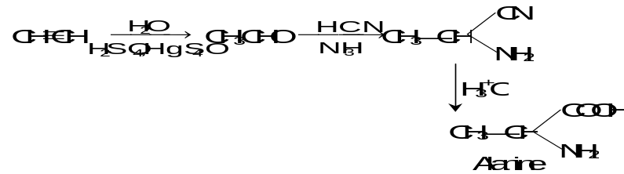

Problem 8: Glycine exists as (H₃N⁺CH₂COO–) while anthranilic acid
(P–NH₂–C₆H₄ – COOH) does not exist as dipolar ion.
Solution: –COOH is too weakly acidic to transfer H⁺ to the weakly basic –NH₂ attached to the electron withdrawing benzene ring. When attached to an aliphatic carbon, the –NH₂ is sufficiently basic to accept H⁺ form
–COOH group.
Problem 9: i) Sulphanilic acid although has acidic as well as basic group, it is soluble in alkali but insoluble in mineral acid
ii) Sulphanilic acid is not soluble in organic solvents.
Solution : i) Sulphanilic acid exist as Zwitterion
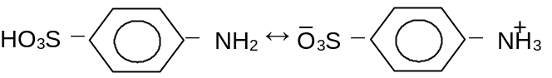
The weakly acidic –⁺NH₃ transfers H⁺ to OH– to form a soluble salt, P–NH₂–C₆H₄–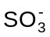Na⁺ on the other hand – is too weakly basic to accept H⁺ from strong acids.
ii) Due to its ionic character it is insoluble in organic solvents.
Problem 10: Why should isoelectric point for Aspartic acid (2.98) be so much lower than that of leucine?
Solution: This may be explained by considering following ion equilibria
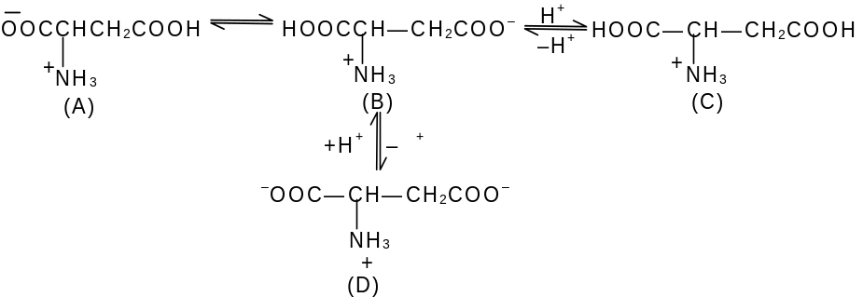
It is apparent that ions (A) and (B) are neutral, while (C) is a cation and (D) is dianion. In species (D), the anion is derived from the second —COOH group present in aspartic acid and is not possible in leucine. At neutral pH a significant concentration of (D), will be present in aqueous solution. It will therefore, be necessary to decrease the pH of such a solution if the formation of (D) is to be suppressed to a stage where anions and cations are present in equal concentration (the isoelectric point).

11. Assignments (Subjective Problems)

LEVEL - I
1. What is the common name for carbohydrates? Name the suffix that indicates a simple carbohydrates.
2. Write Fischer formula of D, L isomers of the simplest known aldosugar give R/S designation.
3. How many chiral carbon one there in aldopentose?
4. How can you differentiate D-erythrose, D-threose?
5. What is the difference between aldotriose and ketotriose?
6. What kind of open chain aldohexose has only right stereoisomers?
7. Do the anomers of D-glucose have specific rotations of same magnitude but opposite signs. (b) How do epimers and anomers differ?
8. What structural feature distinguishes proline from other α-amino acids.
9. Show the structural difference between syndiotactic, isotactic and atactic polymers.
10. When poly (vinyl acetate) was hydrolysed, and the product was treated with periodic acid and then reacetylated, there was obtained poly (vinyl acetate) of lower molecular weight than the starting material. What does this indicate about the structure of the original polymer and about the polymerisation process?

LEVEL - II
1. Why are the optically active tartaric acid and 1, 2, 3, 4-butanetetraol is called D?
2. Define the term epimer and anomer.
3. Give the products of the reaction of HNO₃ with an aldotrise and classify the product. Also describe the product of Br₂ water oxidation.
4. Give the product from the reaction of D-threose with PhNHNH₂, show the intermediates.
5. Draw the Haworth projections of the anomers of D-fructofuranose
6. Describe the digestive disorder known as lactose intolerance.
7. Why do glucose, mannose and fructose form identical osazone.
8. Glutathionine, Glu.Cys.Gly is a tripeptide widely distributed in plants, animals. The Glu residue forms a peptide bond with its γ-COOH. Give the structure of glutathione.
9. How will you distinguish between Glycine and acetamide.
10. Proline and hydroxylproline give a yellow colour with ninhydrin. Explain.

LEVEL - III
1. Outline a process for converting vaniline to rac-3,4-dihyroxy-pentylalamine whose (s) enantiomer is the drug L-Dapa, used for the treatment of Parkinson’s disease.
2. Show how CNBr is used in selective cleavage of peptide linkage.
3. The articifical sweetener aspertame is a synthetic dipeptide. How many stereoisomers are possible.
4. Which amino acid (AA) is chiral? Give the AA’s having more than one chiral centre.
5. Write the structure of histidine at pH < 1.82, and write an equation to show which proton is lost when the pH is raised above 1.82.
6. Which α-AA can provide a cross-linkage of two peptide chains? Explain
7. a) Give a simple test for starch.
b) Describe the change that occurs when the test is performed at elevated temperatures.
c) Discuss the structural change that accounts for the variation in the test.
d) Do amylose and amylopectin give the same colour? Explain.
8. Account for fact, that whatever the mechanism free radical cationic, anionic – vinyl polymerisation gives products with almost exclusively ‘head-to-tail’ arrangement of units.
9. Like other oxygen- containing compounds, alcohols dissolve in cold concentrated H₂SO₄. In case of some secondary and tertiary alcohols, dissolution is followed by the gradual separation of an insoluble liquid of high boiling point. How do you account for this behaviour?
10. How is an AA bonded to its t-RNA?

12. Assignments (Objective Problems)

LEVEL – I

1. Which of the following is a disaccharide?
(A)Glucose (B) Fructose
(C)Maltose (D) Cellulose

2. Glucose is
(A) Aldopentose (B) Aldohexose
(C) Ketopentose (D) Ketohexose

3. The monomer units of starch are
(A) α-glucose (B) β-glucose
(C) Pyranose (D) Galactose

4. Which D-aldohexose are oxidized by HNO₃ tro mesoaldaric acid
(A) D-altrose (B) D-altrose
(C) L-altrose (D) None of these

5. Maltose is made up of
(A) α-D-glucose (B) D-fructose
(C) α-D-Glucose and β-D-glucose (D) Glucose and fructose

6. Which is used to identify glucose
(A) Neutral FeCl₃ (B) CHCl₃ + KOH (alc.)
(C) C₂H₅ONa (D) Ammoniacal AgNO₃

7. Number of possible isomers of glucose is
(A) 16 (B) 14
(C) 10 (D) 8

8. Two isomeric products from the reaction of D-Threose with NaCN/HCN are
(A) C² epimeric cyanohydrin (B) C³ epimeric cyanohydrin
(C) C¹ Anomeric cyanohydrin (D) None of these

9. Product of reaction of HNO₃ with an aldotetrose is
(A) Glycaric acid (B) Glucaric acid
(C) Aditol (B) Gluconic acid

10. Which of the following has a branched chain structure?
(A) Amylopectin (B) Amylose
(C) Cellulose (D) Nylon

11. Glucose reacts with acetic anhydride to form:
(A) Monoacetate (B) Tetra-acetate
(C) Penta-acetate (D) Hexa-acetate
12. D-threose an mild oxidation produces
(A) D(–) tartaric acid (B) L(+) tartaric acid
(C) Mesotartaric acid (D) None of these

13. When sucrose is heated with conc. HNO₃ acid the product is
(A) Saccharic acid (B) Oxalic acid
(C) Formic acid (D) Invert sugar

14. Oligosaccharides are composed of
(A) 3-10 monosaccharides (B) 2-monosaccharides
(C) 1-monosacchardie (D) 12-monosacchrdides

15. Ozazone formation involves only 2-carbon atoms of glucose because of
(A) Oxidation (B) Reduction
(C) Chelation (D) Hydrolysis

16. Buna N is a polymer of
(A) 1, s-butadiene and acrylonitrile
(B) Acrylonitrile
(C) Styrene
(D) None

17. Teflon, polystyrene and neoprene are all
(A) Copolymers (B) Condensation polymers
(C) Homopolymers (D) Monomers

18. Sugars which is/are non-reducing
(A) Glucose (B) Starch
(C) Sucrose (D) Maltose

19. Carbohydrates which differ in configuration at the glycosidic carbon (i.e. C₁ in aldose and C₂₋ in ketoses) are called
(A) Anomers (B) Epimers
(C) Diastereomers (D) Enantiomers

20. Osazone formation of an aldol hexose may lead to the product on reaction with Zn in acetic aicd
(A) Ketopentose (B) Ketohexose
(C) Ketotetrose (D) Glucasic acid

LEVEL – II

1. Killiani-Fischer synthesis is used to
(A) Increase C in aldose (B) Decrease C in aldose
(C) Conversion of Ketose to aldose (D) None of these

2. Two Ruff degradation of an aldohexose gives an
(A) Aldotetrose (B) Aldotriose
(C) Ketotetrose (D) Ketopentose

3. Terylene (Dacron) is a condensation polymer of
(A) Formaldehyde and urea
(B) Ethylene glycol and ethylene diisocyanate
(C) Ethylene glycol and dimethyl terephthalic acid
(D) Maleic anhydride and methyelene glycol

4. Polystyrene is a
(A) Copolymer (B) Addition polymer
(C) Condensation polymer (D) None

5. Inverting the configuration of C⁵ D-glucose gives
(A) L-glucose (B) L-mannose
(C) D-mannose (D) None of these

6. Nylon-6,6 is an example of
(A) Fibres (B) Elastomer
(C) Thermoplastic (D) Thermosetting polymer

7. Teflon is an example of:
(A) Fibres (B) Elastomer
(C) Thermoplastic (D) Thermosetting polymer

8. Nylon-6 is a polyamide having monomer
(A) Caprolactam (B) Cyclohexane
(C) Cyclohexanone-oxime (D) None.

9. Natural rubber is a polymer of
(A) Chloroprene (B) Isoprene
(C) 1, 3-Butadiene (D) None

10. Ring size of hemiacetals mostly observed are
(A) 6 (B) 4
(C) 7 (D) 10

11. Glucose is the only aldose that mutarotates
(A) True (B) False
(C) May be correct (D) None of these
12. D-2-deoxyglucose and D-3-deoxyglucose differs in
(A) Former gives osazone with 3 molecules of PhNHNH₂
(B) Latter gives phenyl hydrazone
(C) Both are correct
(D) None of these

13. The pH value of a solution in which a polar amino acids does not migrate under the influence of electric field is called
(A) Iso electric point (B) Iso electronic point
(C) Neutralisation point (D) None

14. The sequence in which amino acids are arranged in protein is called
(A) Primary structure (B) Secondary Structure
(C) Tertiary Structure (D) Quaternary structure

15. Isoelectric point (pI) is the pH at which
(A) AA exits only as dipolar ion
(B) AA exits only as monobasic acid
(C) AA is only as diboric acid
(D) AA is only as protonated acid

13. Answers to Objective Assignments
Level – I

1. A 2. A
3. D 4. B
5. C 6. B
7. D 8. A
9. A 10. D
11. D 12. A
13. C 14. D
15. A 16. A
17. C 18. B, C
19. A 20. B

Level – II

1. A 2. A
3. C 4. B
5. D 6. A
7. D 8. A
9. B 10. A
11. B 12. C
13. A 14. A
15. A
6

Carbohydrates, Amino
Acids & Polymers

Subjective Problems

LEVEL – I

1. a) Sugars
b) The suffix-ose ketonic sugars sometimes have the suffix-ulose.

2. a) Simplest aldosugar is aldotrose i.e. gyceraldehyde.
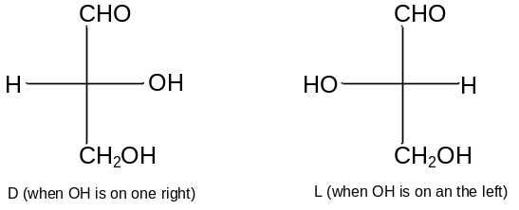
b) By two Walden inversion we get (D) as the following
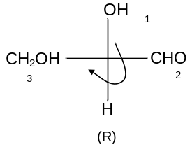
Hence D compound is R so, L is S.

3. 3

4. | 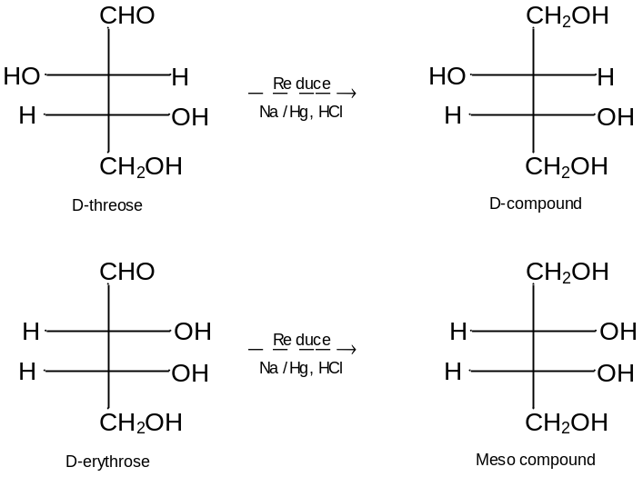
As D-compound is optically active and meso is inactive so by the above reaction we can differentiate D-erythrose and D-threose.
5. Aldotriose has one optically active centre but ketotriose does not have a stereocentre.
6. A deoxyaldohexose has only three chiral carbons and 2³ = 8 stereoisomers consequently.
7. a) No. only enantiomers have this property and anomers are not enantiomers.
b) Anomers are epimers whose conformations differ only about C¹.
8. Proline is secondary amine and also amine N is a part of five membered ring.
9. To explain we take propylene polymer. Propylene can polymerise to three different arrangements.
Isotactic – all methyl groups on one side of an extended chain. Syndiotactic, with methyl groups alternating regularly from side to side, atactic – with methyl groups distributed randomly.
10. Cleavage by HIO₄ indicates occasional vicinal diol groupings, –CH(OH)CH(OH)– and hence vicinal diacetate groups, –CH(OAc)CH(OAc)–. These show that some head to head polymerisation has taken place along with the predominant head to tail orientation.

LEVEL – II

1. Since the configuration of the chiral Cs do not change during the oxidation or reduction, the D-configuration is preferred.

2. Diastereomers with more than one stereocentres that differ in the configuration about only one stereocentre are called epimers. D-threose and D-erythrose are epimers because their configuration about C2 differs. Anomers arises because of hemiacetal formation of glucose by cyclisation. It occurs due to the optically active centre appears at C₁.

3. a) | 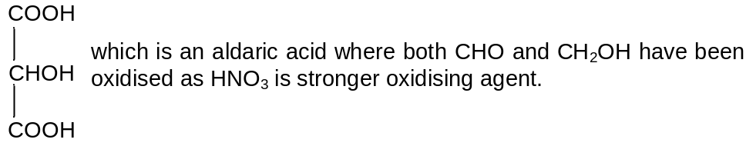
b) Br₂ water is mild oxidising agent. It only oxidises – CHO group to COOH. The product will be
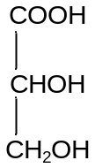
4. | 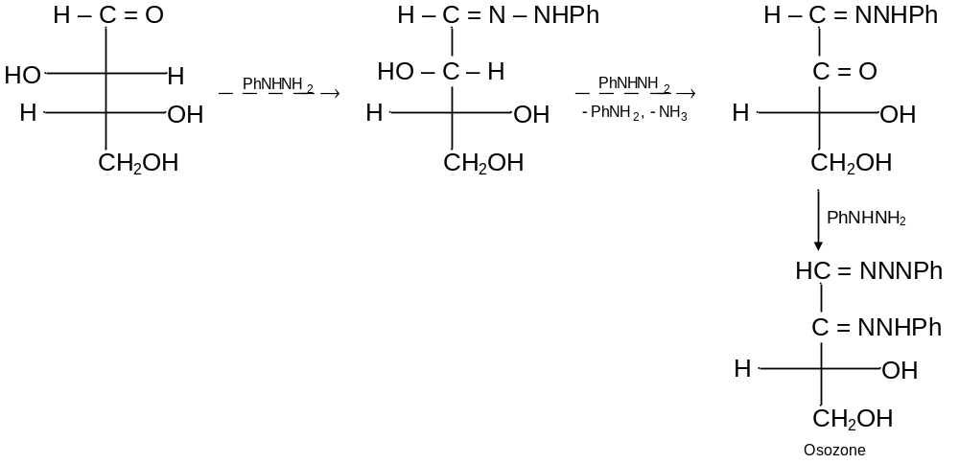

5. | 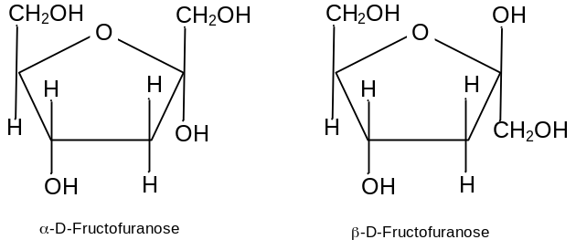
6. Lactose cannot be absorbed directly from the intenstine, into the blood stream. It first hydrolyse to monosaccharide, a reaction catalysed by lactose. Unabsorbed lactose, passing through the intestinal tract of individuals with little lactose, causes colic, diarrheal and other intenstinal distress.
7. The formation of osazone involves C—1 and C–2. Glucose, mannose and fructose have identical configuration at C–3, C–4 and C–5. Hence they form same osazone.

8. | 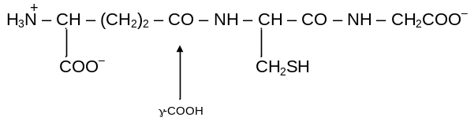
9. Acetamide liberate NH₃ with NaOH while glycine does not. Also Glycine give purple colour with ninhydrin while acetamide does not.
10. The same dye forms from all α-AA’s with 1° amino groups because their N is incorporated into it. 2° amines praline and hydroxyproline give different adducts that absorb light at a different wavelength and thus have a different yellow colour.

LEVEL – III

1. | 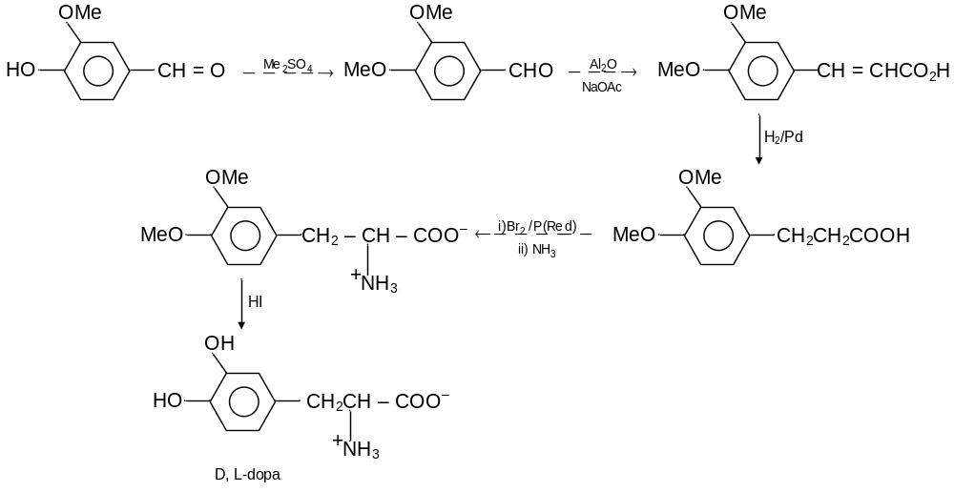

2. | 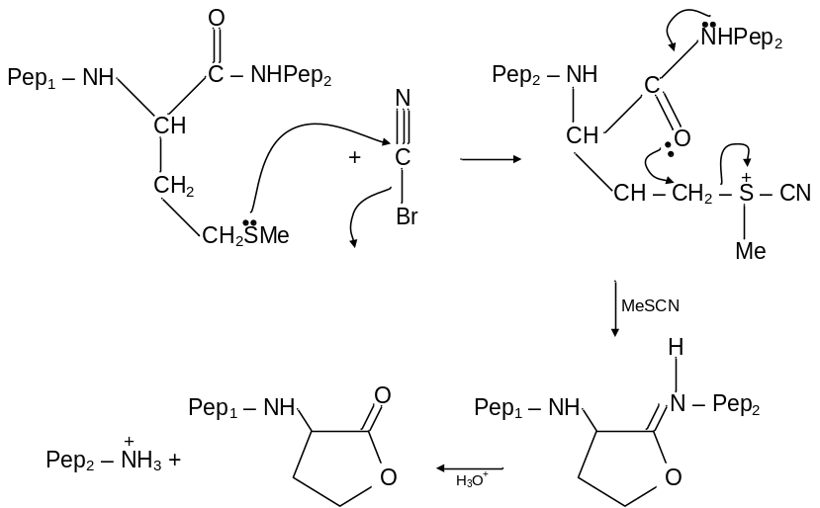

3. Two chiral C’s. Thus four possible isomers are possible.

4. a) | 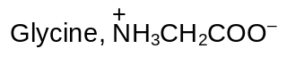 | b) | 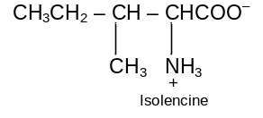

5. | 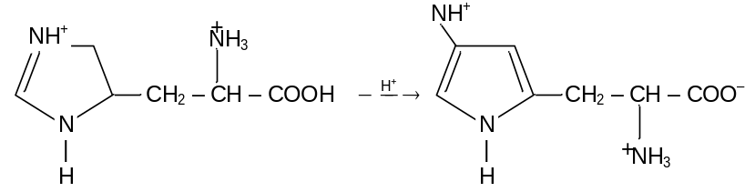
The carboxyl – H is lost.

6. Cystine; though disulphide bonds can provide a cross linkage.
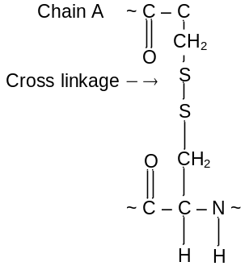

7. a) With I₂ a deep blue black colour.
b) Colour changes to reddish brown.
c) Amylose in starch traps I₂ molecules within its helix, forming a charge-transfer complex with the characteristic blue black colour. At higher temperatures the helix partially unwinds and fewer I₂ molecules are trapped. Upon cooling, the helix reforms, enclosing the I₂, and the original colour returns. (d) Amylopectin gives a less intense red brown colour because the helical structure is disrupted by the branching of the chain.

8. The more stable particle is formed in each step, with the same orientation.
9. There is acid-catalysed polymerisation of the alkene that is easily formed from a 2° or 3° alcohol.
10. An aminoacyl t-RNA complex is formed is a ester linkage between the COOH of the AA and an –OH of the ribose moiety of the terminal adenosine of the t-RNA.

6

