Stoichiometry (Unsolved)
1. How many grams of phosphoric acid would be needed to neutralise 100gm of magnesium hydroxide?
(Molecular weight of H₃PO₄ = 98 and Mg(OH)₂ = 58.3 gm)
(A) 66.7 (B) 252gm
(C) 112gm (D) 168 gm
2. 10 L of hard water required 0.56 gm of lime (CaO) for removing hardness. Hence temporary hardness in ppm of CaCO₃is
(A) 100 (B) 200
(C) 10 (D) 20
3. 20 ml of xM HCl neutralises completely 10 ml of 0.1 M NaHCO₃ solution and further 5 ml of 0.2 M Na₂CO₃ solution in the presence of methyl orange at end point, the value of x is
(A) 0.167M (B) 0.133M
(C) 0.15M (D) 0.2M
4. When 10 ml of ethyl alcohol (d = 0.7893 gm/ml) is mixed with 20 ml of water (d = 0.9971 g/ml) at 25°C, the final solution has a density 0.9571 gm/ml. The percentage change in total volume on mixing is
(A) 3.1% (B) 2.4%
(C) 1% (D) None of these
5. 0.635 gm of a cupric salt was dissolved in water and excess of KI was added in the solution and the liberated iodine required 25ml of N/5 Na₂S₂O₃ solution. The weight percentage of copper in the salt is
(A) 25% (B) 40%
(C) 50% (D) 63.5%
6. The chloride of a metal (M) contains 65.5% of chlorine 100 ml of the chloride of the metal at STP weight 0.72gm. The molecular formula of the metal chloride is
(A) MCl₃ (B) MCl
(C) MCl₂ (D) MCl₄
7. 22.4 litres of H₂S and 22.4 litre of SO₂ both at STP are mixed together. The amount of sulphur precipitated as a result of chemical calculation is
(A) 16gm (B) 23gm
(C) 48gm (D) 96gm
8. In the mixture of NaHCO₃ and Na₂CO₃ volume of a given HCl required is x ml with phenolphthalein indicator and further y ml required with methyl orange indicator. Hence volume of HCl for complete reaction of NaHCO₃ is
(A) 2x (B) y
(C) 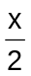 (D) (y – x)
9. A sample of oleum is labelled 109%. The % of free SO₃ in the sample is
(A) 40% (B) 80%
(C) 60% (D) 9%
10. 7.65 × 10^{–3} moles of NaNO₃ require 3.06 × 10^{–2} moles of a reducing agent to get reduced to NH₃. What is the n-factor of the reducing agent?
(A) 2 (B) 3
(C) 4 (D) 5
11. How many grams of sodium bicarbonate are require to neutralise 10ml of 0.902 M vinegar?
(A) 8.4 gm (B) 1.5gm
(C) 0.758 gm (D) 1.07gm
12. 1 gm mole of oxalic acid is treated with conc. H₂SO₄. The resultant gaseous mixture is passed through a solution of KOH. The mass of KOH consumed will be
(A) 28gm (B) 56gm
(C) 84gm (D) 112 gm
13. NH₃ + OCl– ⎯→ N₂H₄ + Cl–
On balancing the above equation in basic solution using integral coefficients, which of the following whole number will be the coefficient of N₂H₄?
(A) 1 (B) 2
(C) 3 (D) 4
14. A certain compound has the molecular formula X₄O₆. If 10 gm of X₄O₆ has 5.72g X, atomic mass of X is
(A) 32 amu (B) 37 amu
(C) 42 amu (D) 98 amu
15. In the following reaction
28NO₃– + 3As₂S₃ + 4H₂O ⎯→ 6AsO₄^{3–} + 28NO + 9SO₄^{2–} + 8H⁺
equivalent weight of As₂S₃ (with molecular weight M) is
(A) 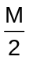 (B) 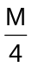
(C) 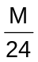 (D) 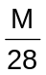

Answers

1. C 2. B 3. C
4. A 5. C 6. A
7. C 8. D 9. A
10. A 11. C 12. D
13. A 14. A 15. D

Solved Objective
Problem 1: One mole of a mixture of CO and CO₂ requires exactly 20 gms of NaOH to convert all the CO₂ into Na₂CO₃. How many more gms of NaOH would it require for conversion into Na₂CO₃ if the mixture (one mole) is completely oxidised to CO₂.
(A) 60 gm (B) 80 gm
(C) 40 gm (D) 20 gm
Solution: Moles of NaOH = 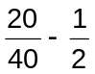
Moles of CO₂ = 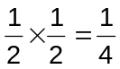[ ‘n’ factor for CO₂ = 2]
Moles of CO = 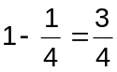
Moles of CO₂ produced = 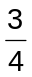 from CO
Moles of NaOH extra = 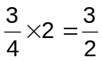
Mass of NaOH extra 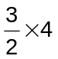 = 60
Problem 2: One litre of 0.1 M CuSO₄ solution is electrolysed till the whole of copper is deposited at cathode. During the electrolysis a gas is released at anode. The volume of the gas is
(A) 112ml (B) 254 ml
(C) 1120 ml (D) 2240 ml
Solution: When copper is deposited at cathode, oxygen gas is released at anode
Equivalents of copper = 0.1 × 2 = 0.2
Equivalents of oxygen = 0.2
Volume of oxygen at NTP = 0.2 × 5600 = 1120 ml
Problem 3: In a reaction
FeS₂ + MnO₄ + H⁺ ⎯→ Fe³⁺ + SO₂ + Mn²⁺ + H₂O
The equivalent mass of FeS₂ would be equal to
(A) Molar mass (B) 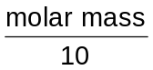
(C) 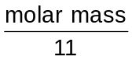 (D) 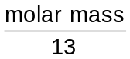
Solution: Fe²⁺ ⎯→ Fe³⁺ + e–
S₂^{–2} ⎯→ 2S⁺⁴ + 10e–
–––––––––––––––––
FeS₂ ⎯→ 2S⁺⁴ + Fe³⁺ + 11e–
∴ Equivalent mass of FeS₂ =

Problem 4: Equal volumes of 0.2M HCl and 0.4M KOH are mixed. The concentration of the principal ions in the resulting solution are
(A) [K⁺] = 0.4M, [Cl–] = 0.2M, [H⁺] = 0.2M
(B) [K⁺] = 0.2M, [Cl–] = 0.1M, [OH–] = 0.1M
(C) [K⁺] = 0.1M, [Cl–] = 0.1M, [OH–] = 0.1M
(D) [K⁺] = 0.2M, [Cl–] = 0.1M, [OH–] = 0.2M
Solution: Resulting solution in alkaline since M(KOH) > M(HCl), hence the molarity of KOH after reaction
= 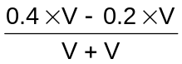 = 0.1M
KOH + HCl KCl + H₂O
t = 0 0.4 0.2
t = t 0.2 0 0.2
0.1 0.1 due to dilution
∴ [K⁺] = 0.1 + 0.1 = 0.2M
[Cl–] = 0.1M
[OH–] = 0.1M
Problem 5: To prepare a solution that is 0.5M KCl starting with 100ml of 0.4M HCl
(A) Add 0.75gm KCl (B) Add 20 ml of water
(C) Add 0.10 mol of KCl (D) Evaporate 10 ml water
Solution: a) 100ml of 0.4M KCl = 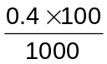mol = 0.04 mol (initial)
= 0.04 × 74.5 (initially) = 2.98gm
= 3.73g (after) = 0.05 mol in 100 ml
= 0.5M
∴ (A) is true
b) Addition of 20 ml water will decrease molarity that will be less than 0.4 M
∴ (B) is false
c) 0.04 (initial as in (a)) + 0.10 (added)
= 0.14 mol KCl in 100 ml
= 1.4 M
∴ (C) is false
d) 0.04 mol KCl in 90 ml solution (after 10 ml water evaporated) = 0.044 M
∴ (D) is also false
Problem 6: For the reaction
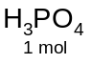 + 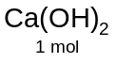⎯→ CaHPO₄ + 2H₂O
Which are true statements
(A) Equivalent weight of H₃PO₄ is 49
(B) Resulting mixture is neutralised by 1 mol of KOH
(C) CaHPO₄ is an acid salt
(D) 1 mol of H₃PO₄ is completely neutralised by 1.5 mol of Ca(OH)₂.
Solution: a) By given reaction
H₃PO₄ ≡ 2OH–
∴ Equivalent weight = 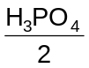 = 49
∴ (A) is true
b) Only one acidic H in CaHPO₄ hence neutralised by 1 mol of KOH
∴ (B) is true
c) One acidic H in CaHPO₄ makes it acidic salt.
∴ (C) is true
d) H₃PO₄ ≡ 3H⁺ ≡ 3OH– ≡ 1.5 Ca(OH)₂
∴ (D) is true

Problem 7: The brown ring complex compound is formulated as [Fe(H₂O)₅NO]SO₄. The oxidation number of iron is
(A) 1 (B) 2
(C) 3 (D) 0
Solution: [Fe(H₂O)₅NO]SO₄ [Fe(H₂O)₅NO]²⁺ + SO₄^{2–}
In this complex NO transfers one of its electron to Fe (which is initially +2)
This gives +1 charge on NO and +1 charge on Fe. Fe has thus three unpaired electrons as confirmed by its magnetic moment which is 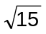B.M.
∴ (A)
Problem 8: An organic compound contains 4% sulphur minimum molecular weight is
(A) 200 (B) 400
(C) 800 (D) 16000
Solution: 4 gm sulphurs is in 100g compound hence 32gm sulphur is in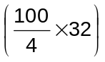 = 800 g compound.
∴ (C)
Problem 9: If 20 ml of 0.2 M K₃[Fe(CN)₆] is reduced by some equivalents of N₂H₄, then calculate numbers of moles of N₂H₄ required for the above reaction the answer is
(A) 10^{–5} (B) 10^{–3}
(C) 10^{–6} (D) 10^{–2}
Solution: N₂H₄ + K₃[Fe(CN)₆ + KOH ⎯→ K₄[Fe(CN)₆] + N₂ + H₂O
∴ Number of equivalents of
K₃[Fe(CN)₆] = 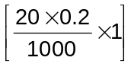
Number of moles of
N₂H₄= 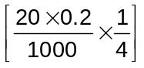 = 10^{–3}
∴ (B)
Problem 10: 0.7gm of Na₂CO₃.XH₂O were dissolved in water and the volume was made to 100 ml, 20 ml of this solution required 19.8 ml of N/10 HCl for complete neutralisation. The value of x is
(A) 7 (B) 3
(C) 2 (D) 5
Solution: Meq. of Na₂CO₃.xH₂O in 20 ml = 19.8 × 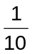
∴ Meq. Of Na₂CO₃.xH₂O in 100 ml = 19.8 × × 5
∴ 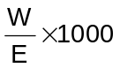 = 19.8 × × 5
or 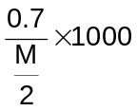 = 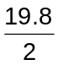
M = 141.41
∴ 23 ×2 + 12 + 3 × 16 + 18x = 141.41
x = 2
∴ (C)
Chemical Equilibrium

1. For the reaction A + B C + D, equilibrium concentrations of [C] = [D] = 0.5M if we start with 1 mole each of A and B. Percentage of A converted into C if we start with 2 mole of A and 1 mole of B is
(A) 25% (B) 40%
(C) 66.66% (D) 33.33%

2. CH₃ – CO – CH_{3(g)} CH₃ – CH_{3(g)} + CO_{(g)}
Initial pressure of CH₃COCH₃ is 100mm when equilibrium is set up, mole fraction of CO_{(g)} is 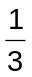 hence K_{p} is
(A) 100mm (B) 50mm
(C) 25mm (D) 150mm
3. For the reaction
CaCO_{3(s)} CaO_{(s)} + CO_{2(g)}
Equilibrium constant K_{p} is 1.642 atm at 1000K, if 40 gm of CaCO₃ was put into a 10 L flask, percentage of calcium carbonate would remain unreacted at the equilibrium.
(A) 66% (B) 34%
(C) 50% (D) 25%
4. If equilibrium constant of
CH₃COOH + H₂O CH₃COO– + H₃O⁺
Is 1.8 × 10^{–5}, equilibrium constant for
CH₃COOH + OH– ⎯→ CH₃COO– + H₂O is
(A) 1.8 × 10^{–9} (B) 1.8 × 10⁹
(C) 5.55 × 10^{–10} (D) 5.55 × 10¹⁰
5. PCl₅ is 40% dissociated when pressure is 2 atmosphere it will be 80% dissociated when pressure is approximately
(A) 0.2 atm (B) 0.5 atm
(C) 0.3 atm (D) 0.6 atm
6. For the reaction: 2HI_{(g)} H_{2(g)} + I_{2(g)}, the degree of dissociated (α) of HI_{(g)} is related to equilibrium constant K_{p} by the expression
(A) 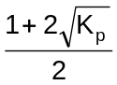 (B) 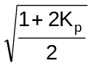
(C) 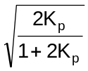 (D) 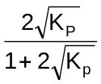
7. For which of the following reactions, the degree of dissociation cannot be calculated from the vapour density data.
i) 2HI_{(g)} H_{2(g)} + I_{2(g)}
ii) 2NH_{3(g)} N_{2(g)} + 3H_{2(g)}
iii) 2NO_{(g)} N_{2(g)} + O_{2(g)}
iv) PCl_{5(g)} PCl_{3(g)} + Cl_{2(g)}
(A) (i) and (iii) (B) (ii) and (iv)
(C) (i) and (ii) (D) (iii) and (iv)
8. Van’t Hoff equation giving the effect of temperature on chemical equilibrium is represented as
(A) 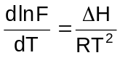 (B) 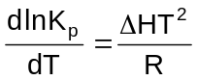
(C) 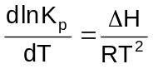 (D) 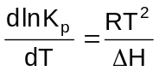
9. Pure ammonia is placed in a vessel at temperature where its degree of dissociation (α) is appreciable at equilibrium.
(A) K_{p} does not change with pressure (B) α does not change with pressure
(C) (NH₃) does not change with pressure (D) [H₂] < [N₂]
10. Steam starts reacting with iron at high temperature to give hydrogen gas and Fe₃O₄. The correct expression for equilibrium constant is
(A) 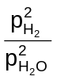 (B) 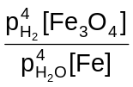
(C) 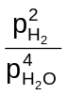 (D) 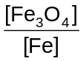
11. X nY, X decomposes to give Y (in one litre vessel) if degree of dissociation is α then K_{C} and its unit.
(A) 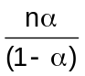,mol^{n–1} lit^{n–1} (B) 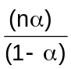,mol^{n} lit^{n}
(C) ,K_{C} is unit less (D) 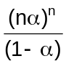,K_{C} is unit less
12. Solubility of a solute in a solvent (say H₂O) is dependent on temperature as given by
S = Ae^{–ΔH/RT} where ΔH is heat of reaction
Solute + H₂O Solution, ΔH = ±X
For a given solution variation of log S with temperature is shown graphically. Hence solute is
(A) CuSO₄.5H₂O (B) NaCl
(C) Sucrose (D) CaO
13. For the reaction A_{(g)} B_{(g)} + C_{(g)}
(A) K_{p} = α³P (B) K_{p} = α²(K_{p} + P + 1)
(C) K_{p} = α² (K_{P} + P) (D) K_{p} = α² 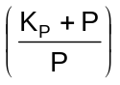
14. The values of K_{C} for the following reactions are given as below
A B, K_{C} =1, B C, K_{C} = 3 and C D, K_{C} = 5
Evaluate the value of K_{C} for A D
(A) 15 (B) 5
(C) 3 (D) 1
15. For the reaction (1) and (2)
A B + C
D 2E
Given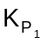: 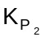 : : 9 : 1
If the degree of dissociation of A and D be same then the total pressure at equilibrium (1) and (2) are in the ratio.
(A) 3:1 (B) 36:1
(C) 1:1 (D) 0.5:1

ANSWERS

1. D 2. B 3. B
4. B 5. A 6. D
7. A 8. C 9. A
10. C 11. D 12. D
13. C 14. A 15. B

Gaseous State

1. At constant pressure what would be the percentage decrease in the density of an ideal gas for a 10% increase in the temperature.
(A) 10% (B) 9.1%
(C) 11% (D) 12.09%
2. A small hole is pricked in a container containing a mixture of CH₄ and O₂ and placed in vacuum. What should be the molar ratio of methane to oxygen in the container when the two gases are effusing out in the ratio of 2:1
(A) 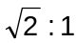 (B) 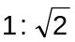
(C) 2:1 (D) 1:2
3. The Van der Wall’s equation is 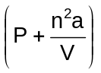(V – nb) = nRT for n moles where ‘a’ and ‘b’ are Van der Wall’s constant which of the following statements are true about ‘a’ and ‘b’ when the temperature of the gas is too low
(A) Both remains same (B) ‘a’ remains same, b varies
(C) ‘a’ varies, ‘b’ remains same (D) both varies

4. The tube in the figure is shielded at both end and heated upto double the original temperature both side of Hg column gases are packed with increasing temperature the Hg column
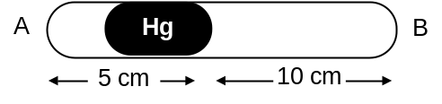
(A) Shift towards ‘B’ (B) Shifts towards A
(C) Remain same (D) Start to vibrate
5. the molar specific heat at constant volume of mixture of gases A and B is 4.33 cal. A is monoatomic and B is diatomic then the ratio of moles of A and B is
(A) 1:1 (B) 2:1
(C) 1:2 (D) 3:1
6. Rate of diffusion of two gases are r_{A} and r_{B}, molecular weights are M_{A} and M_{B} then partial pressure P_{A} is (if number of moles are n_{A} and n_{B}).
(A) 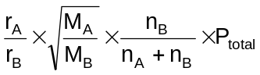 (B) 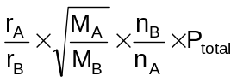
(C) 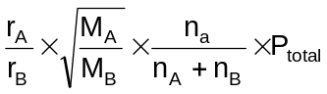 (D) None of these
7. There are two gases A and B having degree of freedom f_{A} and f_{B}, the difference in energy supplied for increment in temperature of one mole gas by 50°C is (in cal)
(A) 50 (f_{A} – f_{B}) (B) 100 (f_{A}– f_{B})
(C) 200 (f_{A} + f_{B}) (D) 50 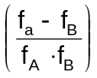
8. When an ideal gas undergoes unrestricted expansion no cooling takes place because the molecules
(A) Exert no attractive forces on each other (B) Do work equal to loss of KE
(C) Colide without loss of energy (D) Are about the inversion temperature
9. If two gases of molecular weights M_{A} and M_{B} at temperatures T_{A}, T_{B} and T_{A}M_{B} = T_{B}M_{A}, then which property has the same magnitude for both the gases.
(A) Density (B) Pressure
(c) KE per mole (D) V_{rms}
10. At low pressure Vander Wall’s equation for 3 moles of a real gas will have its simplified form
(A) 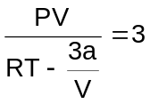 (B) 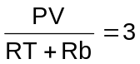
(C) 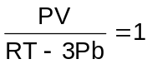 (D) 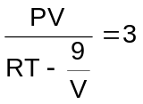
11. for two gases A and B with molecular weights M_{A} and M_{B}, its observed that a certain temperature T, the mean velocity of A is equal to the root mean square velocity of B. Thus the mean velocity of A can be made equal to the mean velocity of B if
(A) A is at temperature T, and B at T′⋅T > T′
(B) A is lowered to a temperature T₂ = 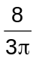T
(C) Both A and B are raised to a higher temperature
(D) Both A and B are placed at lower temperature
12. The quantity 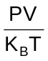represents the
(A) Number of molecules in the gas (B) Mass of the gas
(C) Number of moles of the gas (D) Translational energy of the gas
13. The rms velocity of hydrogen is 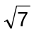times the rms velocity of nitrogen. If the temperature of the gas
(A) T(H₂) = T(N₂) (B) T(H₂) > T(N₂)
(C) T(H₂) < T(N₂) (D) T(H₂) = T(N₂)
14. 1 lt of N₂ and 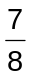l of O₂ at the same temperature and pressure were mixed together what is the relation between the masses of two gases in the mixture.
(A) 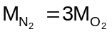 (B) 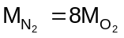
(C) 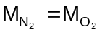 (D) 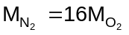
15. Consider a mixture of SO₂ and O₂ kept at room temperature compared to the oxygen molecule, the SO₂ molecule will hit the wall with
(A) Smaller average speed (B) Greater average speed
(C) Greater kinetic energy (D) Greater mass

ANSWERS

1. B 2. A 3. D
4. C 5. C 6. A
7. A 8. A 9. D
10. A 11. B 12. A
13. C 14. C 15. A

Gaseous State (Solved)
Problem 1: The Vander Wall’s constant b is equal to
(A) The molecular volume of 1 mol of the gas
(B) Two times the molecular volume of 1 mole of the gas
(C) Three times the molecular volume of 1 mole of the gas
(D) Four times the molecular volume of 1 mole of the gas
Solution: ‘b’ is the volume occupied by 1mole of a gas molecules. Excluded volume for 2 gas molecules
= 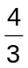π (2r)³ = 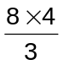πr³
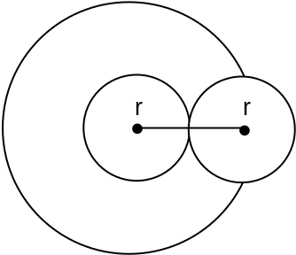
∴ Excluded volume / molecule = 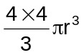
∴ b = × N_{A}
∴ b = 4 × volume of 1 mole of molecules
Problem 2: What will be percentage of ‘free volume’ available in 1 mole of H₂O_{(l)} at 760 mm and 373 K. Density of H₂O_{(g)} at 373 K is 0.958 gm/ml.
(A) 0.0613% (B) 99.9386%
(C) 0.0543% (D) 99.9457%
Solution: Volume occupied by 1 mole of H₂O_{(g)} at 373 K = 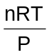
= 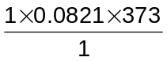 = 30.62L
Volume of 1 mole of H₂O_{(l)}
= 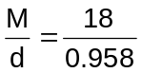= 18.789 ml
% of volume occupied by liquid water
= 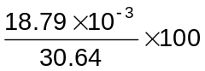
= 0.0613%
% of free volume
= 100 – 0.0613 = 99.9386%

Problem 3: One mole of each monoatomic, diatomic and triatomic gases are mixed, C_{p}/C_{V} for the mixture is
(A) 1.40 (B) 1.428
(C) 1.67 (D) None of these
Solution: C_{v} = 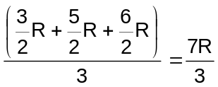
C_{p} = 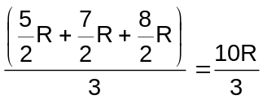
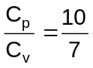 = 1.428
Problem 4: The vapour pressure of water at 20°C is 17.5 torr. What will be the no. of moles of water present in one litre of air at 20°C and 40% relative humidity.
(A) 4.2 × 10^{–4} mole (B) 4.2 × 10^{–6} mole
(C) 3.82 × 10^{–4} mole (D) 3.82 × 10^{–6} mole
Solution: Relative humidity (RH) = 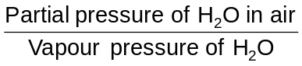
∴ Partial pressure of H₂O = RH × Vapour pressure of H₂O
= 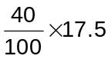 = 7 torr
= 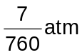 = 0.0092 atm
Now PV = nRT
∴ 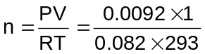
= 0.000382 mole
= 3.82 × 10^{–4} mole
Problem 5: The compressibility factor of a gas is less than unity at STP. Therefore
(A) V_{m} > 22.4 litre (B) V_{m} < 22.4 litre
(C) V_{m} = 22.4 litre (D) V_{m} = 44.8 litre
Solution: Z = 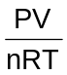
Ar Z < 1 (given)
∴ 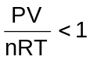or PV < nRT
P = 1 atm
V = V_{m}
R = 0.082
T = 273
∴ V_{m} < 0.0821 × 273
= V_{m} < 22.4 litre
Problem 6: The composition of the equilibrium mixture (Cl₂ 2Cl), attained at 1200°C, is determined by measuring the rate of effusion through a narrow aperture. At 1.80 mm Hg pressure, the mixture effuses 1.16 times as fast as Krypton under the same conditions. What will be the fraction of chlorine molecules dissociated into atoms (Atomic mass of Kr = 84)
(A) 13% (B) 13.7%
(C) 26% (D) 26.4%
Solution: 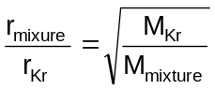
or 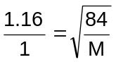
or M = 62.425
for Cl₂ 2Cl
initially 1 0
at equilibrium (1 – α) 2α
i (Van’t Hoff factor) = 1 – α + 2α = 1 + α
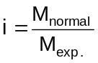
or 1 + α = 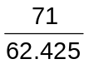
on solving α = 0.137
or α = 13.7%
Problem 7: A spherical balloon of 21 cm diameter and 4.851 L volume is to be filled with hydrogen at NTP from a cylinder containing the gas at 20 atm and 27°C the cylinder can hold 2.82 litre of water at N.T.P. what will be the number of balloons that can be filled up?
(A) 5 (B) 10
(C) 15 (D) 20
Solution: Volume of one balloon = 4.821 litre
Volume of n balloons = 4.821 n litre
Total volume of hydrogen in the cylinder at NTP
V = 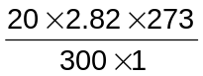 = 51.324 litre
Actual volume of H₂ to be transferred to balloons
= 51.324 – 2.82 = 48.504 litre
(∴ 2.82 L is retained in the cylinder)
∴ NO. of balloon, n = 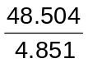≈ 10
Problem 8: The numerical value of 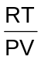 for a gas at critical condition is … times of 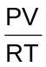at normal condition
(A) 4 (B) 8/3
(C) 3/8 (D) 1/4
Solution: At critical temperature
∴ P_{C}V_{C}= 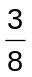RT_{C}
∴ for a gas at critical temperature is 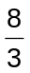times of that gas at NTP
Problem 9: What will be the molecular diameter of Helium if Vander Waal’s constant, b = 24 ml mole^{–1}?
(A) 2.71Å (B) 2.71mm
(C) 5.42Å (D) 542Å
Solution: b = 4V_{m}
(V_{m} is the volume occupied by one mole of gas)
or 24 = 4 × N₀ × πr³
or r = 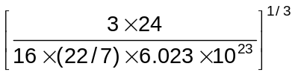
= 1.355 × 10^{–8} cm
∴ d = 2r = 2 × 1.355 × 10^{–8} cm
= 2.71Å
Problem 10: the density of phosphorus vapour at 310°C and 775 torr is 2.64g dm^{–3}. What is the molecular formula of phosphorus?
(A) P (B) P₂
(C) P₄ (D) P₈
Solution: 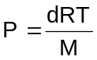
or M = 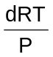
Put d = 2.64gm dm^{–3}
R= 0.0821 dm³ atm K^{–1} mol^{–1}
P = 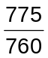atm
and T = 310 + 273 = 583K
We get M = 123.9g mol^{–1}
No. of P atoms in a molecule
= 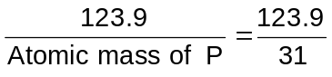= 3.99≈ 4
Thus the molecular formula of phosphorus = P₄
Electrophilic Aromatic Substitution (UNSOLVED)

1. | 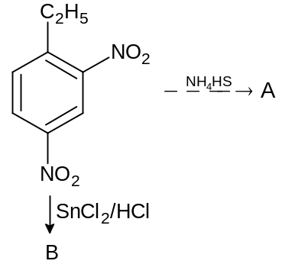  A and B are
(A) |  | 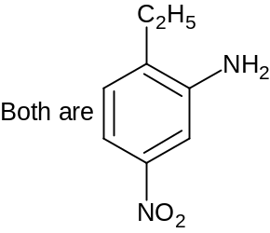 | (B) | 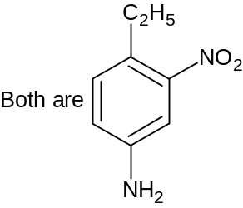
(C) |  | 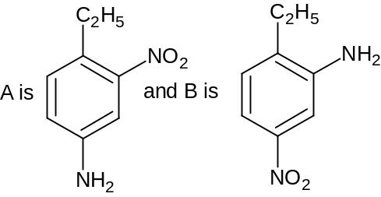 | (D) | 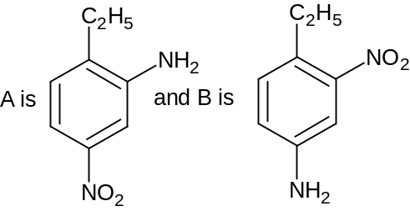

2. Benzene diazonium chloride most readily couples with
(A) Anisole (B) Naphthalene
(C) Alkaline β-naphthol (D) Mesitylene

3. | 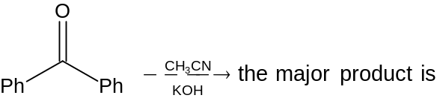
(A) |  | 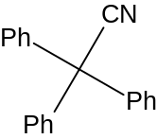 | (B) | 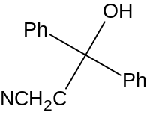
(C) |  | 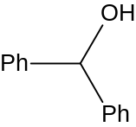 | (D) | 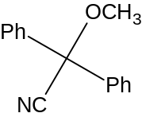

4. | 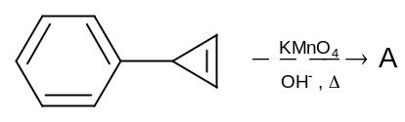  So A is
(A) |  | 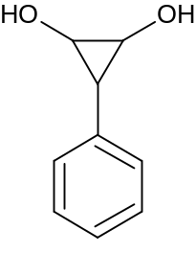 | (B) | 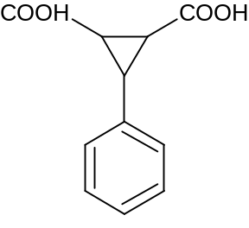
(C) |  | 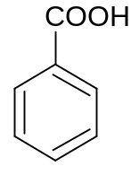 | (D) | 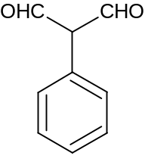

5. | 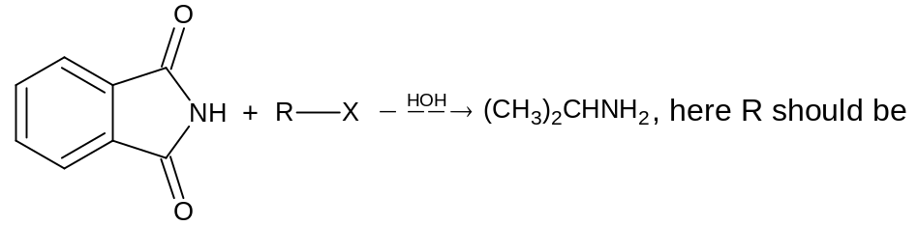
(A) Et– (B) Me–
(C) (CH₃)₂CH– (D) Propyl

6. | 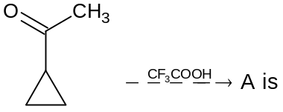
(A) |  | 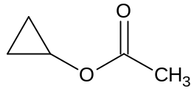 | (B) | 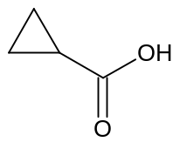
(C) |  | 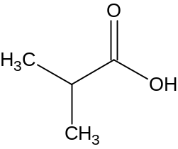 | (D) | 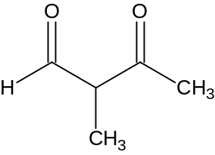

7. | 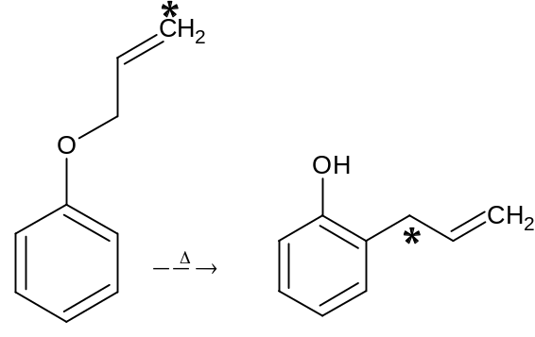
What is the name of the reaction?
(A) Fries rearrangement (B) Claisen rearrangement
(C) Kolbe reaction (D) Riemer-Tiemann reaction

8. Which of the following can react with TsCl?
(A) Glycerol (B) n-propyl cyanide
(C) Trimethylamine (D) Methoxy dimethyl amine

9. | 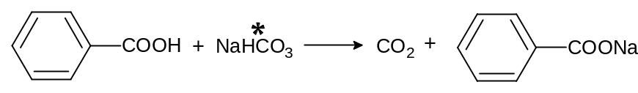
C* is with the product
(A) | CO₂ | (B) | 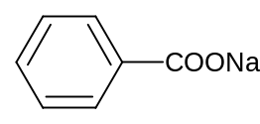
(C) | Both | (D) | None

10. | 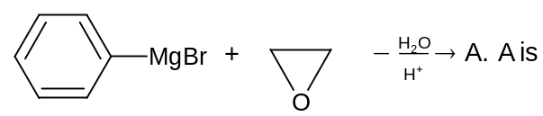
(A) |  | 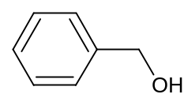 | (B) | 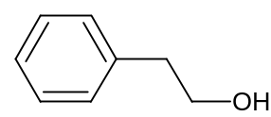
(C) |  | 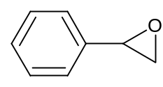 | (D) | No reaction

11. | 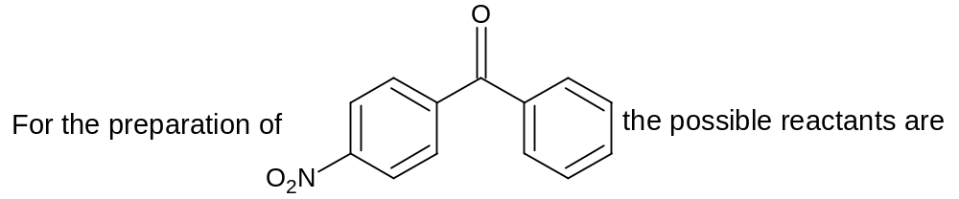
(A) |  | 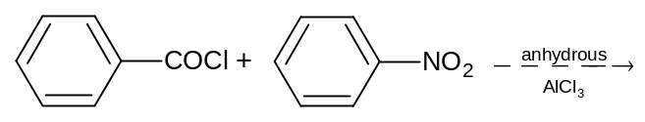
(B) |  | 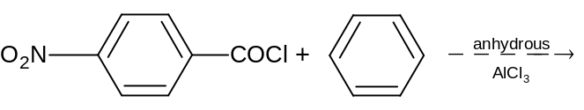
(C) |  | 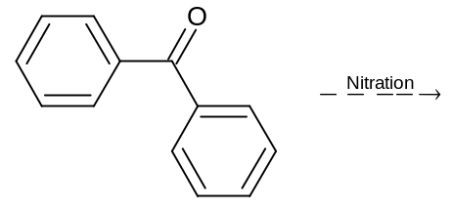
(D) |  | Any of these

12. | 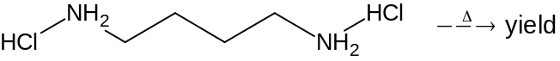
(A) |  | 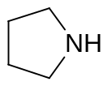 | (B) | 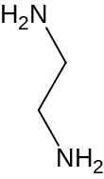
(C) |  | 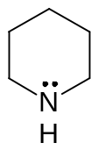 | (D) | 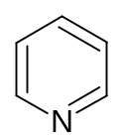

13. | 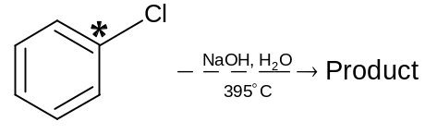  Product is
(A) |  | 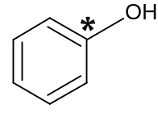 | (B) | 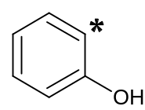
(C) |  | Both | (D) | None

14. | 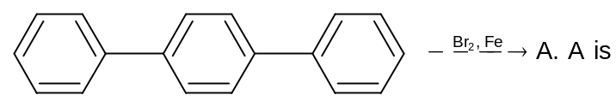
(A) |  | 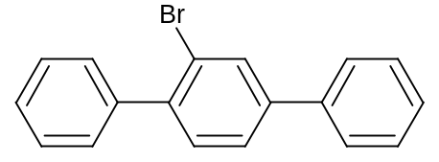 | (B) | 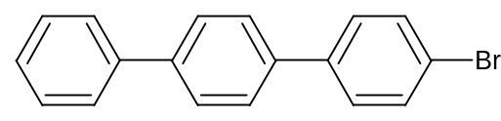
(C) |  | Both are correct | (D) | None is correct

15. End product of the following reaction is
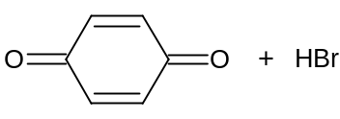
(A) | 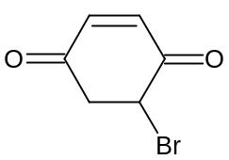 | (B) | 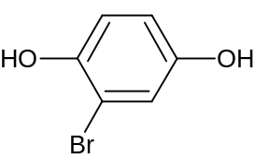
(C) | 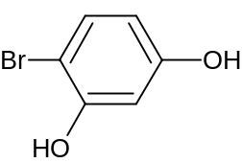 | (D) | 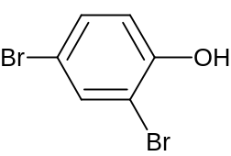

Answers

1. C 2. C 3. B
4. C 5. C 6. A
7. B 8. A 9. A
10. B 11. B 12. A
13. C 14. A 15. B

Solved Problems

Problem 1: | 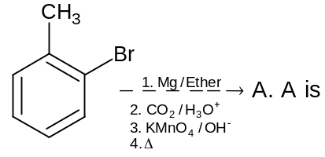
(A) |  | 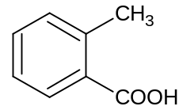 | (B) | 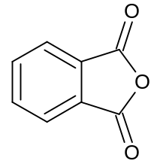
(C) |  | 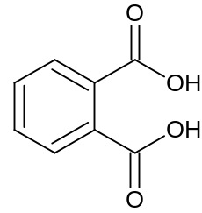 | (D) | 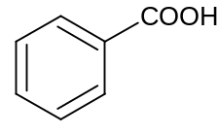

Solution: | 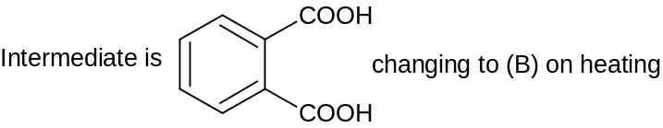
∴ (B)
Problem 2: | 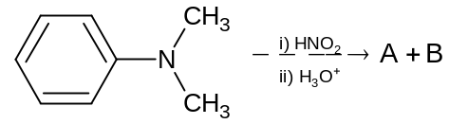  A and B are
(A) |  | 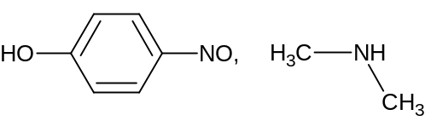
(B) |  | 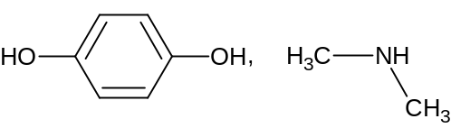
(C) |  | 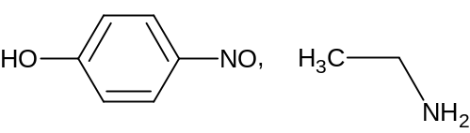
(D) |  | None is correct

Solution: | 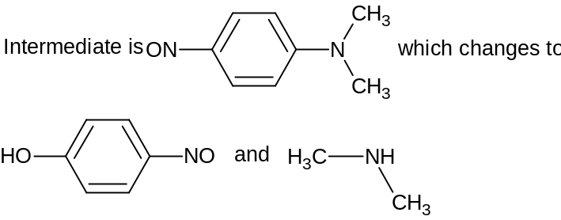
∴ (A)

Problem 3: The products of ozonolysis of two xylenes I and Ii are
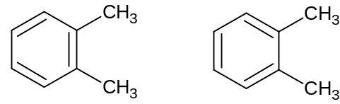
(A) Same (B) Different
(C) May be same or different (D) Cannot be predicted

Solution: | 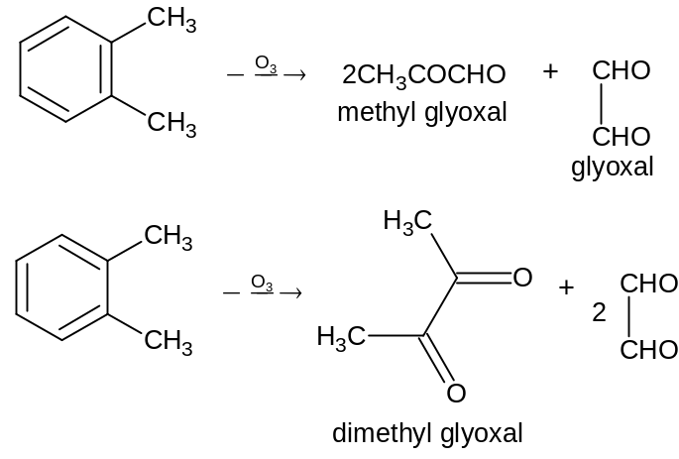
o-xylene gives a mixture of glyoxal, methyl glyoxal and dimethyl glyoxal due to different positions of double bonds in the ring.
∴ (B)

Problem 4: | 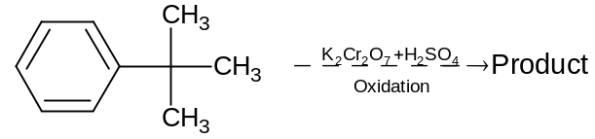  The product is
(A) |  | 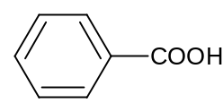
(B) |  | 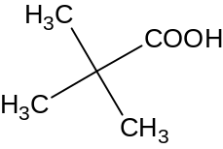
(C) |  | 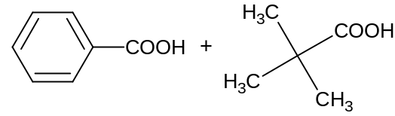
(D) |  | Oxidation is not possible

Solution: An alkyl side chain attached to the benzene ring can be oxidised to –COOH group only when it contains atleast one α-hydrogen atom. Since t-butyl group has no α-H atom, it can not be oxidised, instead of this ring is oxidised.
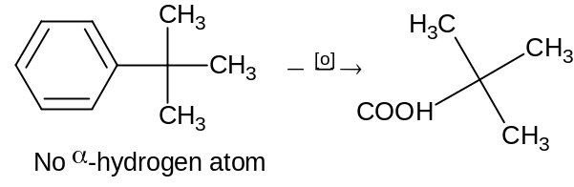

Problem 5: When benzene in excess reacts with CH₂Cl₂ in presence of anhydrous AlCl₃ the product formed is
(A) | 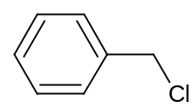 | (B) | 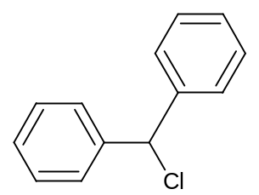
(C) | 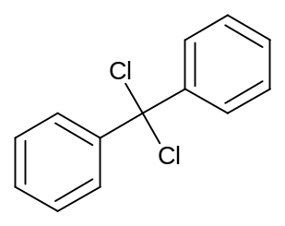 | (D) | 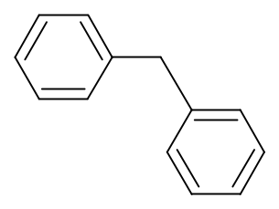

Solution: | 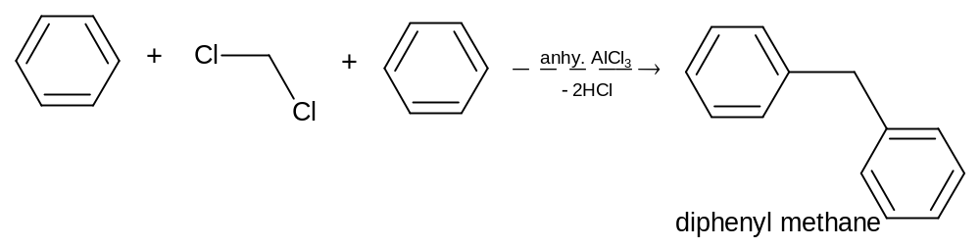

Problem 6: The acid undergoes decarboxylation readily is
(A) | 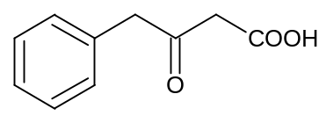 | (B) | 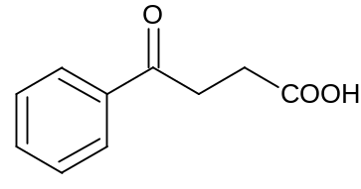
(C) | 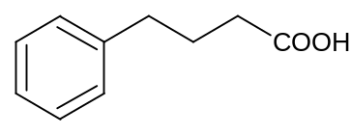 | (D) | 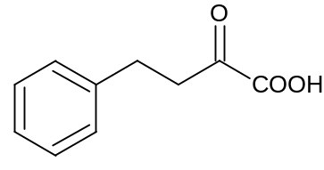

Solution: β-keto acids undergo spontaneous decarboxylation on heating to form a ketone.
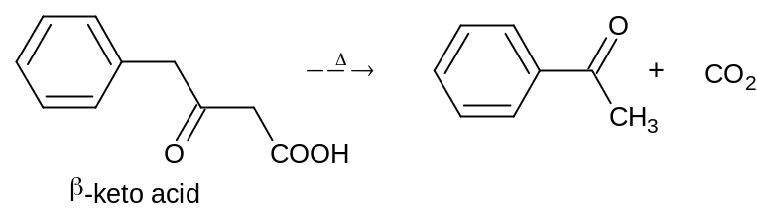

Problem 7: The conversion which can be brought about under Wolff Kishner reduction conditions is:
(A) Benzaldehyde into benzyl alcohol
(B) Benzophenone into diphenyl methane
(C) Cyclohexanone into cyclohexanol
(D) Cyclohexanal into cyclohexanone
Solution: Under Wolf Kishner reduction a >C = O group is converted to >CH₂
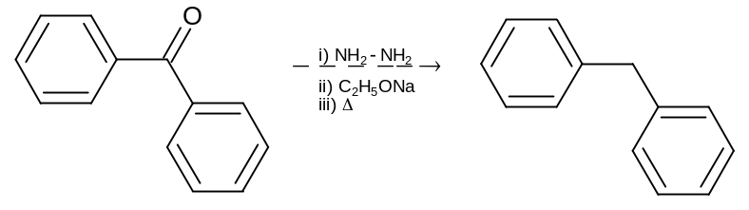
Problem 8: The product obtained by heating salicylaldehyde with ethanoic anhydride in presence of sodium ethanoate is
(A) | 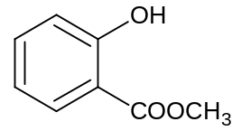 | (B) | 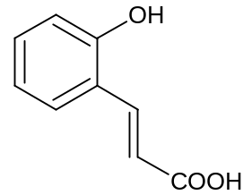
(C) | 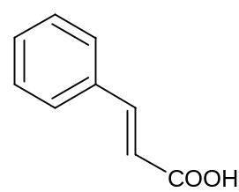 | (D) | 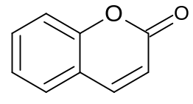

Solution: | 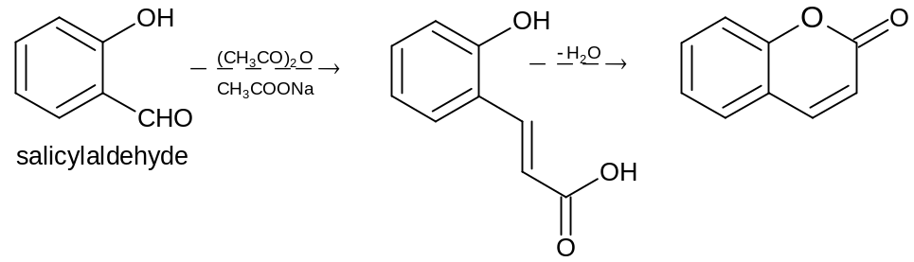

Problem 9: The intermediate formed in the following reaction is
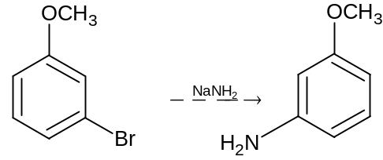
(A) Carbene (B) Nitrene
(C) benzyne (D) Carbonium ion

Solution: The reaction is an example of cine substitution or elimination addition
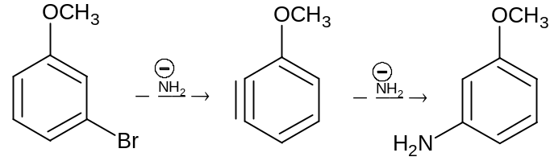

Problem 10: A new carbon – carbon bond is formed in:
Cannizaro reaction Freidal-Craft’s reaction
(I) (II)
Clemmensen’s reduction Riemer-Tiemann reaction
(III) (IV)
(A) (II) (B) (II) and (IV)
(C) (I), (II), (III), (IV) (D) None

Solution: New carbon-carbon bond is formed is Friedal Craft reaction and Reimer-Teimann reaction
Friedal Craft’s reaction
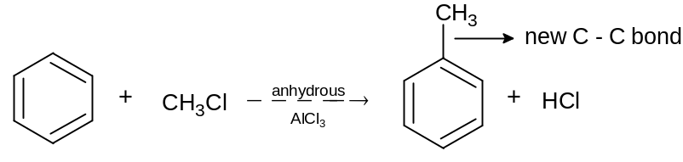
Riemer Teimann Reaction


